I have divided the learning goals into two activities.

1 Wave Representation Learning Goals:
Students will be able to think about waves as a function of time, space or space-time and explain why waves might be represented in these different ways.

2 Superposition of Waves Learning Goals:
Students will be able to:
- Define harmonic, determine the relationship between the harmonics,
- Explain the relationship between harmonics and the corresponding wave function.
- Predict what happens when more than one wave is present. I want the students to be able to superpose waves to find the sum.

Background:
We will have added several types of vectors. They will have done the Waves on a String activity.

Fourier-Making Waves Introduction:
Show the students that you can change the amplitude by grabbing the bar or typing in a number in the box. As soon as you do, the function changes to custom. Also, show how to set the SUM window on Auto scale. Discuss that it only auto scales the y axis and reflect axes scales. When you reset, the scale returns to default. I’ll explain that the Sum Graph is the observable disturbance. I have a wave demonstrator that I’ll use to explain what the graphs are modeling.

Lesson:
The students will need their papers from the Waves on a String activity. Have the students use the lab sheet for guidance. I may use the first activity as a Homework, but then I would need to reword the first question. (Maybe I would have them describe waves to someone in their family). The activity is for my honors physics students. Untested

Things I want to remember when I designed the activities:
Activity 1:
1. When you change function from space to time. There are no changes other than the axis label and period tool now available rather than wavelength.

Activity 2:
- Harmonics have same amplitude but wave lengths that get smaller. To calculate the wavelength of n harmonic divide the wavelength of the fundamental wave (n=1), by the n of the harmonic. In our physics books, the fundamental frequency is given value of n=0 so the equation is not in this form, but I expect this is the form that students will derive. We will have to reconcile with the books convention, but I’ll do this later.
- I would want them to see that the SUM window looks like the name and that the individual waves add to give that shape, more harmonics make the sum curve smoother. I am not concerned that they discover the sum part yet.

- The amplitudes were 1 and .35. The sum looks like this.
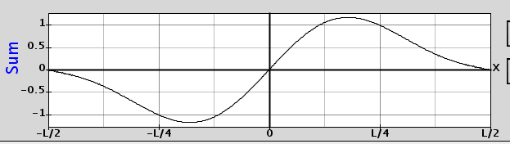

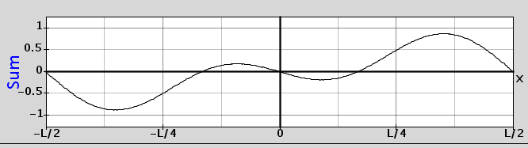
- The amplitudes were .5 and -.5 for amplitudes. The sum looks like this.

- The amplitudes were .5 and 1. I had to use Auto scale to see the whole graph.
