Learning Goals: Students will be able to
- Use free body diagrams to draw position, velocity, acceleration and force graphs and vice versa
- Explain how the graphs relate to one another.
- Given a scenario or a graph, sketch all four graphs.

- Consider this story: A man wakes up from his nap under the tree and goes toward the house. He stops because he is worried that he dropped his keys. He stands still as he searches his pockets for his keys. He realizes he has them, but he left his jacket under the tree and heads back to get it.

- Open Moving Man. Make the Man model the story with the following stages.
1) The man starts by the tree and moves toward the house 2) Walks with constant velocity.
3) Slows to a stop 4) Stands still for a while 5) Changes direction moving towards the tree.

- When you get a good set of graphs, print them and label the 5 stages of his trip. Don’t clear your graphs because you may want to replay them.

- Below your graphs, draw free body diagrams to explain what forces you think are acting during each stage. Then, explain your reasoning for each diagram.

- Sketch what you think the force graph would look like. (Just try to get the general shape don’t include a scale)

- Open Forces and Motion. Make similar graphs using the Dog to mimic the Man’s motion.
  - When you get a good set of graphs, print them and label the stages of his trip. Don’t clear your graphs because you will want to replay them.

  - Below your graphs, draw the actual free body diagrams for each stage by using Playback.

  - Compare the diagrams and force graph to the ones you predicted. Explain the differences and rewrite your reasonings where your predictions didn’t work.

- This is a set of graphs from Moving Man.
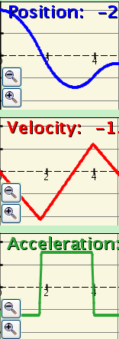
  - Make up a story that could describe what the man was doing.

  - Make free body diagrams for each part of your story, draw what the force graph would look like and include your reasoning (Just the general shape)

  - Use Forces and Motion to test your predictions and use a different color to modify your diagrams, force graph and thinking.

- If you were given just a position graph, explain what you could use to make a force graph. Test your theory by having one person draw a graph, have the other predict the force graph. Then use the sim to verify or modify your ideas.

- Use a similar testing model to produce a plan to use a velocity graph to make a force graph and then how to use an acceleration graph.

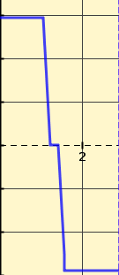
- Below is a total force graph from Forces and Motion.
  - Make up a story that could describe how the dog was pushed. (I had friction off, so the total force is the push)

  - Draw what the position, velocity and time graphs might look like. Explain how you used the force graph to develop the other three.

  - Use Forces and Motion to test your predictions and use a different color to modify your story, force graph and plan to use the force graph.

