The figure below shows a rope on a tile floor with a knot at point A. Someone has shaken the end sideways to make a pulse. You are looking down and taking a movie of the motion. Below is one freeze frame of the movie.


A

- If you advance the movie one frame, the knot at point A would be
a) in the same place b) higher c) lower d) to the right e) to the left

- If the person generates a new pulse like the first but more quickly, the pulse would be
a) same size b) wider c) narrower

- If the person generates another pulse like the first but he moves his hand further, the pulse would be
a) same size b) taller c) shorter

- If the person generates another pulse like the first but the rope is tightened, the pulse will move
a) at the same rate b) faster c) slower

Now the person moves his hand back and forth several times to produce several waves. You freeze the movie and get this snapshot.

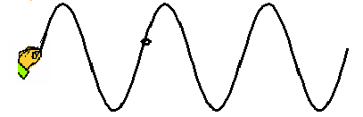
A

- If you advance the movie one frame, the knot at point A would be
a) in the same place b) higher c) lower d) to the right e) to the left

- If you advance the movie one frame, the pattern of the waves will be _________relative to the hand.
  - in the same place
  - shifted right
  - shifted left
  - shifted up
  - shifted down

- If the person starts over and moves his hand more quickly, the peaks of the waves will be
a) the same distance apart b) further apart c) closer together

