- Below is a graph of a balls motion. Which of the following gives the best interpretation of the ball’s motion?
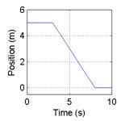
- The ball moves along a flat surface. Then it moves forward down a hill, and then finally stops.
- The ball doesn’t move at first. Then it moves forward down a hill and finally stops.
- The ball is moving at constant velocity. Then it slows down and stops.
- The ball doesn’t move at first. Then it moves backwards and then finally stops.
- The ball moves along a flat area, moves backwards down a hill and then it keeps moving.

- Which graph would best depict the following scenario? A man starts at the origin, walks back slowly and steadily for 6 seconds. Then he stands still for 6 seconds, then walks forward steadily about twice as fast for 6 seconds. Note that these are velocity-time graphs.

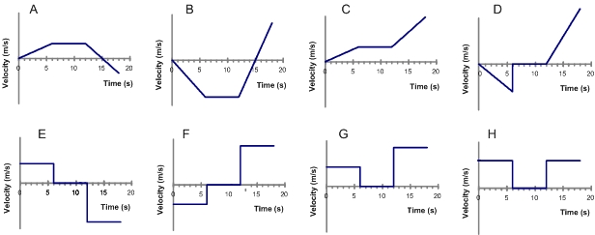
- For the same scenario as # 2, which position-time graph best depicts the motion?
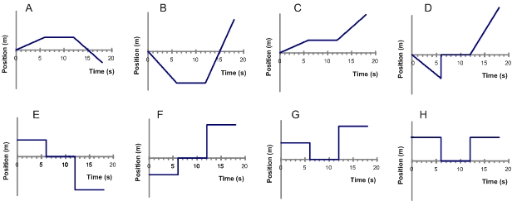

- A car is traveling along a road. Its velocity is recorded as a function of time and is shown in the graph below.
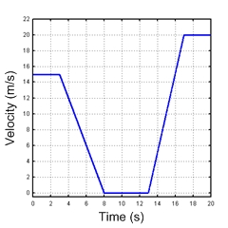
During which intervals is the car accelerating? Choose all the answers that apply.
  - between 0 and 3 seconds
  - for a brief instant at 3,8,13 and 17 seconds
  - between 3 and 8 seconds
  - between 8 and 13 seconds
  - between 13 and 17 seconds
  - between 17 and 20 seconds

5. Which of the following position-time graphs would be consistent with the motion of the car in question #4?
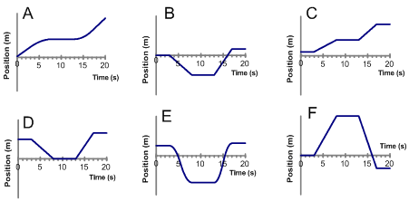

6. A car is moving forward and applying the break. Which position-time graph best depicts this motion?
