Teacher Pages
N
S

Prior Knowledge – The students should know:
- What current is
- That a magnet has to have both a north pole and a south pole
- The basic rules of magnetism
  - Bi-polar
  - Rules for attraction and repulsion
  - Basic magnetic field shape and polarity
- That a compass can show the magnetic field lines

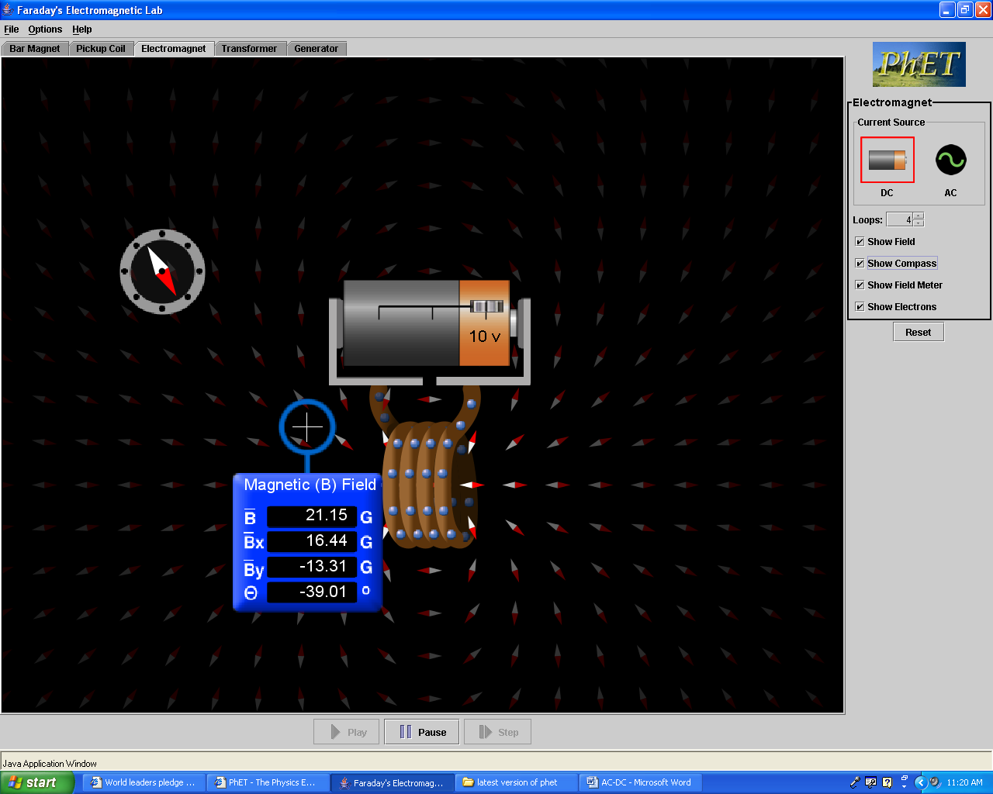
Activity & Simulation Instructions-
Field Meter
- This assignment is intended as an assignment the students will complete outside of class either at home or in a library.
- Talk about the balls moving in the wire representing the current and the faster they travel the greater the current.
- Talk about the field meter and how the top measurement gives the overall field strength. For you advanced learners talk about the angle Ө, and the force acting as a vector which is why there are the x and y components for .You might also what to tell them about the unit G standing for Gauss, the scientific unit of magnetic field strength
B.

Learning Goals – The students will:
- Develop an understanding of the difference between AC and DC current.
- Develop an understanding of how an electromagnet works
- Develop an understanding of how AC and DC current affect the magnetic field of an electromagnet

Student Pages
Background – Electromagnets and the principles that make them work are in many of the electrical appliances we use daily. The electricity we use is mostly generated using electromagnets. All electric motors use this technology and charging your cell phone uses a transformer that is based on the concepts that make electromagnets work. Today we will look at two types of current and how they affect with an electromagnet

Learning Goals – The students will:
- Develop an understanding of the difference between AC and DC current.
- Develop an understanding of how an electromagnet works
- Develop an understanding of how AC and DC current affect the magnetic field of an electromagnet

Procedure – do the following activity using this web site
http://www.colorado.edu/physics/phet/simulations/faraday/faraday.jnlp
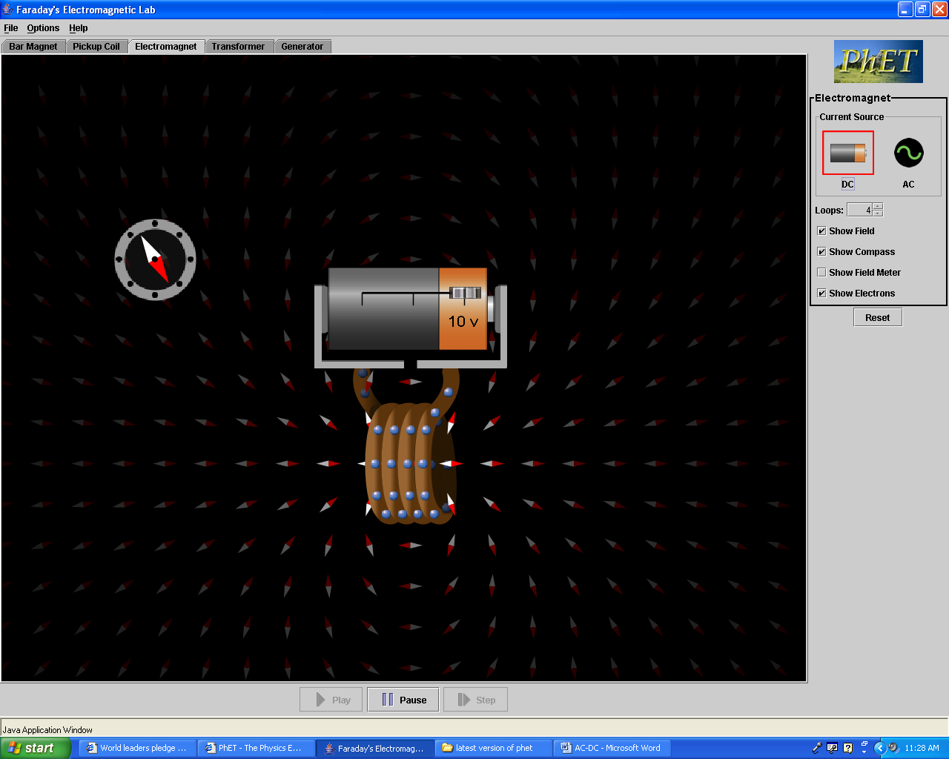
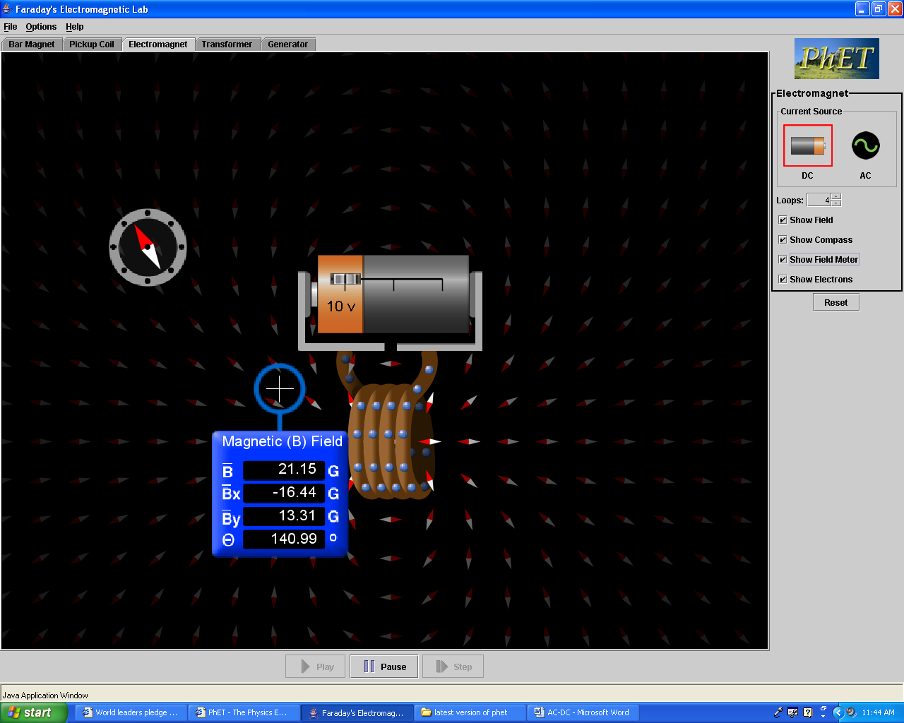
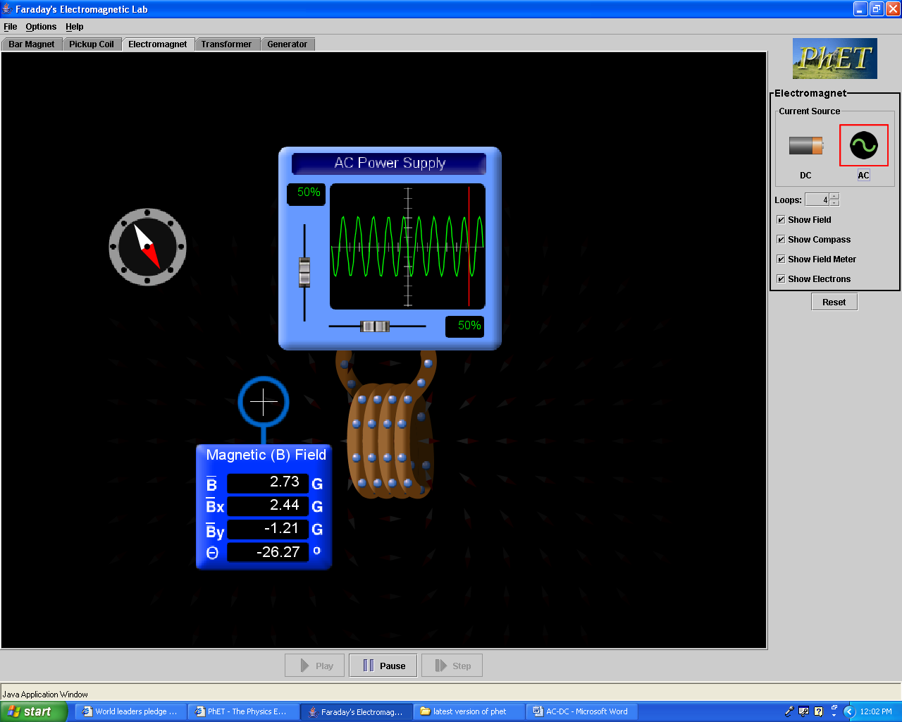
- Getting started. Open the website listed above and on the top of the screen select the tab marked electromagnet.
Screen 1
Screen 2
Screen 3
- Make observations & draw conclusions. Change the current source back and forth from DC to AC looking for how the electrons move in the wire. AC current is distinguished from DC current by the motion of the current. In this applet the current is represented by the balls moving in the wire. Based on your observations write a general rule for how current moves in AC verses how current moves in DC.
- Make observations & draw conclusions. Set up the applet so it is using a DC current and place a compass near the electromagnet. Your screen should look something like what you see to the right, on Screen 1. Using the slider on the battery, observe how changing the voltage changes the current flow and what happens to the compass needle. Write down your observations regarding the voltage, the current flow and the change in the compass. What does changing the current flow do to the magnetic field?
- Make observations & draw conclusions. Insert a field meter into your screen. Your screen should now look something like what you see to the right, Screen 2. move the battery slider back and forth and observe what happens to the strength of the magnetic field, the top number on the field meter. Write a general rule for how the voltage affects the magnetic field’s strength.
- Make observations & draw conclusions. Using the same setup as you used in step 4 change the number of loops and observe how this affects field strength. Write a general rule for how the number of loops affects the magnetic fields strength.
- Make observations & draw conclusions. Using the same setup as you used in step 4 move the filed meter from place to place and observe how the field strength changes. Write a general rule for how changing the distance from the magnet affects the magnetic fields strength.
- Make observations & draw conclusions. Use the same setup as you used in step 4 but change the source of current to AC. Your screen should look something like what you see to the right, Screen 3. Observe how the AC changes the compass and the magnetic field strength. Write down your observations regarding the change in the strength and direction of the magnetic field. Describe a way to get a DC supplied electromagnet to change the direction of the magnetic field, like the AC does.

- Apply what you learned.
- In an industrial situation where you are using an electromagnet to pick up heavy objects, you want an unchanging magnetic field. What type of current would you want to use to create that electromagnet? Support your answer using your observations and conclusions from above. that would have a steady constant magnetic field
- In an electrical motor you use an electromagnet that is constantly changing its magnetic field. What type of current would you want to use to create that electromagnet? Support your answer using your observations and conclusions from above.

