Prior Knowledge – The students should know:
- The basic construction of a series and a parallel circuit.
- What a resistor is and what it does.
- What current is
- The model for electricity used in my class is of an elevated water tank
  - The voltage is the potential energy of the top of the water in the tank in relation to the ground.
  - The current flow is the amount of water coming out of the hose connected to the tank.
  - A resistor is a valve that lets more or less water pass through it.
Amount of flowing water represents the current
Valve represents a resistor
Potential energy represents the voltage
An Elevated Water Tank Model for Electricity
Activity & Simulation Instructions-
- This assignment is intended as an assignment the students will complete outside of class either at home or in a library.
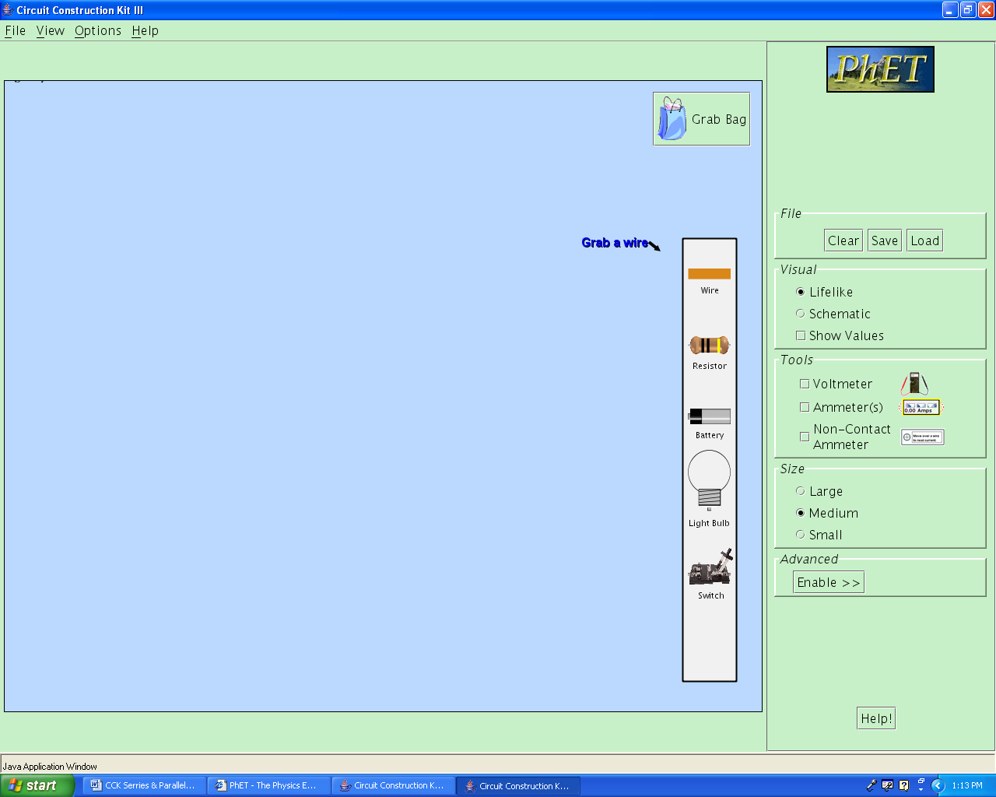
- Explain that in the simulation the balls moving in the wire represent the current and the faster they travel the greater the current.
Main field
Menu
- Explain that the way to build a circuit is to click on the item they need in the menu and drag it out into the main field
- Talk about how to change resistor values by right clicking on the resistor.
- Review the definitions of current, resistor and voltage in terms of the elevated water tank model used above.

Learning Goals – The students will:
- Develop a general rule regarding how resistance affects current flow when voltage is constant.
- Learn how changing resistance values affect current flow in both series and parallel circuits.

Student Pages
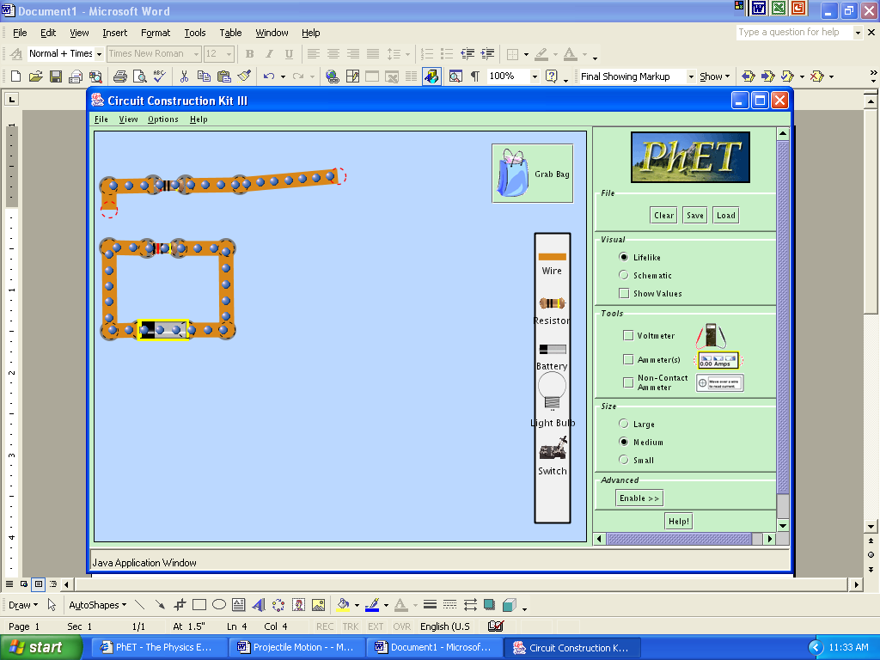
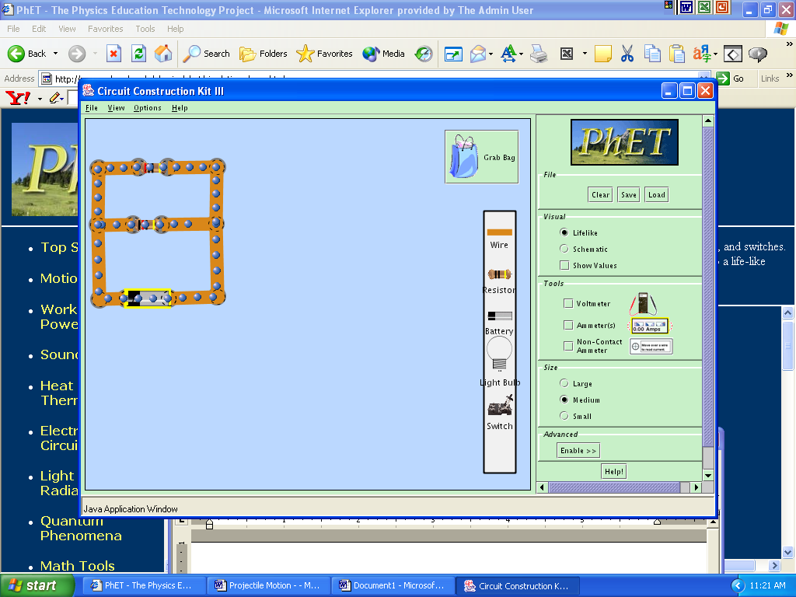
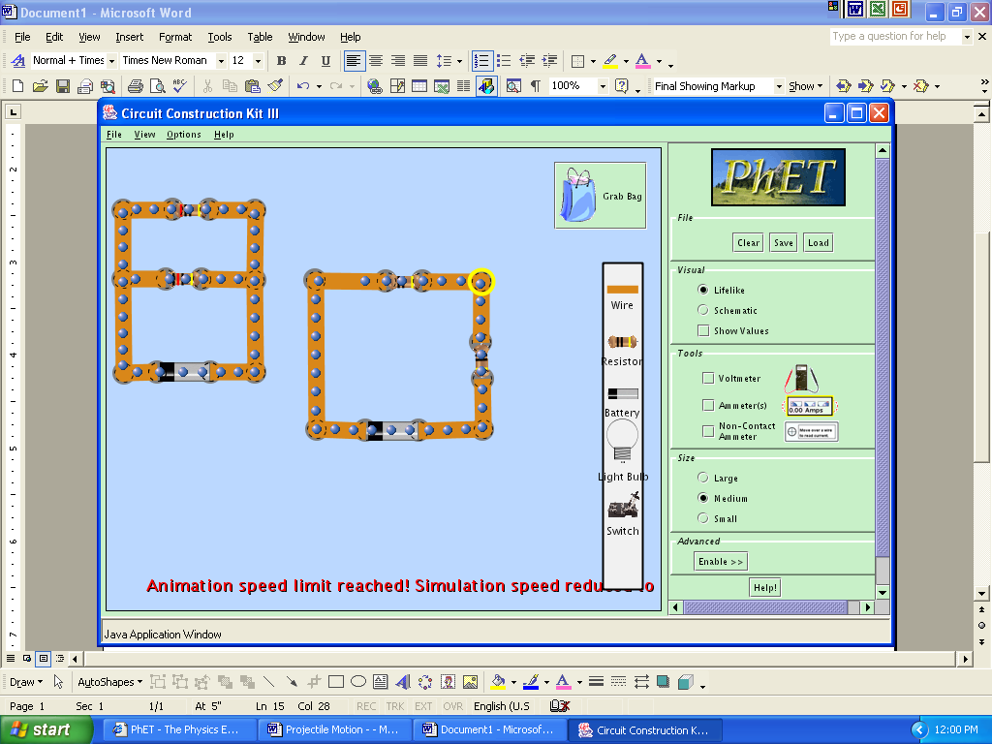
Background – Everyday we use devices that have electric circuits in them; they perform different tasks for us. It is the design of the circuit that enables them to perform these different tasks. We will look at the two basic designs of circuits and learn a little about how they are different.
Circuit A
Circuit B

Circuit C

Learning Goals – The students will:
- Develop a general rule regarding how resistance affects current flow.
- Learn how changing resistance values affect current flow in both series and parallel circuits.
Procedure – do the following activity using this web site
http://www.colorado.edu/physics/phet/simulations/cck/cck.jnlp
- Build a circuit. - Using 1 resistor and a battery, construct a circuit like you see to the right, Circuit A.
- Make observations & draw conclusions. By right clicking on the resistor, change the value of the resistor and observe what happens to the rate that the electrons move through the circuit. The rate at which the electrons move is called current. Make a general rule about the relationship between current and resistance. For instance: The higher the resistance the ________ the current.
- Build another circuit. - Add another resistor to your circuit, making it a parallel circuit like you see to the right. It should look like Circuit B.
- Make observations & draw conclusions. - By right clicking on the resistors, change the values of the resistors, making one very high and one very low and visa versa. Look for what happens to the current flow through the different resistors.
With regards to circuit B write a brief statement to;
- Describe the current flow at different locations in the circuit, concentrating on the rate of the current and the value of the resistors.
- Explain your observations of the current flow in terms of the water tank model of electricity given to you in class
- Describe how your general rule from step 2 relates to your observations.
- Build another circuit. - Next to the parallel circuit B, build a second circuit making it a series circuit using 1 battery and 2 resistors. It should look like Circuit C.
- Make observations & draw conclusions. - By right clicking on the resistors, change the values of the resistors, making one very high and one very low, and visa versa. Look for what happens to the current flow through the different resistors.
Write a few brief statements about what you see regarding;
- Describe the current flow at different locations in the circuit, concentrating on the rate of the current and the value of the resistors.
- Explain your observations of the current flow in terms of the water tank model of electricity given to you in class
- Describe how your general rule from step 2 relates to your observations?
Apply what you learned. Write a few brief statements about how series and parallel circuits are similar and how they are different, by looking at your work in steps 4 & 6. Include the following
- Possible pathways the electric current can move in the series and parallel circuits,
- How different resistance values for the individual resistors affects the current in the series and parallel circuits.

