 Name_____________________________________ Per____

PhET Simulation: Balloons and Static Electricity

Open the PhET simulation, “Balloons and Static Electricity.”
https://phet.colorado.edu/en/simulation/balloons

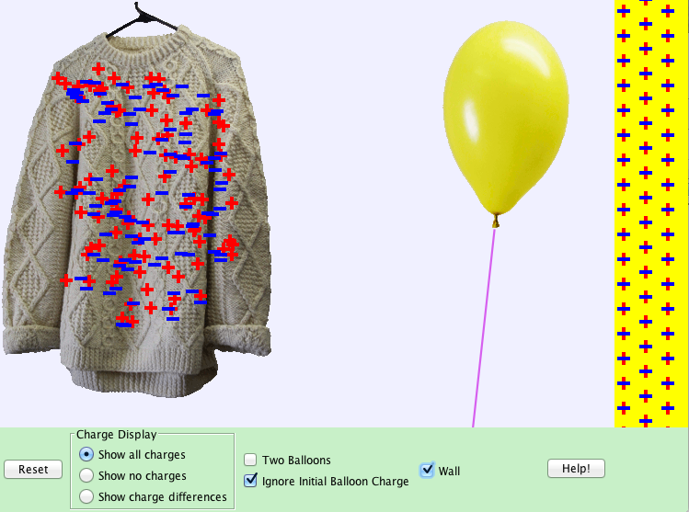

- What do you notice about the charges of the..
- sweater?

- balloon?

- wall?

Set the simulation to “Show no charges.”
- Rub the balloon against the sweater, bring it back to the center and let it go. What happens?

- Prediction: How can you explain the balloon’s behavior?

- Bring the balloon close the wall and let it go. What happens?

- Prediction: How can you explain the balloon’s behavior?

Set the simulation to, “Show all charges.”
- Now that you can see the charges, why did the balloon stick to the sweater?

- What do you notice as you bring the balloon closer to the wall?

- Based on your observations, are positive or negative charges “more free” to move?

Set the simulation to include, “Two Balloons” and turn OFF, “Wall.”
- Rub the yellow balloon to pick up half the charges and the blue balloon to pick up the other half. Both will stick to the sweater. Working quickly, bring one to the center and before it can stick to the sweater again, bring the other near the first. What happens when two balloons with the same charge are near each other?

- Write a statement the attraction of two oppositely charged objects are near each other. And one for similarly charged object.

- Claim: Objects need to be in contact in order to influence one another. Use evidence from this simulation to support or refute this claim.

