Module 5 (Lab-5FWA)
 | Name Key
 | FVDES Student Number:
 | Date:
Physics 12 | Marks: /30 = %

Objectives:
• To determine the relationship between a magnetic field, electric circuit and electromotive force – a phemomenon call electromagnetic induction.

Description:

The simulations involve moving a bar magnets, electromagnets, coils, generators and transformers. You will conduct a series of experiments from which you will derive rules that will help you understand the concepts.

Simulation: go to: https://phet.colorado.edu/en/simulation/faraday

Hint: Download the file using the ‘save’ option then run the ‘.jar’ file using Java.

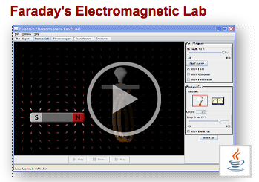
Click on the arrow to launch the program.
You may have to “Allow” and “Run” to get the Java program running.

Data Collection and Analysis: Bar Magnet (7 marks)
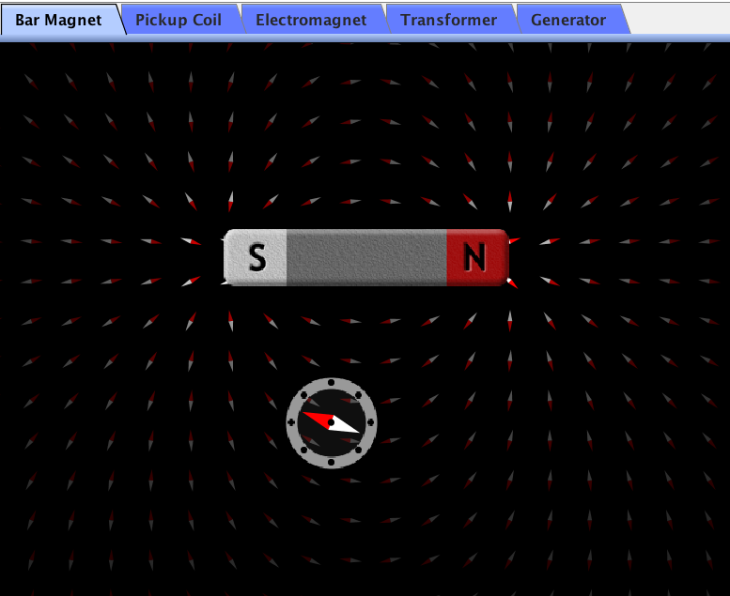

Select “Bar Magnet” in top left corner.
Bar magnet
1. Click on the magnetic compass and move around the bar magnet.
Magnetic compass

Explain the orientation of the compass needle (1 mark)
N

The magnetic compass needle is orientated the exact opposite direction as the magnetic field as opposite-poles attract and like-poles repel

2. Click on “Flip Polarity” button on right menu

Explain two changes this causes in the simulation (2 marks)

Magnetic field:

The magnetic field direction is reversed

Magnetic compass:

The magnetic field direction is reversed so the magnetic compasses reverse as well

3. Click on “Show Field Meter” toggle on right menu.
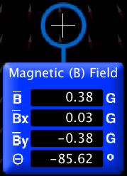

Move the meter around and observe the magnetic field strengths. Note: the meter reads in G (Gauss) rather then T (Tesla); 1 T = 10 000 G

Complete the following statements (4 marks) and do NOT put the meter on top of the magnet.

a) B (total B) gets stronger as you move closer to the poles of the magnet and weaker as you move farther from the poles of the magnet.

b) B_{x} (x-component of magnetic field) is strongest where the magnetic field

comes straight off the ends of the magnet.

c) B_{y} (y-component of magnetic field) is strongest where the magnetic field

is perpendicular to the ends of the magnet.

d) θ (angle of magnetic field) is angle of magnetic field measured from

the bilateral longnitudinal line of the magnet.

Data Collection: Pickup Coil (9 marks)

Select “Pickup Coil” in top left corner.

1. Move the bar magnet left and right THROUGH the coil of wire. Describe the orientation of the magnetic field compared to the coil when the most current is generated. (1 mark)

By is the strongest when the greatest current is created.
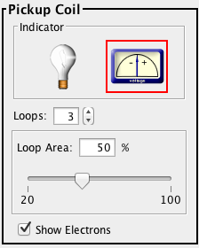
You can toggle the Indicator from the bulb to the voltage gauge.

2. Increase the number of Loops to 3.

How does the number of loops affect the current flow: the greater the number of loops, the greater the current. (1 mark)

3. Increase or decrease the Loop Area

How does Loop Area affect the current flow? Describe the effect and provide a plausible explanation. (1 mark)

There is little or no effect. The greater loop area encompasses more of the magnetic field but it is weaker farther out which offsets any area gains.

4. Why is little to no current generated when the bar magnet is moved up and down? (1 mark)

The perpendicular magnetic field is not moving across the coil.

Note: the animations all demonstrate Real Current. Conventional current is the opposite direction
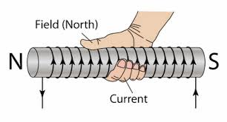

5. As the bar magnet enters the coil from the left, draw (see example) a Right-Hand-Rule to describe the conventional current flow. Remember, thumb always points north. (1 mark)

Conventional current is the opposite of actual electron flow; it is +ve to –ve (use “Right-Hand-Rules”)
Real current = actual electron current from –ve to +ve (use “Left-hand-rules”)

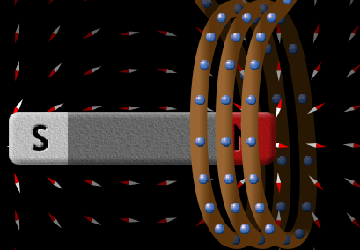
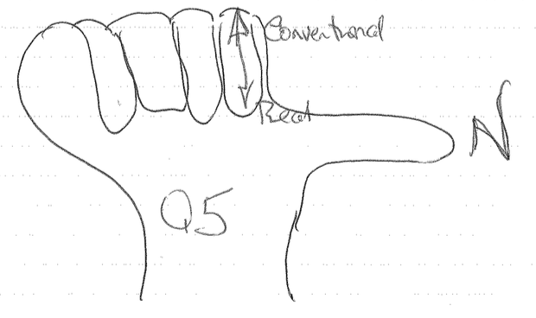

Notice how the induced current is the opposite direction to the Right-Hand-Rule (i.e. current created in an electromagnet).

6. For a magnetic field to be induced (an electro magnet) so north is to the right, predict the conventional current flow in the coil by drawing arrows in the coil. (1 mark)
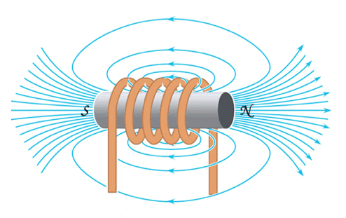

+
-

7. As the bar magnet leaves the coil to the right, draw a right-hand rule to describe the conventional current flow. Remember, thumb always points north. (1 mark)
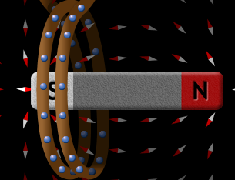
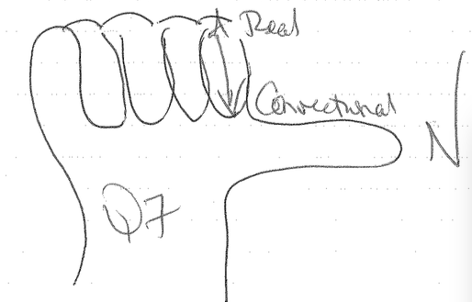

8. Predict the conventional current flow if you move the bar magnet from right to left: (1 mark)
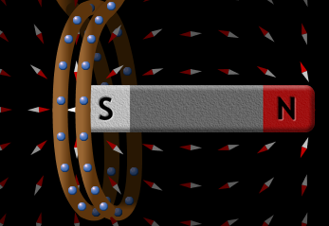

a) as the S-pole enters the coil to the left: electrons at front move up or down (circle the correct answer)
b) as the N-pole leaves the coil to the left: electrons at front move up or down (circle the correct answer) Now test your hypothesis and make any necessary corrections.

9. Complete the statement: a current is induced in the coil only when the magnetic field is

moving or changing

This is important to understand how transformers work. (1 mark)

Data Collection: Electromagnet (5 marks)

Select “Electromagnet” along the top.

- The animation demonstrates Real Current; Conventional Current is the opposite direction.
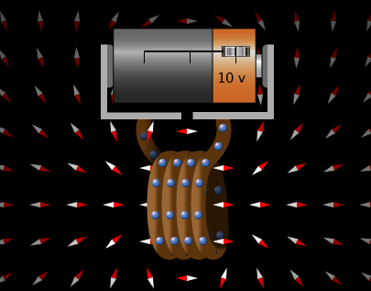
+
-

Using the Right-Hand-Rule, correctly label the poles of the battery + and - (1 mark)

2. Demonstrate your understanding of the Right-Hand-Rule by drawing a labeled hand that best represents the above situation. (1 mark)
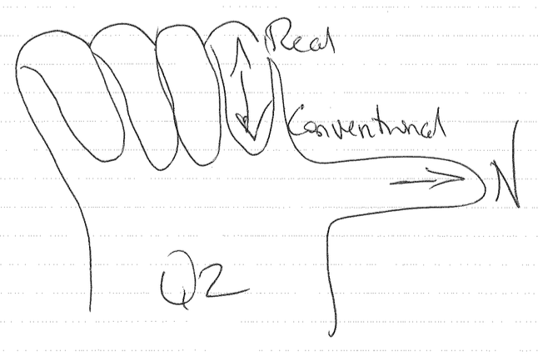

3. Slowly reverse the battery polarity by sliding the switch on the battery from the right position to the left position. Describe the electron flow and magnetic field ½ way and all the way to the left (fully reversed). (2 marks)
½ way:
electron flow: _______________stops_____________________
magnetic field: ______________none_______________________________

fully reversed:
electron flow: _______reversed_____________________________________
magnetic field: _______ reversed ________________________________________
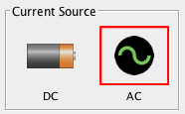
4. Now toggle the Current Source from DC to AC.
Click here.

Describe the magnetic field and electron flow each time the current polarity reverses: (1 mark)

electron flow: ___flows back and forth_________________
magnetic field: ___reverses each time the polarity reverses_

In your home, the current completes a complete cycle (from forward -> to reverse -> back to forward) 60 times / second (60 Hz). See map below.
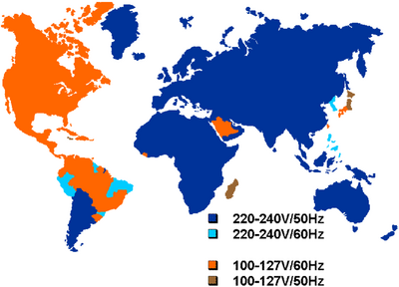

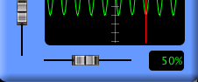

5. Slow the AC Current Supply down by sliding the frequency switch to the left (5%).

Name the wave: sine wave. (1 mark)

If you are feeling nerdy, you can graph it on your Ti-83 or Ti-84.

Turn on calculator.
Press: “Y=”
Type in y₁ = sin(X) (sin ALPHA X)
Press” “WINDOW”
Set Xmin to 0 and Xmax to 360
Set Ymin to -1 and Ymax to 1
Press: “GRAPH”

Data Collection: Tranformer (3 marks)

Select “Transformer” along the top.

- Move the smaller, left, powered, primary coil close to or inside the larger, secondary coil.
Why is no current generated in the secondary coil? (1 mark)

__because the magnetic field is not moving or changing_________
2. Now toggle the Current Source from DC to AC.
Click here. Click here.
Cc
(1 mark)

Why is current generated in the secondary coil now?

The magnetic field is constantly changing/reversing
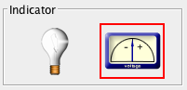
3. Now toggle the Pickup Coil Indicator from bulb to voltage meter.
Click here.



Now vary the frequency from 5% to 100%.

Describe the relationship between frequency and current flow (or voltage as from the voltage meter) in the secondary coil (1 mark)

As frequency decreases _current/voltage decreases____
and as frequency increases _ current/voltage increases ___

Transformer Ratings:
- Typical ratings for power transformers are 50, 60 and 400 Hz.
- A power transformer with a frequency rating of 400 Hz cannot be used to 50 or 60 Hz because it will overheat.
- Most power transformers are designed to operate at either 50 or 60 Hz.
- Power transformers with a 400 Hz rating are often used in aircraft because these transformers are much smaller and lighter than 50 or 60 Hz transformers.

Data Collection: Generator (3 marks)

Select “Generator” along the top.

1. Adjust the water flow on the faucet so the generator rotates at 20 to 25 RPM.
Examine the power generated in the coil. What kind of current is being generated?

Alternating current (1 mark)

Notice how the water flow varies the frequency of the current. This how it is controlled at hydroelectric dams. The water flow into the water turbine is controlled by guide vanes.
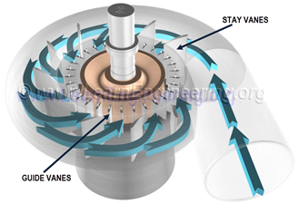
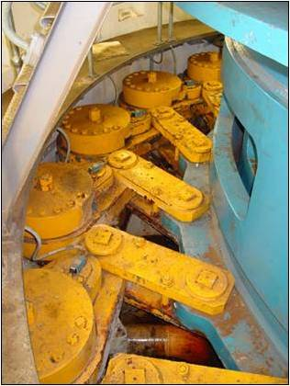
Guide vane control mechanism.

2. Vary the number of Loops in the coil. Make a statement that relates the number of coils to the amount of power generated. (1 mark)

Ex: 3 coils produce 3x the power as 1 coil

3. The spinning magnet is called the stator. If the water flow ceased and you supplied power to coil causing the stator to spin you would then have a motor instead of a generator. (1 mark)

Conclusion: summarize, in a brief paragraph, what relationships you have learned from these simulations. Be sure to include supporting evidence. (3 marks)

Answers will vary____________________________________

___________________________________________________________________________

___________________________________________________________________________

___________________________________________________________________________

___________________________________________________________________________

___________________________________________________________________________

___________________________________________________________________________

___________________________________________________________________________

___________________________________________________________________________



