Name: Date: Week of March 18, 2013

Lab #33: Exploring Equilibrium Mini-Lab

Equilibrium
When a reversible reaction reaches equilibrium, the amount or concentration of products and reactants level off (slope approaches zero; basically become constant) due to the fact that the forward reaction changes reactants into products at the same rate that the reverse reaction changes products into reactants.

Stress
When a system at equilibrium is stressed, the chemicals in the closed system respond to the stress and make either more products or reactants. Once again, the concentrations will level off and a new equilibrium with different concentrations will be established.

An increase in heat energy to the system causes an increase in the rate of the endothermic reaction and vice-versa.
An increase in concentration of a compound causes an increase in the rate of reaction that consumes the compound and vice versa.
An increase in pressure causes an increase in the reaction that produces fewer moles of gas and vice versa.

If one considers how effective collisions are affected by these stresses or changes, the result of the stress should make some sense!

Shift
The term shift is simply indicates the direction (forward or reverse) of a reaction that increases in rate when a stress is applied. For example, if a reaction shifts to the right as a result of a stress being applied, the forward reaction rate increases and the concentration of the products increase. Logically, the concentration of the reactants must decrease.

The Equilibrium Constant
There is a mathematical expression called the equilibrium constant. It is written as Keq. The equilibrium constant is a ratio of the product of the concentration of the products raised to the power of their coefficients divided by the product of the concentration of the reactants raised to the power of their coefficients.

For example, in the reversible reaction 2 HI (g) H₂ (g) + I₂ (g), the Keq is calculated using this formula:

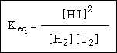

The greater the value of the Keq, the greater the concentration of products at an equilibrium. Industrial engineers and chemists work to increase the Keq, which indicates an increase in efficiency and yield of a chemical process. Fritz Haber invented a process that raised the equilibrium constant to a point that made the synthesis of ammonia a viable and commercially feasible level. Carl Bosch took Haber’s lab set-up and scaled it up to an industrial production level.

What are we doing in the ITC?
In this activity, your job is to examine how stress (temperature, pressure and concentration) causes a system at equilibrium to shift and establish a new equilibrium.

You should hypothesize (and write that on a line below) about which direction the equilibrium will shift after you apply the stress.

Use one line per step in the chart below. Keep careful track of what’s going on so that you can look back and discuss what happened.

At the end of the day, you will make a graph of concentration vs. time. You will be responsible for interpreting your graph.

Login to the computer and open a web browser. Go to http://phet.colorado.edu. Click “Play with Sims,” then find the “Chemistry” section, and choose “Reactions and Rates.” When the simulation is open, click on the “Many Collisions” tab. 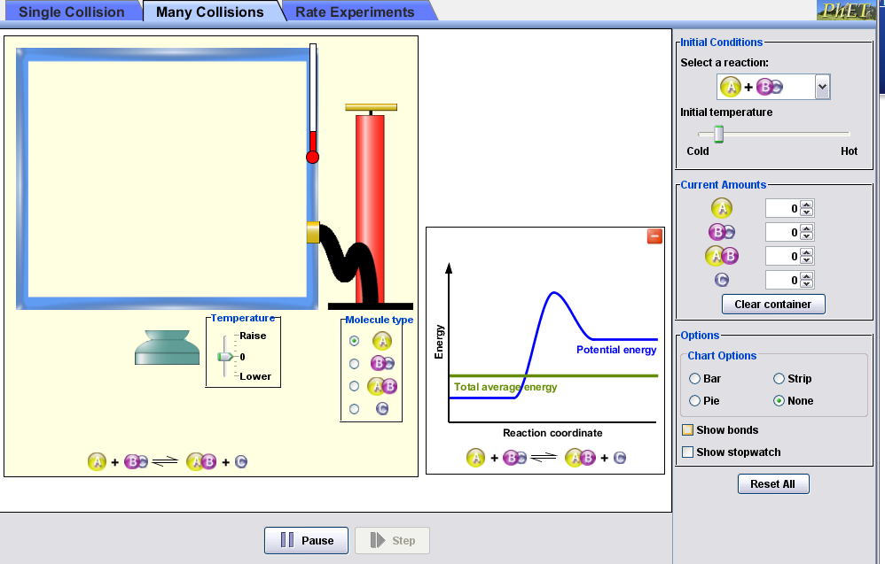

Look at the screen and observe everything you can find out about the reaction pictured, A + BC AB + C.
Click “Show stopwatch”.
Turn on the bar chart.
Let each experiment run for 600 seconds to allow enough time for equilibrium to be established.

Look at the graph. Is this forward reaction endothermic or exothermic? __________________________________

LINE | STRESS | [A] | [BC] | [AB] | [C] | Comments, Notes, etc
1 | START | 10 | 10 | 0 | 0
2 | Equilibrium |  |  |  |  | Waited 600 seconds
3 | EXAMPLE | 10 | 10 | 0 | 0
4 | Raised energy above activated complex |  |  |  |  | Wait 600 seconds
 |  |  |  |  |  | Reaction shifts right
5 | Equilibrium established | 6 | 6 | 4 | 4
6 | Added 20 more A | 26 | 6 | 4 | 4 | Waited 600 more seconds
 | Equilibrium | 16 | 2 | 8 | 8 | Reaction shifted right, producing more AB & C (product of the forward reaction)

 | START NEW EXPERIMENT
LINE | STRESS/SHIFT | [A] | [BC] | [AB] | [C] | Comments, Notes, etc
1 | Start
2 | Prediction
3 | Run experiment
4 | Results
5
6 | Start
7 | Prediction
8 | Run experiment
9 | Results
10
LINE |  | [A] | [BC] | [AB] | [C] | Comments, Notes, etc
11 | Start
12 | Prediction
13 | Run experiment
14 | Results
15
16 | Start
17 | Prediction
18 | Run experiment
19 | Results
20
21 | Start
22 | Prediction
23 | Run experiment
24 | Results
25
26 | Start
27 | Prediction
28 | Run experiment
29 | Results
30
31 | Start
32 | Prediction
33 | Run experiment
34 | Results
35
36 | Start
37 | Prediction
38 | Run experiment
39 | Results
40
41 | Start
42 | Prediction
43 | Run experiment
44 | Results
45
46 | Start
47 | Prediction
48 | Run experiment
49 | Results

Conclusion:

