Name: ____________________________ Date: ________ CP: _____

Virtual Circuit Lab
Learning Goals: Students will be able to understand Ohm’s Law. Students will be able to see the relationship between voltage, current, and resistance.
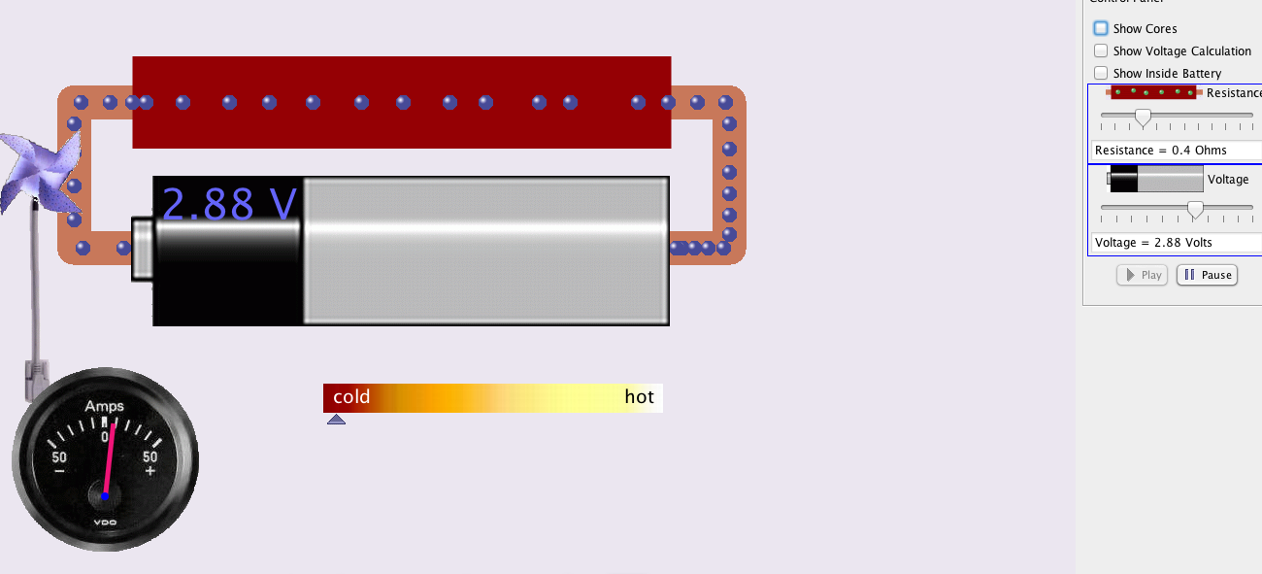

Go to ➔Battery-Resistor Circuit. Click on the green “Run Now” button.
The simulation should look like the picture to the right.

- Change the resistance and voltage. Observe what happens to the current. Note the relationship you observed between each of the following: (direct, inverse, none)

- resistance and current = ________________________

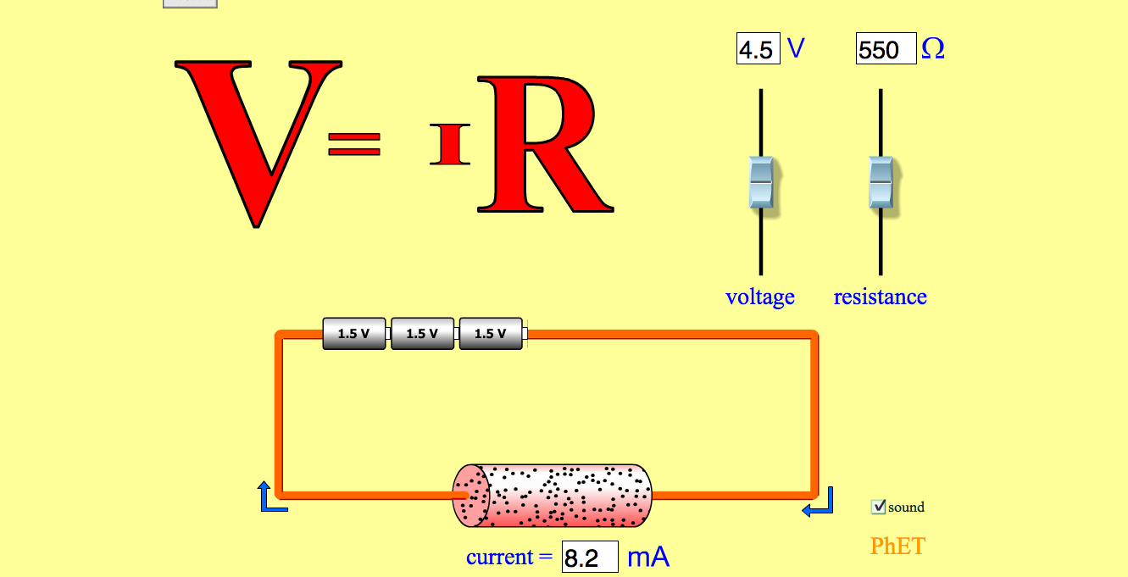
- voltage and current = __________________________

Go to ➔Ohm's Law. Click on the green “Run Now” button. The simulation should look like the picture to the right.
- What is the current through a resistor with the following resistances? Let voltage = 6 V

- R = 100 ohms I = _____ mA(current) b. R = 300 ohms I = ______mA(current)

- Now, determine the current through the wire with the following volts. Let resistance = 500 ohms

- Volts = 3 V I = _____mA(current) b. Volts = 6V I = _______mA(current)

- Think about the formula (V=IR), does this make sense according to this formula? Explain! (Be sure to include the relationship between resistance and current, and the relationship between voltage and current in your answer)

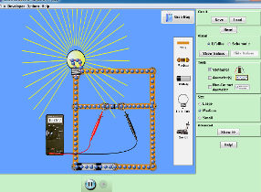
Go to ➔Circuit Construction Kit (DC Only). Click on the green “Run Now” button. The simulation should look like the picture to the right.

- Construct a circuit with one battery, four wires, and one load (light bulb). Sketch your circuit below. Label the battery, load, and conductor (wire). This is an example of a simple circuit.

- Click on “show values” and calculate the current using Ohm’s Law (V=IR). Show all work in the space below.
Place an ammeter in series with the circuit and confirm your answer.

- Select the voltmeter and hook it up to the battery (red is positive). What is the voltage (potential energy) across the battery? You should NOT get a negative number _______ V

- Leave the red lead in place on the battery; place the black lead on the load end (the light bulb) where the electrons flow into the load. What is the voltage (potential energy)? _______ V

- The potential energy in the circuit is supplied by the _________________. Potential energy is transferred into kinetic energy when the load releases energy as _________________.

- Think about the energy supplied by the battery and the energy used by the load. What must the battery do to constantly keep the load lit?

- Add another load to your circuit. Use the voltmeter to determine the voltage drop across the original load (load 1) and the additional load (load 2).

  - load 1 ______ V b. load 2 ______ V

- What happened to the brightness of the original load when you added another bulb to the circuit?

- Light bulbs have filament in them that act as resistors. Resistance in the filament makes the light bulb light up. Notice the reading on the ammeter in series with the 2-load circuit. Did the current increase, decrease, or stay the same. Why did the reading on the ammeter change? (Think about Ohm’s Law and look at your answers to #1)

- Add in another battery to your circuit. Use the voltmeter to measure the voltage across each load.

  - load 1 ______ V b. load 2 ______ V

- What happened to the brightness of each load when you added another battery to the circuit?

- Notice the reading on the ammeter with the additional battery. Did the electric current change with the addition of another battery? Explain why this happened. (Think about Ohm’s Law and look at your answers to #1)

- Construct a parallel circuit with two batteries next to each other and one load in each pathway. Sketch your parallel circuit.

- Add another load to one of your pathways. Notice the brightness of the two loads one pathway and the brightness of the single load in another pathway. What can you conclude about loads in different pathways in a parallel circuit opposed to loads in a series circuit?

- Real world application: Suppose you’re wiring a Doll House for a younger sibling. You want the lights in the Doll House to be as bright as possible. You have a choice between two wires. Wire A is slightly thicker than wire B. Which wire should you choose for your Doll House? Why? Be sure to use concepts and vocabulary used in this lab in your answer.

- Reflection of Learning: Time to summarize what you have learned. Explain Ohm’s law. Be sure to include the following vocabulary words in your explanation: Ohm’s Law, current, current, resistance, voltage, and circuit.

Name: ____________________________ Date: ________ CP: _____

Virtual Circuit Lab
Learning Goals: Students will be able to understand Ohm’s Law. Students will be able to see the relationship between voltage, current, and resistance.

Go to ➔Battery-Resistor Circuit. Click on the green “Run Now” button.
The simulation should look like the picture to the right.

- Change the resistance and voltage. Observe the fan and notice what happens to the current. Note the relationship you observed between each of the following: (direct relationship, inverse relationship, no relationship)

- resistance and current = If resistance increases, then current decreases (inverse relationship).

- voltage and current = If the voltage increases, then the current increases (direct relationship).
Go to ➔Ohm's Law. Click on the green “Run Now” button. The simulation should look like the picture to the right.
- What is the current through a resistor with the following resistances? Let voltage = 6 V

- R = 100 ohms I = _45___mA(current) b. R = 300 ohms I = __15___mA(current)

- Now, determine the current through the wire with the following volts. Let resistance = 500 ohms

- Volts = 3 V I = __10___mA(current) b. Volts = 6V I = _20____mA(current)

- Think about the formula (V=IR), does this make sense according to this formula? Explain! (Be sure to include the relationship between resistance and current, and the relationship between voltage and current in your answer)
Yes, if one factor (resistance) increases in a multiplication problem, then the other factor (current) must decrease in order for the product to remain the same. And if the product (voltage) of a multiplication problem increases then at least one of the factors (current in this case) must increase.

Go to ➔Circuit Construction Kit (DC Only). Click on the green “Run Now” button. The simulation should look like the picture to the right.

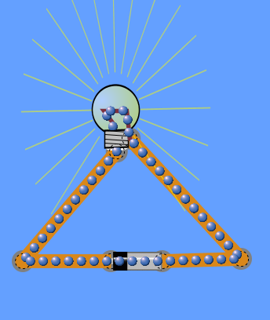
- Construct a circuit with one battery, four wires, and one load (light bulb). Sketch your circuit below. Label the battery, load, and conductor (wire). This is an example of a simple circuit.

- Click on “show values” and calculate the current using Ohm’s Law (V=IR). Show all work in the space below.
Place an ammeter in series with the circuit and confirm your answer.
9v = (I)(10ohm) 9v/10ohm = .9amps
- Select the voltmeter and hook it up to the battery (red is positive). What is the voltage (potential energy) across the battery? *You should NOT get a negative number. ___9____ V

- Leave the red lead in place on the battery; place the black lead on the load end where the electrons flow into the load (light bulb). What is the voltage (potential energy)? ___9____ V

- The potential energy in the circuit is supplied by the _battery_______. Potential energy is transferred into kinetic energy when the load releases energy as ___light_______.

- Think about the energy supplied by the battery and the energy used by the load. What must the battery do to constantly keep the load lit? The battery must continually supply energy to the circuit.

- Add another load to your circuit. Use the voltmeter to determine the voltage drop across the original load (load 1) and the additional load (load 2).

  - load 1 __4.5____ V b. load 2 __4.5____ V

- What happened to the brightness of the original load when you added another bulb to the circuit?
The original load dimmed.

- Light bulbs have filament in them that act as resistors. Resistance in the filament makes the light bulb light up. Notice the reading on the ammeter in series with the 2-load circuit. Did the current increase, decrease, or stay the same. Why did the reading on the ammeter change? (Think about Ohm’s Law and look at your answers to #1) The current decreased. Adding more bulbs increases the resistance. According to Ohm’s Law resistance and current have an inverse relationship if the resistance increases the current must decrease.

- Add in another battery to your circuit. Use the voltmeter to measure the voltage across each load.

  - load 1 ___9___ V b. load 2 ___9___ V

- What happened to the brightness of each load when you added another battery to the circuit? They became brighter.

- Notice the reading on the ammeter with the additional battery. Did the electric current change with the addition of another battery? Explain why this happened. (Think about Ohm’s Law and look at your answers to #1) The current increased with the addition of another battery. Batteries supply volts in a circuit. According to Ohm’s Law the amount of voltage is directly related to the flow of current. This means as voltage increases the current must also increase.

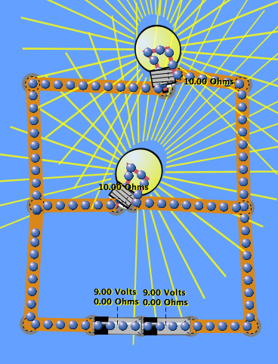
- Construct a parallel circuit with two batteries next to each other and one load in each pathway. Sketch your parallel circuit.

- Add another load to one of your pathways. Notice the brightness of the two loads one pathway and the brightness of the single load in the other pathway. What can you conclude about resistance and current in different pathways of a parallel circuit? With parallel circuits, the current can be different in different pathways. For example, a pathway with two loads will have more resistance than a pathway with only one load; therefore, the current will be less in a pathway with two loads and more in a pathway with only one load.

- Real world application: Suppose you’re wiring a Doll House for a younger sibling. You want the lights in the Doll House to be as bright as possible. You have a choice between two wires. Wire A is slightly thicker than wire B. Which wire should you choose for your Doll House? Why? Be sure to use concepts and vocabulary used in this lab in your answer. Wire A is the best choice. A thicker wire will have less resistance and allow the bulbs to burn brighter.

- Reflection of Learning: Time to summarize what you have learned. Explain Ohm’s law. Be sure to include the following vocabulary words in your explanation: Ohm’s Law, current, current, resistance, voltage, and circuit.

Ohm’s law explains the relationship between voltage, current, and resistance. Voltage and current are directly related. This means as voltage increases, current will flow faster through a wire. Resistance and current are inversely related. This means as more loads are added to a circuit the resistance will increase, and the current will decrease. Increasing the resistance in a circuit will make it harder for current to flow.

