The Ramp—PHET Inclined Plane Mechanical Advantage Simulation Activity
Name: _________________________
1. Choose one of the objects to push up the ramp.
2. Record its name and mass in kg on the chart.
3. For the first trials, set the height of the ramp to 1.5 meters. If using the “More Features” tab, be sure that the Coefficient of Friction is set to 0.3. 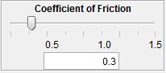
4. Turn on the Measuring Tape, 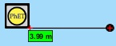use it to measure the LENGTH of the ramp. Record this in the chart. Calculate the Ideal Mechanical Advantage of this ramp by dividing the Length of the ramp by the height. Record this in the chart.
5. Turn on the Parallel Force Graph. 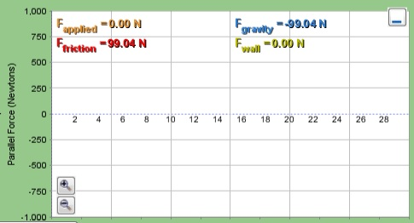 You can minimize the other graphs.
6. Set the Position of the object to 0—you can use the slider on the right and type in “0” if necessary. 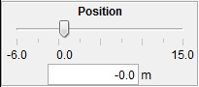
7. Click “Clear” to clear all of the graphs before each trial.
8. Increase the Applied Force until the object begins to move up the ramp. Record this applied force on the chart. See the Parallel Force Graph—it should record the same value for the Applied Force.
9. You can click “Pause” to stop the object or just stop it when it reaches the end of the ramp.
10. Read the Parallel Force Graph and record the Friction Force (N) on the chart below.
11. Calculate the Output Force by subtracting the Friction Force from the Applied Force. Record this value in the chart as Output Force (N).
12. Calculate the Actual Mechanical Advantage by dividing the Output Force by the Applied (Input) Force. Record this in the chart below.
13. Calculate the Efficiency of this ramp with this object by dividing the Actual Mechanical Advantage by the Ideal Mechanical Advantage. Record this value in the chart.
14. Repeat this procedure for one additional object at this height, then change the height to 3.0 m and repeat for these same objects. Be sure to calculate the Mechanical Advantages and the Efficiencies for each object on the ramp.

Object | Mass (kg) | Height of Ramp (m) | Length of Ramp (m) | IMA = Length/Height | Applied Force (N) | Friction Force (N) | Output Force (N) | AMA = Output Force/Input Force | Efficiency = AMA/ IMA
 |  | 1.5
 |  | 1.5
 |  | 3.0
 |  | 3.0
Analysis Questions:
1. What is the relationship between the height of the ramp and it’s Ideal Mechanical Advantage?

2. What affected the efficiency of the ramp? How did it affect it?

3. Turn on the Work graphs and repeat some of the trials. How did changing the height of the ramp affect the amount of work done?

4. What is the relationship between the height of the ramp and the Actual Mechanical Advantage?

5. Choose a DIFFERENT object from those used before and use it to complete the chart below. Use several different heights of the ramp. For this object, if the force is kept constant, how does changing the height of the ramp affect the speed at which it can be pushed up the ramp?

Object | Mass (kg) | Height of Ramp (m) | Length of Ramp (m) | IMA = Length/Height | Applied Force (N) | Friction Force (N) | Output Force (N) | AMA = Output Force/Input Force | Efficiency = AMA/ IMA

Extension (Phases 2 and 3):
Turn on the Energy and Work graphs. Repeat one of the trials. What do you notice about the Thermal Energy and the Friction Work? Explain.

Extension (Phase 3)
How can you use this simulation to get an object to move without pushing it? Try it, explain and what does this show?

