PHET Simulation Activity
Energy Forms and Changes Name: ____________________________
Intro: Thermal Energy
- Go to the Intro tab on the simulation 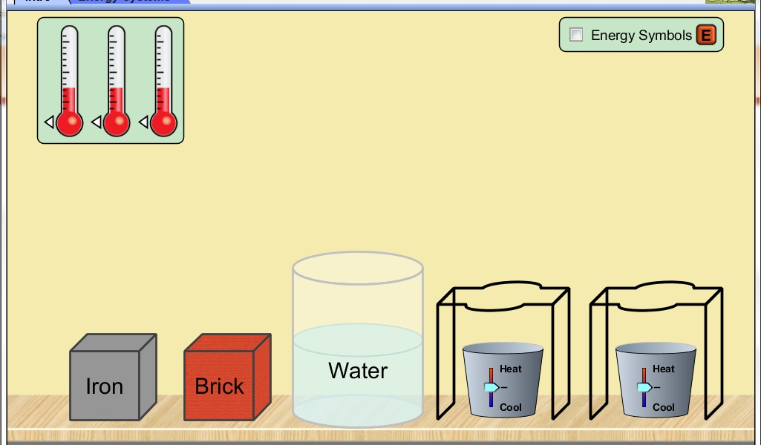
- Drag and attach thermometers to the iron block, brick, and water—attach on the right hand side.
Part 1: Heating
1. Place the iron block on a stand
2. Drag the temperature slider underneath to heat the block. Heat the block to its maximum temperature based on the thermometer reading.
3. Drag and place the iron block into the water. 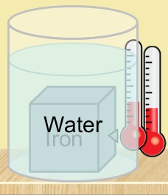
4. Observe and describe how this affects the temperature of:
a. the iron block
________________________________________________________________
b. the water.
________________________________________________________________
5. Drag the iron block back to the stand
6. Drag the temperature underneath to cool the block. Cool the block to its maximum temperature based on the thermometer reading.
7. Drag and place the iron block into the water again.
8. Observe and describe how this affects the temperature of:
a. the iron block
________________________________________________________________
b. the water
________________________________________________________________
9. Turn on the energy symbols tab: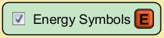 and repeat the process above.
10. Observe and describe what is happening to the energy symbols as the iron block is heated, and then placed into the water:

11. Repeat this same process above, but this time use the brick. 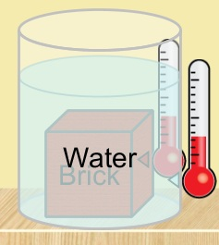
12. When the heated brick is placed into the water, how does this affect the temperature of :
a. the brick
_______________________________________________________________
b. the water
_______________________________________________________________
13. When the cooled brick is placed into the water, how does this affect the temperature of:
a. the brick
_______________________________________________________________
b. the water
_______________________________________________________________
14. Describe any similarities and differences that you observed for the iron block and the brick during this process.

15. What thermal process is being simulated here? Explain.

Part 2: Cooling

1. Repeat this process for both the iron block and brick, but this time cool each to its maximum low temperature and place into the water. Do this by dragging the tab of the bin under the stands to create ice.
2. Describe what you observe happening to the objects and the water when combined:

3. Repeat and turn on the energy symbols tab: , then describe what is happening to the energy symbols as the objects are cooled and then placed into the water.

4. How is this process similar to and different from the heating process?

Part 3: Thermal contact properties 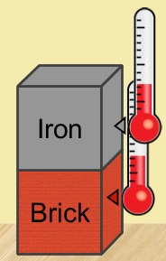
1. Heat the iron block to its maximum temperature and place it ON TOP of the brick. Observe and describe what happens to both the iron block and the brick:

2. Heat the brick to its maximum temperature and place it ON TOP of the iron block. Observe and describe any similarities and differences from what you observed in #1.

3. Heat the water to maximum and place it ON TOP of the iron block and the brick. 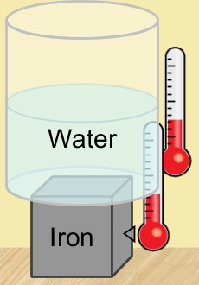 Record the results below:
a. Water on Iron block:

b. Water on Brick:

4. Repeat the processes above, but this time COOL the iron block and the brick. Note any differences in this process below:

5. What thermal process is being simulated here? Explain.

6. How is this process different from Parts 1 and 2? Explain.

7. Investigate: How could you heat/cool and arrange the objects here to show BOTH of the properties mentioned above? Explain: (Hint: Can you stack up all of these objects or put one inside the other one?

Energy Systems:
- Click on the Energy Systems tab: 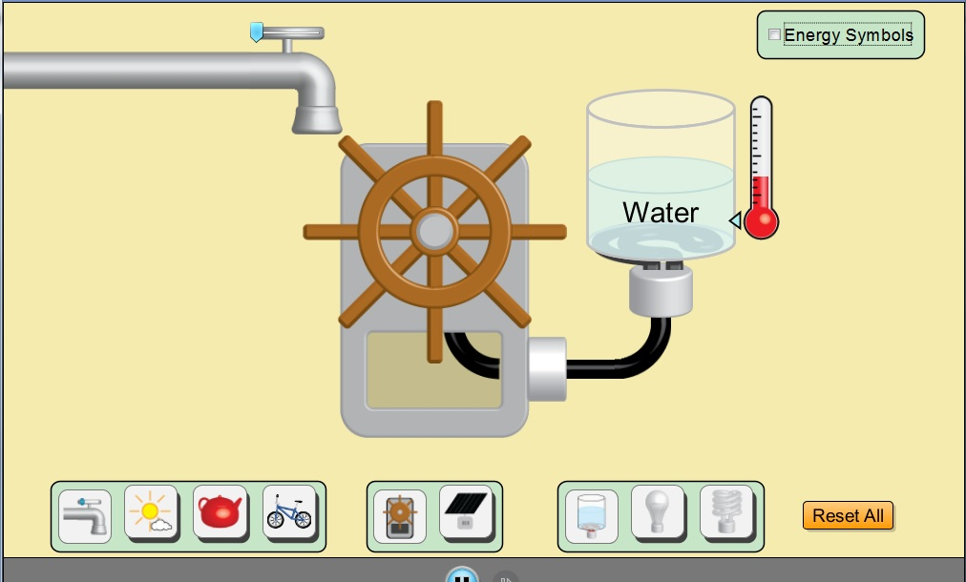
- Turn on the Energy Symbols tab: 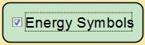
- Experiment with the water faucet by sliding it all the way to the right. Observe what happens to the wheel turbine as you do this. Describe below:

- Using the objects in the chart, turn them all the way “on” and observe the energy flow.

- Fill in the Chart below:
Energy Source | Turbine—rate of spinning | Water—rate of heating | Energy Forms used | Energy Transfers—list ALL
Faucet
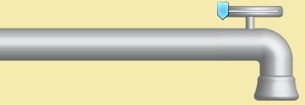

Sunshine
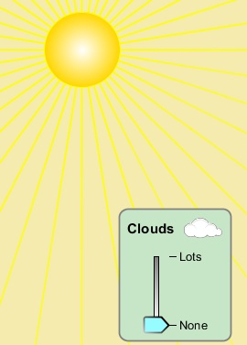
Tea Kettle
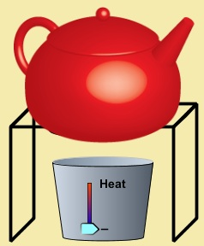
Cyclist
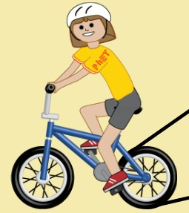

- Why must the cyclist be fed in order to continue? Explain.

- Place a light bulb in the circuit instead of the water heater: 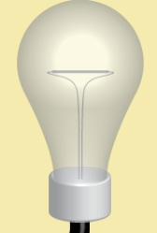
- Describe how this changes the forms of energy in the circuit:
- _______________________________________________________________
- _______________________________________________________________
- Replace the turbine with the solar panel: 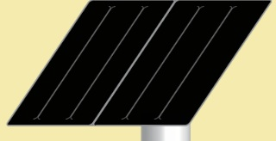
- How will this affect the results of each of the energy sources?
- ________________________________________________________________
- ________________________________________________________________
- If you increase the amount of clouds in the sunshine tab, what happens?
- ________________________________________________________________
- Compare the output of energy of the standard (incandescent) light bulb: with that of the fluorescent light bulb: 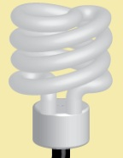.
- What do you notice about the energy and output of these bulbs?
- ________________________________________________________________
- ________________________________________________________________
- Which form of energy is used to transfer all of the other energy types to the output?
- ________________________________________
- Why do you think this form of energy is used most often for this purpose?
- ______________________________________________________________
- ______________________________________________________________
- What form of energy do you think is missing from this simulation and why? Explain.
- ______________________________________________________________
- ______________________________________________________________
- ______________________________________________________________

