PhET Lab: Forces in 1 Dimension Name: _________________________

Google Search: “Forces 1d phet”, click on top link. Date: ____________
Click “run now”, then “keep”.
Open the .jnlp file Hour: ____________

1st FBD

2nd FBD

    - Click the tabs “Graph Applied Force”, “Graph Acceleration”, “Graph Velocity”, and “Graph Position” to open these graphs.
    - In the upper right of the simulation, make sure friction is turned “off”
    - Make sure the “File Cabinet” is selected, and the initial position is set to -7.0 m (negative seven meters).
    - Draw the free-body diagram found in the upper left corner of the sim in the 1st box above.
    - In the upper left of the simulation, set the applied force to 200. This is in Newtons (N), but only type in “200” in the sim, and then press “Enter” on the keyboard.
    - Draw the new free-body diagram in the box labeled 2nd FBD, now that you have added a force of 200 N to the system.
    - Note: The sim is currently paused. What do you expect the net force will cause the file cabinet to do when you click “Go” in the sim? ________________________________________________________________________
    - Click “Go” near the upper left corner of the sim. Let it run for about 10 seconds and then Pause the sim.
    - Label and Graph each of the following: Total (Net) Force, Acceleration, Velocity, and Position. Include title, scaling, units, and graphed line for each of the four graphs. Include scaling for at least 5 seconds of time in the X-axes below (time is almost always graphed on the X-axis).
The Y-intercept of Force vs. Time is____. The Y-intercept of Acceleration v. Time is____
The Y-intercept of Velocity vs. Time is_____. The Y-intercept of Position v. Time is____
These Y – intercepts represent the ______________, ______________, _______________, and _____________ at time t = 0.
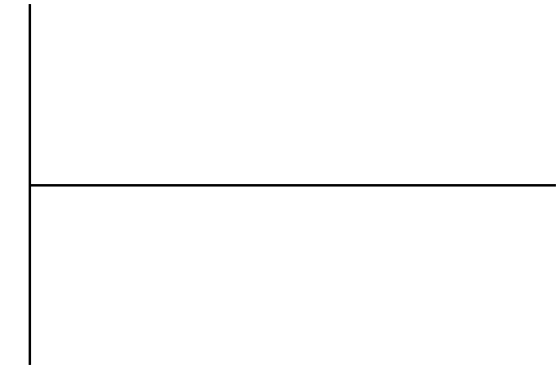

    - Now turn friction “on.”
    - Clear the graphs by pressing “Clear”. Then “Yes”, you want to clear the graphs.
    - Again, set the “Applied Force” to 200 (Newtons). Press “Enter” on your keyboard.
    - Draw the new free-body diagram in the space to the right:

3rd FBD
    - What is the total/net force? _______ Why? _______________________________________________
    - How do you predict the cabinet will behave when you press “Go” on the sim?___________________________________
    - Press “Go” on the sim. Were you correct?_______________
Did the Cabinet move?_________________________________
    - Now Clear the graphs by pressing “Clear”. Then “Yes”, you want to clear the graphs.
    - Set the “Applied Force” to 600 (Newtons). Press “Enter” on your keyboard.
    - Draw the new free-body diagram in the space to the right:

4th FBD
    - Is there a total/net force? _______ How do you know? _______________________________________________
    - How do you predict the cabinet will behave when you press “Go” on the sim?___________________________________
    - Press “Go” on the sim. Were you correct?_______________
Did the Cabinet move?_________________________________

    - Record the new graphs and include all relevant markings on the next page.
    - Record all observations you notice, especially observations that relate to the force and acceleration graphs, but other graphs too: ____________________________________ ________________________________________________________________________________________________________________________________________________________________________________________________________________________________________________________________________________________________________________________________________________________________________________________________________________________________________________________________________________________________________________________________________________________________________________________

The mass of the cabinet is 200 kg (m = 200kg).
The coefficient of static friction µ_{S} = 0.3
The normal force of an object on flat ground is F_{N} = mass * gravity = mass * 9.8 m/s². Note that this is equal in magnitude and opposite in direction of the equation for the force due to gravity (also known as weight):
F_{g} = m * g

The maximum opposing force due to static friction is F_{S}, and is given by:

F_{S} = µ_{S} * F_{N} = µ_{S} * m * g
    - Calculate the maximum force due to static friction, using the information above, in the space below.

    - Predict the amount of force it would take to get the cabinet moving, that is, how much force would be required to overcome static friction and produce a net horizontal force?

