
UTeach Outreach The University of Texas at Austin

Chemistry Theater

Lesson created by: UTeach Outreach, Master Teacher: Candy Ellard, Intern: Wade Green, Program Coordinator: Elyse Zimmer
Description of class: 5th or 6th grade
Length of lesson: Four 50-minute class periods
Resources used:
Concept connections were derived from Atlas of Science Literacy, Project 2061
Chemistry Theater - Mary Walker, PhD. (lesson adapted by Wade Green)
Water images from Scott Foresmann
http://www.chem.purdue.edu/gchelp/atoms/states.html
http://ga.water.usgs.gov/edu/waterproperties.html
http://www.visionlearning.com/library/module_viewer.php?mid=57

TEKS addressed:
§112.16. Science, Grade 5, Beginning with School Year 2010-2011.
(5) Matter and energy. The student knows that matter has measurable physical properties and those properties determine how matter is classified, changed, and used. The student is expected to:
(A) classify matter based on physical properties, including mass, magnetism, physical state (solid, liquid, and gas), relative density (sinking and floating), solubility in water, and the ability to conduct or insulate thermal energy or electric energy;
(B) identify the boiling and freezing/melting points of water on the Celsius scale;

§112.18. Science, Grade 6, Beginning with School Year 2010-2011.
(2) Scientific investigation and reasoning. The student uses scientific inquiry methods during laboratory and field investigations. The student is expected to:
(E) analyze data to formulate reasonable explanations, communicate valid conclusions supported by the data, and predict trends.
(3) Scientific investigation and reasoning. The student uses critical thinking, scientific reasoning, and problem solving to make informed decisions and knows the contributions of relevant scientists. The student is expected to:
(B) use models to represent aspects of the natural world such as a model of Earth's layers;
(C) identify advantages and limitations of models such as size, scale, properties, and materials;

(5) Matter and energy. The student knows the differences between elements and compounds. The student is expected to:
(A) know that an element is a pure substance represented by chemical symbols;
(C) differentiate between elements and compounds on the most basic level;

NSES (1996) – Grades 5-8 – Content Standard B
PROPERTIES AND CHANGES OF PROPERTIES IN MATTER
- A substance has characteristic properties, such as density, a boiling point, and solubility, all of which are independent of the amount of the sample.

Assumptions:
- Students have a basic understanding of the similarities/differences of atoms, elements and compounds.

I. Overview
This lesson takes the concepts developed in previous class periods regarding atoms, elements, and compounds and uses those concepts to develop students’ understanding as to how and why matter exists in three forms on Earth (solid, liquid, gas) and what causes matter to change from one form to another. The lesson cycle begins with students portraying particles and exploring how particles behave in the different states of matter. Then students learn how heat energy affects the interactions and behavior of these particles in the three states/phases. Students learn that particles are in constant motion and that this motion/movement changes with the addition of or removal of heat energy. Students model water particles and the interactions between water particles. Students create a project using photos from the modeling of water particles to demonstrate their understanding of the properties of matter and what causes phase changes in matter.

This lesson introduces or further develops the following science content vocabulary/terminology: atom, particle, matter, heat energy, condensation, evaporation, melting, freezing, water vapor, freezing point, boiling point, classify, compound, model, model limitations, physical property/change, solid, liquid, gas, phase change, states of matter, beaker, hot plate, thermometer.

II. Objectives
Students will be able to:
- Draw/identify a model that represents matter in three states – solid, liquid, gas.
- Use correct terminology to describe the phase changes of matter (melting, freezing, evaporating, boiling, condensing) and be able to identify the sequence of phase changes with water.
- Explain the temperature conditions (Celsius and Fahrenheit) for water to boil or freeze.
- Predict the effect on a substance’s state of matter when heat energy is increased or decreased.
- Relate the phases of matter to the relative energy level of the particles.
- Identify characteristic properties of substances that remain constant.
- Classify the effects of electrical charges at the molecular level: like charges repel and opposite charges attract.
- Read the scale on a thermometer.
- Explain why water particles behave they way they do when heat energy is increased/decreased.

III. Resources, materials, and supplies
- Supply of ice and liquid water
- Materials required for making a large thermometer
  - 18 in by 1 3/4 in piece of cardboard
  - 5 ¾ in by 19 ½ in piece of paper
  - 19 ½ in piece of ½ in thick red ribbon
  - 19 ½ in piece of packing tape
  - Yardstick or Ruler
  - Templates (provided)
- Digital camera/printer
- Template for phase changes project
- Beaker with hot plate and ice
- 3 sheets of Poster board
- Two – bar magnets
- Two – brown paper bags
- A few meters of string

IV. Advanced Preparation
Day 1
- Heat a beaker on a hot plate in front of class.
- Turn on all computers and bookmark States of Matter Basics PhET simulation (http://phet.colorado.edu/en/simulation/states-of-matter-basics).
  - For more ways to get PhET sims on computers see: http://phet.colorado.edu/en/get-phet.
Day 2
- Make a large thermometer see attached document “How to Make a Large Thermometer.”

Day 3
- Print out pictures of students from Day 2.

Day 4
- Place bar magnets in brown paper bags.
- Make oxygen and hydrogen cards
  - Print two O’s and two H per student on different colored paper. Tie string between the two O cards so that students can wear it like a sandwich board. Cut the H card in half and then tie string connecting the sides of each piece so that students can wear them on their hands.

V. Supplementary worksheets, materials, and handouts
- States of Matter Basics Activity Sheet 1 per pair
- Lined paper 1-2 sheets per student
- Sheet for students to post pictures on
- Water images

VI. Background Information

College Level

Matter is anything that takes up space and has mass. There are five states of matter: solids, liquids, gases, plasma and Bose-Einstein condensates. The most common states of matter on Earth are solids, liquids and gases. Scientists determine what state of matter a substance is in based on its properties.
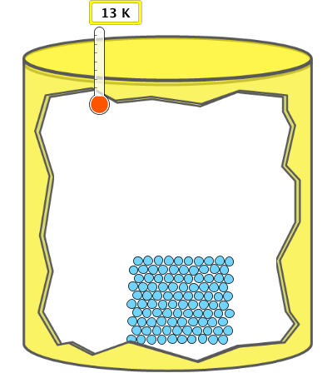

Solids
A solid is a state of matter that has a fixed volume and shape. The particles are tightly packed and vibrate next to each other. Sometimes the atoms in a solid have a crystal structure or a regularly repeating pattern.

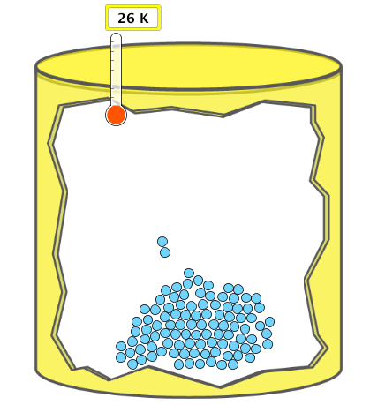

Liquids
A liquid is a state of matter that has a defined volume but no fixed shape. A liquid takes the shape of part of whatever container it is placed in. Particles that are in a liquid can slide past each other.

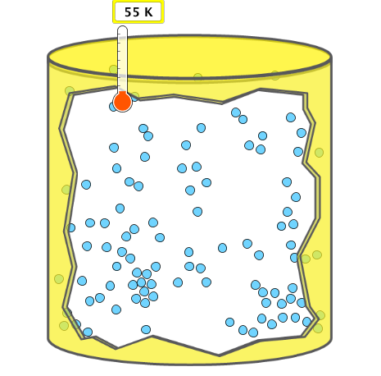
Gases
A gas is a state of matter that has no size or shape of its own. The particles of a gas are able to move freely and assume the shape and volume of its container.

Images taken from States of Matter Basics PhET

All matter is constantly in motion regardless of state. The amount of motion of the particles can help determine what state of matter a substance is in. This quantity of motion represents the thermal energy of the substance and is directly measured in Kelvin. The Kelvin unit is an absolute measurement of the average kinetic energy of the molecules that the substance is composed of. Energy in Kelvin relates the approximate kinetic energy of the individual molecules and thermal energy in the form of temperature. Celsius is a unit for temperature where the thermal energy of the substance is compared to known temperature states, such as, the freezing and boiling energies of pure water at standard pressure. Matter that has a temperature and thermal energy of zero Kelvin has no vibration and is said to be at absolute zero. In reality, this state is unattainable for scientists.

Heat and temperature are not the same, although they are also used interchangeably in every day speech. Heat explains the transfer of energy between two substances. On the other hand, temperature describes the average motion of the particles within a substance.

Matter can change states when enough heat energy is added or subtracted from it. A change in pressure can also result in a change in state. A change of state or phase change is a physical change from one state of matter to another.
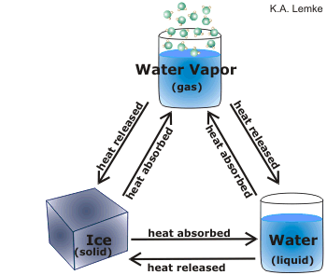
Diagram of water changing states based on heat being absorbed or released

Examples of phase changes include
- Melting: the transformation of a solid to a liquid, occurs when heat is added to a solid.
- Freezing: the transformation of a liquid to a solid, occurs when heat is removed from a liquid.
- Evaporation: the transformation of a liquid to a gas, occurs when heat is added to a liquid.
- Condensation: the transformation of a gas to a liquid, occurs when heat is removed from a gas.

The temperatures at which a substance changes state are unique to that substance. These are considered to be a physical property of the substance and can be used to distinguish substances from each other. The point at which a substance melts or freezes is called the substance’s melting and freezing points, respectively. These temperatures are the same. Likewise, the point at which a substance evaporates is called its boiling point and the point at which a substance condenses is called its condensation point. These values are also identical.

In laboratory experiments, water is used as an example substance to demonstrate changes of state. This is because the temperatures at which water changes state are easily attainable. The melting/freezing point of water is 0ºC and the condensation/boiling point for water is 100ºC.

The following diagram summarizes the possible changes of state between solid, liquids and gases.
Solid
Liquid
Gas
Evaporation
Condensation
Deposition
Sublimation
Melting
Freezing

Diagram of the phase changes that occur between different states of matter
Water

Water is essential for life processes and the survival of living organisms. It comprises 55-65% of the content in the human body and it covers 75% of earth’s surfaces. In addition, water is the only chemical substance on earth that exists in all three physical states: solid, liquid, and gas. What are the properties that make water so unique?

H₂O is the chemical formula for water and it is a compound made up of two hydrogen atoms and one oxygen atom. Water is colorless, odorless, and tasteless when it is found in its pure form. In addition, it is also a universal solvent, which means that it can dissolve most other chemical substances. Therefore, when water passes through our bodies or through the ground it can dissolve nutrients and minerals along with it. Pure water also has a neutral pH, which means it is neither acidic nor basic. This quality makes it able to participate in various biological processes. Another unique property of water is that ice is less dense then the liquid form of water, which allows it to float on the surface of liquid water.

Polarity of Water Molecules

The chemical composition of water is a polar covalent bond and because of this a dipole forms across the entire water molecule. A dipole is an asymmetrical distribution of electrical charge across an object. Dipoles result from the unequal sharing of electrons between the hydrogen and oxygen atoms. At the oxygen end of the molecule, a partial negative charge forms and at the hydrogen ends, positive charges form. The opposing charges of the two atoms causes other nearby water molecules to be attracted like magnets. The magnetic like attraction formed by electrostatic attraction between the partial negative oxygen and partial positive hydrogen in nearby water molecules creates hydrogen bonding.
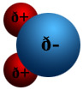
http://www.visionlearning.com/library/module_viewer.php?mid=57

Hydrogen Bonding

Hydrogen bonding is a specific bond between electropositive hydrogen and an electronegative atom, such as oxygen, fluorine, or nitrogen. The bonds are weak in strength compared to ionic bonds but they are strong enough to make water molecules “stick” together. Hydrogen bonding is the reason that ice floats on the surface of liquid water. The water molecules become frozen in place and arrange themselves in a rigid lattice structure. The lattice crystalline structure that forms has large holes in it, which results in fewer water molecules in the same volume of liquid water.
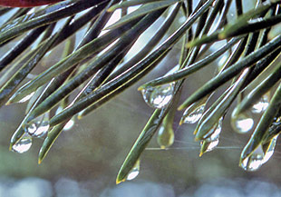
http://ga.water.usgs.gov/edu/adhesion.html

Water is also “sticky” because it is highly cohesive which means water attracts water. Cohesion is a result of the polarity and hydrogen bonds between water molecules. Water droplets are an example of cohesion and the morning dew on leaves is an example of another property called adhesion. Adhesion is the attraction of water molecules to other substances.
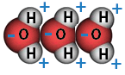
http://ga.water.usgs.gov/edu/adhesion.html

Surface tension is another property of water. Cohesive forces exerted on molecules at the surface of a liquid make it tend to assume a spherical shape. Molecules at the surface are not surrounded by as many molecules around all of their sides so they share a stronger interaction with the molecules on either side of them. This is why when a small object is placed on water carefully; it will remain suspended on the surface.

Middle School Level

Matter is the “stuff” that everything is made of. Everything that has mass and takes up space is matter. Mass is the amount of matter an object or substance has.

Substances can exist in many different states. The three basic states of matter are solids, liquids and gases.

Three States of Matter
Solid |  | has a definite volume and shape, particles are close together and vibrate a little
Liquid |  | has a definite volume but takes the shape of its container, particles can move around one another
Gas |  | takes the volume and shape of its container, particles are spread out and move freely
Images taken from States of Matter Basics PhET

A substance can change states when enough heat energy is either added or removed from it. This is called a phase change or a change in state. Phase changes are examples of physical changes. A physical change is when a substance changes form without turning into a new substance. Ice cream melting is an example of a physical change.

Heat energy is the energy of moving particles. A thermometer measures temperature, which is the average speed of the particles in a substance. When a substance is heated, the particles speed up and this is seen by an increase in temperature.

Diagram of the phase changes that occur between different states of matter
Solid
Liquid
Gas
Evaporation
Condensation
Melting
Freezing

The temperature at which a substance will change from one state to another is unique to that substance. The point at which a solid turns into a liquid is called the substance’s melting point. For example, when ice is heated to 0ºC it begins to melt. Therefore, water’s melting point is 0ºC. The point at which a liquid changes into a solid is the substance’s freezing point. The freezing point is the same as the melting point for any substance. Similarly, the boiling and condensation points for a substance are equal. For water, its condensation and boiling point are 100ºC. These temperatures are considered physical properties of water.

Water

Water is the most famous molecule on earth and it also covers 71% of earth’s surface. Living things would not be able to survive without water because it is essential to life.

A molecule is two or more atoms joined together tightly and a compound is made up of molecules that contain atoms of different elements. Water is a compound that is made up of elements hydrogen and oxygen. Its well-known chemical formula is H₂O. The sub script 2, under the H means that there are two hydrogen atoms and the O with no subscript means there is only one atom of oxygen present.
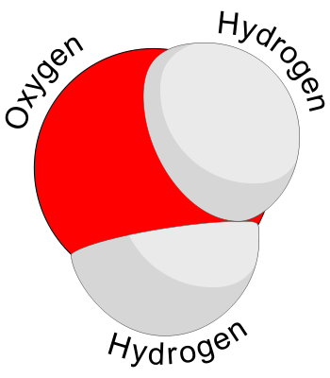
http://www.webbofscience.com/2009/06/06/molecule-of-the-week-water/

The physical properties of water include its neutral pH, which is a measure of acidity. Water is odorless, tasteless, and has no color. Water can exist in the solid (ice), liquid (water), and gas (water vapor) states of matter. All living organisms need water to carry out biological processes correctly; the human body is 55% to 78% water. Water is also very good at absorbing heat, which helps it to protect earth from extreme temperatures. In addition to all of the above characteristics, water is also a universal solvent, which means it can dissolve many other chemicals.

Water molecules are unique because they have both a positive and a negative end. The hydrogen molecules are positively charged and the oxygen molecule is negatively charged. Water molecules work in a magnetic like way because a positive end must always bond with a negative end, which means the oxygen of one water molecule always binds to the hydrogen of a water molecule nearby. Remember that like repels like and opposites attract. Due to this unique property, the structure of water as a liquid, solid, or gas differs from other chemicals.

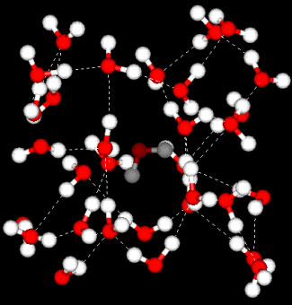

The 3-D structure of water as a liquid where the dashed lines show a bond between negatively charged oxygen and positively charged hydrogen.
http://www-ssrl.slac.stanford.edu/nilssongroup/pages/project_liquid_structure.html

VII. Possible Misconceptions – also denoted by “MC” in lesson
- Condensation on the outside of a glass is water that sweated through the sides of the glass. – Condensation forms on a glass because there is water vapor in the air that condenses into liquid water.
- Particles in a solid do not move. – The particles in a solid have restricted motion and vibrate with respect to a fixed position.
- All liquids boil at 100ºC and freeze at 0ºC. – These are the melting and boiling points for water. The temperature at which a substance boils or freezes is a physical property of that substance meaning it is unique to the substance.
- The particles within a specific state all move at the same speed. – Some of the particles may be moving faster or slower than others. The temperature is a measurement of the average heat or thermal energy, which is related to the average kinetic energy of the particles. Kinetic energy is proportional to the speed of the particles.
- When a substance evaporates, the molecules break down into individual atoms (i.e. water breaks into two hydrogen atoms and one oxygen atom) – When a liquid evaporates, the average speed of the molecules increases which causes the pull between the atoms or molecules to weaken and no longer hold them together. The molecules are separated not the hydrogen and oxygen atoms within the molecule.
- The bubbles formed during boiling are air (nitrogen, oxygen, etc.) not water vapor (H₂O). – See previous misconception.
- Phase changes are chemical changes. – Phase changes are physical changes because the chemical structure of the particles does not change. Also, phase changes are reversible with the addition or subtraction of heat.

VIII. Vocabulary & Definitions

College Level
- Matter: anything that takes up space and has mass
- Mass: the amount of matter a substance is composed of
- Solid: a state of matter that has a defined shape and volume. The particles vibrate slightly and usually form an orderly pattern.
- Liquid: a state of matter that has a defined volume but takes the shape of its container. The particles can slide by one another.
- Gas: a state of matter with no defined volume or shape. The particles are spread out and move freely.
- Phase Change: a process where a substance changes from one state to another, occurs because of the addition or removal of heat or change in pressure.
- Evaporation: the process where a liquid becomes a gas due to an addition of heat or change in pressure.
- Melting: the process where a solid becomes a liquid due to the addition of heat or change in pressure.
- Condensation: the process where a gas turns into a liquid due to the removal of heat or change in pressure.
- Freezing: the process where a liquid turns into a solid due to the removal of heat or change in pressure.

Elementary Level
- Matter (materia): Anything that has mass and takes up space
- Mass (masa): The amount of matter that makes up a substance
- Solid (sólido): Matter that has a definite shape and volume
- Liquid (líquido): Matter that has a definite volume, but takes up the shape of its container
- Gas (gas): Matter that spreads to fill up any volume, taking the shape of its container
- Phase Change (cambio de fase): A change from one state (solid, liquid, gas) to another
- Evaporation (evaporación): The process where a liquid turns into a gas
- Melting (de fusión): The process where a solid turns into a liquid
- Condensation (condensación): The process where a gas turns into a liquid
- Freezing (congelación): The process where a liquid turns into a solid

IX. Safety Instructions
- Use caution when operating hot plates.
- When students are acting as particles, ensure all are following proper safety guidelines (no pushing others, no running, etc.)
5-E Organization

Engagement Day 1 |  | Time: 10 minutes
What the Teacher Will Do | Probing Questions | Student Responses  Potential Misconceptions
Hold a piece of ice in your hand. Show students how it melts either into a cup or warm it in a test tube.  I’m holding a piece of ice in my hand.  The ice is melting because my hand is warmer than the ice.  Pour the melted water from your hand or cup into a heated beaker.  Yes, the water started out as a solid, melted into a liquid and then turned into a gas by evaporating.  That’s correct! A water particle is the smallest amount of water that can exist and still be water. However, water is not on the Periodic Table, so it is not a pure element.  Fill a beaker with water and place on the hot plate.  I need a volunteer to help me note how much water is in the beaker. This will be our initial volume of water.  Write this value on the board. We will refer to this information later. Leave the beaker on the hot plate.  In your Interactive Journals, write a statement about the initial volume of the water in the beaker and write a prediction about how you think the water volume will change or not change by the end of the lesson.  If students do not understand the meaning of initial, prompt them by asking the initials of their name. Help students understand that their initials are the beginning or first letters of their names – the meaning of initial volume = beginning volume. | - What is happening? Why? How?  - If I put this water in a beaker on a hot plate, what do you think will happen? Why?  - What happened now?  - What is the smallest amount of water that could exist and still be water?  - What is the initial volume of water in the beaker? | - The ice is melting! It’s turning into a liquid because your hand is warm.  - The water will evaporate or turn into a gas because the hot plate is very hot.  - The water turned into a gas. It made a hissing sound.  - A water particle is the smallest amount. H₂O.  - Answer will depend on amount of water poured by teacher.

EXPLORATION DAY 1 Time: 30-45 minutes
What the Teacher Will Do | Probing Questions | Student Responses
Chemistry Theater Act 1, Part 1  Today, we are going to inquire into as to how evaporation happens. You all will act as water particles to model the phase changes.  I need some volunteers to come up to the front and be a model of an ice cube. Each one of you will be a water particle in a solid ice cube.  Guide the students (through questioning) to become very orderly rows (to model the arrangement of atoms/particles in a solid state).  That’s a good guess. It would seem like the particles in a solid would stay very still, but in fact all particles move! Just not very much. You might just keep your feet still and wiggle or vibrate.  Guide students to move their bodies slightly as particles in a solid would move.  This is called a state or phase of matter (use both words interchangeably). The state or phase of matter you are modeling is a solid.  Let’s model a liquid! Have students model a liquid. Invite more students or a new group of students to participate.  As we model a liquid, let’s remember what happened earlier when I held the ice cube in my hand.  The water particles in a liquid do move more. The boundaries for our liquid will be the walls in this classroom. Modify as appropriate.  I am going to pour you into a hot plate or add heat energy.  Now, show me what happens after evaporation.  Everyone, please return to your seats. Let’s examine what happened to the water in the beaker on our hot plate. Turn off the hot plate. I need a volunteer to read the new water level.  Those are excellent observations. We are going to continue investigating the different states of matter using a computer simulation  PhET Simulation  Today, we are going to work in pairs. One student will be the driver and the other will be the navigator.  That’s right! Our driver will be responsible for operating the computer and the navigator will assist the driver by pointing out where to go. The navigator will also record your group’s observations on the activity sheet. Halfway through our investigations, we will switch roles.  You will have five minutes to play with the simulation to discover what it can do. After five minutes have passed, we will share what we have observed.  Give students five minutes to explore. After five minutes, instruct all students to put their computers at “half mast” or “acute angles” and collect students’ attention. Select a few students to come to the front of the class and show what they have discovered using the projected simulation.  Those are all excellent observations. I am passing out an activity sheet for you to complete. You will have 15 minutes to complete your investigations. Remember to work as a team with your partner!  Pass out activity sheets (1 per pair) and allow students 20 minutes to complete their investigations.  Possible probing questions to ask students in pairs or as a group include | - How do you think you would position yourselves?  - How would you stand if all of you were water particles in one ice cube?  - Now, if I told you that all the particles in a solid were very tightly packed together, how would you adjust your model?  - Ok, next hint. Particles in a solid are very orderly. What should you do?  - Do you think the particles in a solid move? Why or why not?  - What is another state of matter? Recall what happened when I held the ice cube in my hand.  - If particles in a solid were orderly or in rows, and moved, how do you think the particles in a liquid would behave?  - What would happen to the particles now? Why?  - Would you stay in your container? Why or why not?  - What process did you just describe?  - What state of matter are you modeling now?  - How has the volume of the water changed?  - What changed about the water in the beaker?  - When you say water evaporates, what does this tell you about what happened to the water?  - How did your prediction compare to what we observe now?  - What does the driver of a car do?  - Knowing this, what do you think a driver of a computer will do?  - Where have you heard the word “navigate” before?  - What do you think a navigator will do today with the computer?  - What can the simulation do?  - What can you change about the simulation?  - What do you notice about the simulation?  - What happens when you change the state using this model?  - When the particles are moving really fast, does the matter being modeled have more or less heat energy? How do you know?  - How does each state of matter compare to the other when you keep the amount of particles and the energy the same?  - How does this model connect to the Chemistry Theater we just acted out?  - What is the purpose of the computer model and the Chemistry Theater we just acted out? (Try to use the words particle, heat energy, phase change and states of matter in your response)  - What are the limitations of this model?  - How is the computer model not like real life?  - How would you change the simulation to make it better? | - Close together.  - In a small space.  - Move closer.  - Move into rows.  - Yes. [MC: No because they are so close together.]  - A liquid or gas.  - They would move more.  - We would move faster because we have more heat energy.  - No, we would float into the air because we would be a gas.  - Evaporation.  - A gas.  - The water level has gone down or decreased.  - The water went from a liquid to a gas, the water evaporated or “went away.” [MC: it disappeared]  - The water is now in the form of a gas.  - It agrees. It is different.  - Operate the steering wheel, drive the car.  - Operate the computer!  - Sailing ships, give directions.  - Point out where to go.  - Show different states of matter. Add and remove heat.  - Change the state of matter, add heat to the container.  - The little dots move around. The solid stays really close together in a block, the liquid moves around a bit more, but stays near each other and the gas spreads out and moves around a lot.  - The particles get closer together or spread out.  - The matter has more heat energy. I know because they are moving more/faster.  - The solid stays in orderly rows like a box. The liquid moves more but still stays in the yellow box. The gas moves freely around still staying inside the box. [Note: the lid can pop off when a lot of heat is added or in the second tab if pressure is increased.]  - We were the particles!  - The purpose of these models is to help us understand how particles behave and move around differently when matter changes states or when a phase change has occurred.  - The model only shows how particles move when heat energy is added or removed. The model doesn’t show what the particle really looks like. You can only choose a few different elements/compounds.  - It’s showing the particles bigger than they really are. Everything has to stay in the yellow box. There is a pause button. You can add more heat than you could in a lab.  - Add more elements/compounds. Allow you to change the temperature on a scale instead of just holding it down.

EXPLANATION DAY 2 Time: 20 minutes
What the Teacher Will Do | Probing Questions | Student Responses
Chemistry Theater Act 1, Part 2  Let’s review what we modeled yesterday.  That’s right! In a solid particles are moving only a little bit, they more in a liquid and even more in a gas.  As heat energy is increased, the particles do begin to move more/faster.  As heat energy is decreased, the particles move less.  When heat was added, the particles had more heat energy. With more heat energy, the particles moved more.  We are going to model a solid.  Select a few students to be water particles. Set boundaries in class.  We will use this large thermometer (hold up thermometer) to indicate how the heat energy will change in our imaginary container. Model increasing and decreasing the heat energy with the thermometer.  Heat does not just mean something is hot. All matter has heat energy. How much heat energy a substance has depends on the movement of the particles.  As the amount of heat energy in matter increases, and they begin to move faster and faster (as particles), a phase change occurs. As the energy increases, particles begin to move more and more and they gain enough energy to break free from the tight order of the rows. That is how the ice cube changed from a solid cube to a liquid in my hand.  This is a model of a phase change. As the energy increases, particles begin to move more and more and gain enough energy to break free from the tight order of the rows. That is how the ice cube changed from a solid cube to a liquid.  Now, let’s discuss another state of matter.  Yes, the liquid turned into a gas when heat energy was added. So much heat energy was added that the particles broke away from each other and they were released into the air.  Now, let’s try it.  Put the thermometer on a temperature between 0ºC - 100ºC and then model decreasing the temperature/heat energy to 0ºC (freezing point of water).  As students model the phase changes and as these changes are described, record the phase changes and the corresponding terms that describe them on a large post-it for all students to see. TAKE PICTURES DURING EACH PHASE CHANGE TO USE FOR THEIR PROJECTS (to be completed the following day).  Yes, the less energy the more order the particles have. Now, I am increasing the heat.  Now, I am increasing the heat energy even more. You were a solid, now you are a liquid.  As terms are introduced, write them on the board.  Now, I am decreasing the heat energy.  An example of condensation happens when you leave a cold drink on a surface on a warm day.  The water vapor in the air comes in contact with the cold glass. When the water particles are in the air, they have lots of energy. The water particles that touch the glass lose energy and the gas becomes a liquid against the cold glass container. This Is condensation.  Repeat the Chemistry Theater decreasing and increasing the heat energy several times.  Because you are water particles, you will be changing states at certain temperatures. The temperatures where water changes from a solid to liquid to gas and reverse are physical properties of water. A change in state is also a physical change.  That’s right! A change in state is a physical change because it is reversible and the chemical composition stays the same. Another way of saying this is that something new is not produced. When water changes states it maintains its chemical composition. We will discuss this more tomorrow.  At 0°C (32°F) water particles become a solid (if heat energy is being decreased) and water particles become a liquid (if heat energy is increased).  At 100°C (212°F) water would be in a liquid state and the water would boil (if heat energy is increased). At this same temperature, water vapor/steam will condense into liquid form (if heat energy is decreased).  0°C (32°F) is both the freezing and melting point of water.  The melting and boiling points of water are physical properties of water making them unique to water. Turn to your shoulder partner and discuss the next question.  Because these values are unique to the substance, they can be used to identify what the substance is made of.  Density is another physical property that can be used to identify what a substance is. | - How would you describe the difference in the movement of the particles in a solid, liquid or gas?  - If you increased the amount of heat energy of a container of water, what do you predict would happen to the particles of water?  - If you decreased the amount of heat energy of a container of water, what do you predict would happen to the particles of water?  - Recall what we modeled yesterday with the simulation. How did you get from an orderly, tightly packed solid to a free flowing liquid?  - If I turn up the energy, show me what happens.  - What does it mean when you said “add” or “turn up heat energy”?  - How can we measure the amount of heat energy in matter?  - When the number goes up on the thermometer, what does this tell us about the heat energy?  - How could I model decreasing heat energy with the thermometer?  - Does an ice cube have heat energy? Why or why not?  - Thinking about the ice cube, where did the heat energy come from?  - Think about the water we put in the beaker on the hotplate. What changed about the water?  - What caused the change?  - What are two ways I can tell you are modeling a solid?  - What phase change are you modeling when heat is added to a solid?  - What term describes the phase change from a solid to a liquid?  - What phase change are you modeling when heat is added to a liquid?  - What term describes the phase change from a liquid to a gas?  - What phase of matter are you now? What are two ways I can tell you are modeling this phase?  - What phase change are you modeling when heat energy is subtracted or removed from a gas?  - In order for water vapor to condense, how would the energy level have to change?  - What happens to the glass?  - Why is a change in state a physical change?  - What happens to water particles when the temperature reaches - 0°C (32°F)? 100°C (212°F)?  - If water is in a liquid form, what happens to the state of water if the temperature reaches 0°C (32°F)?  - If water is in gas form – water vapor or steam - what happens to the state of water if the temperature reaches 0°C (32°F)?  - Why would knowing a substance’s melting and boiling points be useful or important to know?  - What is another physical property of a substance that can be used for identification? | - In a solid, particles are moving around the least amount; in a liquid, particles move more and particles move the most in a gas state.  - The particles of water would begin to move faster.  - The particles of water would begin to move more slowly.  - We got hotter. We had more energy. The more energy we added, the more the particles moved.  - Students should get into orderly rows, standing next to each other but still “vibrating” or moving. Students move around within their boundary.  - Something is getting hotter.  - A thermometer.  - The amount of heat energy has increased.  - Make the number on the thermometer lower.  - Yes. [MC: no – because it’s “cold”]  - Your hand.  - It got hot and turned into a gas because more energy was added, so the particles escaped from the cup.  - We added more heat energy.  - We are not moving very fast and we are in orderly rows.  - Increasing heat energy represents a solid changing to a liquid.  - Melting.  - The liquid’s heat energy is increased, the liquid changes to a gas.  - Evaporation.  - We are a gas. We are moving freely around the room and we can escape our container.  - Condensation.  - The energy level would have to decrease for water to condense.  - Liquid water appears on the outside of it.  - Because it can be reversed and the chemical composition does not change.  - At 0°C, the particles become a solid (if heat energy is decreased) and become a liquid (if heat energy is increased.) At 100°C, water would boil if its in a liquid state (if heat energy is increased) and would become a liquid if it is in gas form (if heat energy is decreased).  - The liquid water would become ice – a solid.  - The water vapor/steam condenses or comes together to form a liquid.  - It can help a scientist distinguish between substances.  - Density!

ELABORATION DAY 3 Time: 30 minutes
What the Teacher Will Do | Probing Questions | Student Responses
Chemistry Theater Act 1, Part 2 (continued)  Divide students into groups of 4.  Now we are going to put together the pictures we took yesterday to help us explain the relationship between heat energy and phase changes. I need one student from each group to retrieve the set of pictures for your group.  Place the pictures in order (gas to liquid to solid or vice versa), label the phase change, label the amount of energy and order/disorder using arrows, write a brief essay to explain the relationship between heat energy and phase changes.  In some of your pictures you may use dots to denote each particle.  Using the same number of dots helps us see that matter isn’t being created or destroyed during phase changes.  Despite their different volumes, the melting and freezing point for water stays the same. For instance, the water will boil at 100ºC. The difference would be the amount of time it would take for the larger volume of water to reach its boiling point.  The water’s volume does change. As a liquid, the water fills a definite space. As a gas, the water spreads out. The water is still water – hydrogen and oxygen. Water has not been created or destroyed! The water particles have only moved from one place to another during evaporation. | - When you make the dots to represent the water particles, why should you use the same amount of dots for each state of matter? Using the same number of dots is a way to model what concept?  - Suppose one classmate uses 50 dots to represent water particles and another uses 100 dots to represent water particles. What would the difference in the number of dots represent?  - Even though the students are modeling different volumes of water, what physical properties of their water are the same?  - What physical properties of their water are different?  - When liquid water changes to a gas, what physical properties of the water change? What properties remain constant – the same? | - When matter changes from a solid to a liquid, the mass of the matter does not change. Using the same number of dots is a way to show that when the water is a solid, it has a certain amount of water particle – matter – and when the solid ice melts, there is still the same amount of matter, but it is in a different form and may be in a different place.  - The difference in the number of dots would represent a difference in the amount or volume of water.  - Both have the same boiling and freezing points. Both are made of the same elements.  - The containers of water have a different volume and therefore a different mass.  - The water’s volume changes – the water fills a definite space (volume) in the form of liquid, but spreads out in the air as a gas. The water is still water – hydrogen and oxygen. No water has been created or destroyed – the water particles have moved from one place to another during evaporation.

ENGAGEMENT DAY 4 Time: 10 minutes
What the Teacher Will Do | Probing Questions | Student Responses
Hold up either two paper bags each containing a bar magnet or two bar magnets wrapped in paper.  There are two objects in these paper bags.  Those are all excellent observations. Let’s try bringing the bags close together.  Let’s see what is inside. Open bags and pull out bar magnets. Interestingly, these bar magnets are attracted to one another when their poles are different and repel when their poles are the same. Demonstrate with bar magnets. | - What do you think could be in these bags?  - How could we determine what is inside of these bags without opening them?  - Now what do you think is in these bags?  - How could we test your hypothesis that they are magnets? | - Candy, beads, rocks, etc.  - Shake them! Move them close together!  - Magnets.  - Do many tests moving them in different directions or open the bag.

EXPLORATION/EXPLAINATION DAY 4 Time: 30 minutes
What the Teacher Will Do | Probing Questions | Student Responses
Chemistry Theater Act 2  We are going to continue exploring water, phase changes and states of matter.  Turn to your shoulder partner and discuss the name/chemical symbols for water.  Give students five minutes to discuss.  The elements that water is composed of are hydrogen and oxygen. The subscript of 2 tells us that there are 2 hydrogen atoms. Because oxygen has no subscripts we know that there is one oxygen atom.  Water particles in a solid are closely packed and move a little bit. In a liquid, particles are more spread out and move past one another. In a gas, particles are spread out further and fill the entire space of their container.  Today, we are going to act as water particles and model the phase changes from solid to liquid to gas. Your torsos represent the oxygen atom and their hands represent hydrogen atoms when held in a “V” shape. Show Human Model of a Water Particle on document camera. The attractions and repulsions of the charges on these atoms control the arrangement of the water particles.  We began yesterday to understand how water particles act around each other and how heat energy affects them. Today, we are going to begin to inquire into how and why that happens. To do that, we need to understand a little more about what water is.  Show H₂O Water Molecule model on document camera.  The water particles are in constant motion. At the same time, the water particles act like little magnets. Oxygen atoms are greedy for electrons and try to steal them from the hydrogen atoms, which are small and wimpy. They can’t steal them completely, but they can pull the electrons closer. This leaves the oxygen negative (**hint** for remembering this concept – negative = needy) and the hydrogen atoms are positive.  Different charges (positive and negative) are attracted or pull toward each other. Like charges (positive to positive or negative to negative) are repelled or pushed away.  When oxygen bonds with two hydrogen atoms to make water, the hydrogen atoms sit on opposite sides of the oxygen atom and form a bent “V” shape. The water particles are like little bent magnets with one negative charge in the middle and positive charges on both ends.  Clear a large area in the center of the room for the “water particles” (kids) to move around. For the liquid and solid phase parts of the lesson, restrict the students to a small enough area that they can move around in (make a “beaker” out of desks or use tape marks on the floor), but are always close enough to each other to “feel” interactions. When students move into the gas phase, they escape this area and fill the available space. If the classroom is too small to show a distinct difference between liquid and gas interactions, open the door and allow the “gas particles” to escape into the hall, if appropriate.  Now we are going to begin our Chemistry Theater. I will need three students to be water particles. Because we can’t see individual water particles to study them, you will be playing the part of the water particles so we can understand how they interact.  The amount of heat energy in our classroom system will decide how the water particles move. I will tell you at each stage what the temperature is with a big thermometer display and what movements are possible.  The oxygen (O⁻) card will be placed on your body and the hydrogen (H⁺) will be placed on your hands.  Show Human Model of a Water Molecule on document camera as an example of how to hold their arms.  This image demonstrates how you should hold your arms when you are acting as a water particle.  Two students will act as “Recorders” and will draw the molecular arrangements portrayed by their fellow students. You will have a poster to use so we can use the images later for discussion. We will also have two “Directors” to help arrange the water particles. The rules are that the particles may NEVER touch each other, like charges repel and opposite charges attract. Assign students to roles: 3 – water particles, 2 – recorders, 2 – directors.  Let’s begin our show! I have created our “beaker.” Please work as a team to create a solid made of three water particles. Recorders please draw the final configuration! Allow “Directors” to direct three water particles in a solid arrangement.  As particles, you will move around, when two opposite charges are near each other, they are attracted. When two like charges are close together, they repel. At the same time, the particles are always vibrating and want to move around.  Now that we are more familiar with how the charges interact in a solid, let’s add a few more students as water particles until our beaker is full. Select a few more students to act as water particles. The students should be packed fairly tightly, but still be able to move around.  Directors: please instruct the water particles to make a liquid.  You are now acting like liquid water particles, moving around but always interacting with other water particles. Student should constantly vibrate their arms and hips and shuffle their feet to slide around each other. Ensure that the students are recognizing the brief attraction/repulsion interactions as they move near other ‘water particles.’  Now that we’ve successfully modeled a liquid, I’m going to turn down the temperature and remove heat from the system. Set the thermometer to 0ºC.  The water particles should be moving around less and attraction/repulsion interactions become more dominant.  Instruct some students to return to their seats so only 6 water particles are present.  Now we are going to arrange only six water particles according to the knowledge we have just gained.  Students should be arranged in a hexagonal shape. If help is needed, ask other students for ideas.  Show Solid Water picture.  Based on viewing this image, please rearrange yourselves, if needed. This shape places opposite charges near each other and keeps like charges apart. Recorders, please be sure you are drawing this arrangement!  Show the Water Crystals picture.  When several water crystals come together, they continue the six-sided (hexagonal) arrangement.  Now, let’s add heat to our system. As heat is added, the particles start to move more and break free from the crystal structure. The students should start to slide past each other and model liquid water.  Show the Water Vapor picture. Set the thermometer to 100ºC.  As more heat is added, the particles move faster and break away from interactions with each other. At this point, the water particles escape to move randomly around the room and fill the available space.  Now, everyone may return to your seats. In your groups, please work as a team to develop a play/skit to portray the life of a water particle (solid→ liquid → gas).  The “story” should take a group of water particles through several phase changes. I will post the Recorders’ pictures at the front of the class for you to use as reference. | - What is the chemical name/symbols for water?  - What does the chemical symbol H₂O tell us about water?  - How do water particles behave when they are in a solid? Liquid? Gas?  - What information does the model show us about a water particle?  - What information does the model not show us about a water particle?  - What do you know about how like charges interact? Different charges?  - How many oxygen atoms are in a water particle? Hydrogen atoms?  - What should be added/removed for a phase change to occur?  - How could we model a water particle?  - What could a recorder do during our Chemistry Theater? Director?  - What do we know about solids?  - What do you know about a liquid?  - If the heat is turned down (removed), what will happen to the movement/location of the particles?  - What is a six-sided shape?  - What will happen to the water particles as heat is added?  - What should you include in your play/script? | - H₂O.  - There are two hydrogen atoms and one oxygen atom.  - In a solid – close together, little movement, liquid – more spread out, more movement, gas – even more spread out and more movement.  - It looks like a V. The hydrogen atoms are far apart.  - It doesn’t show any movement.  - Like charges move apart. Different charges move together.  - Two hydrogen, one oxygen.  - Heat energy.  - Make our body be different atoms. Wear signs. Make each person be a hydrogen or oxygen atom.  - Recorder – write down observations, Director – tells the particles where to go.  - The particles are close together and move a little bit.  - The particles are more spread out and can move past one another.  - They will move slower and move closer together.  - A hexagon.  - They moved further apart and moved faster.  - Pictures, words, explanations for each phase.

ELABORATION DAY 4 Time: 5 minutes
What the Teacher Will Do | Probing Questions | Student Responses
Have students reform the solid water crystal.  Solid ice is less dense and therefore floats in water. This property is almost unique to water as almost all other compounds expand in volume as they go from solid to liquid. | - Why does water take the six-sided shape when it forms a solid crystal?  - What would happen if we tried to put another water particle in the solid crystal?  - What would be more dense, solid ice or liquid water? | - Opposite charges are held close together and like charges are kept apart.  - The solid crystal structure of ice is stabilized but additional water particles disrupt this stability.  - Ice floats in water, making it less dense.

EVALUATION Time: 10 minutes
What the Teacher Will Do | Probing Questions | Student Responses
Now that we have completed our investigations, it’s time for us to show off what we know!

Pass out “Show off what you know!” quizzes for students to complete individually.

Name: _____________________
States of Matter Basics
I. States of Matter
a) Explore how you can change the state of matter. Draw the particles inside the container for each state.
State of Matter | My picture

b) How do you know what state of matter particles are in?

STOP
Change
Roles!!
II. Changing States of Matter
a) Explore how you can change the state of matter of the particles in the container. Use the table above to determine what state of matter the particles are in. Fill in the table with your observations.
Challenge | Add or remove heat (circle your answer) | Observations or Picture
Solid → Liquid | Add heat  Remove heat
Add heat
Remove heat
Add heat
Remove heat
Add heat
Remove heat
b) When heat is added or removed, what type(s) of energy are changing?

III. Analysis of a model
- What advantages does using a computer simulation have?

- How is this model similar and different from what we acted out in class? List two similarities and two differences.

- If you could change the simulation to make it a better, what would you do? Draw a picture and label your changes.

My new model

Name: _____________________

Show off what you know!

1. When heat energy is increased for a substance the
- particles move slower.
- particles move faster and spread out.
- particles move faster and move closer together.
- new particles are formed.

The following are temperature readings from a sample of water being heated. Use the image below to answer Questions 2 and 3.

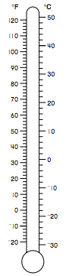
A
B
C

Images of thermometers © Scott Foresman – Addison Wesley 2

2. Which thermometer represents water’s melting point?
- A
- B
- C
- None of the thermometers depict the melting point of water.

3. Which thermometer represents water’s boiling point?
- A
- B
- C
- None of the thermometers depict the boiling point of water.

4. Sam was outside swimming in the pool when his mom brought him a glass of ice water. He noticed that the outside of the glass was wet after a few minutes. Over time, the there were no ice cubes in his glass and he just had liquid water. What phase change(s) were present in this situation?
- melting
- condensation
- freezing and evaporation
- melting and condensation

5. Explain how water molecules interact in a solid, liquid and gas state using pictures and words.

H₂O, a Water Molecule

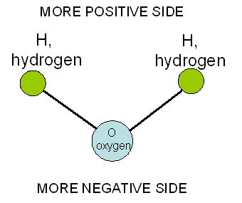

Human Model of the Water Molecule
(as seen from above)

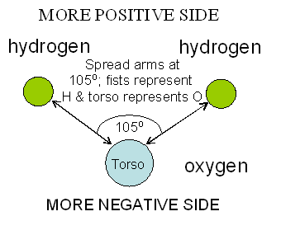

Water Molecule Interactions

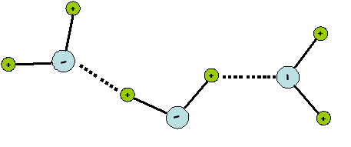

- The two hydrogen atoms stay at the same 105° angle.
- Water is very stable, so every oxygen keeps its two hydrogen atoms.
- Opposite charges attract or pull toward each other, but they never touch.
- Like charges repel or push away from each other.

Solid Water (Ice)

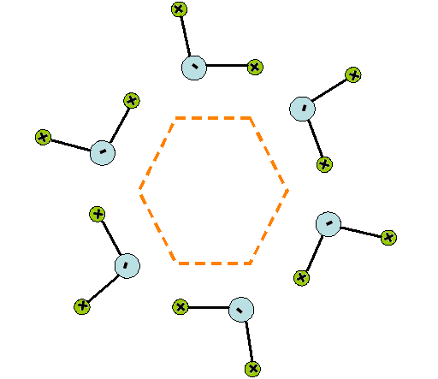

- In the solid form, the water molecules still vibrate but don’t move.
- In this shape, the attractions and repulsions are balanced and the crystal is stable.
- What would happen if you tried to squeeze another water molecule into the center?
Water Crystals

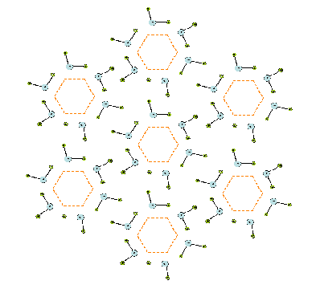

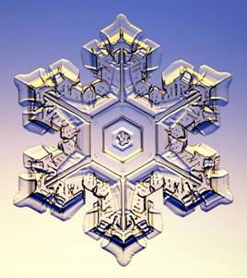

Water Vapor

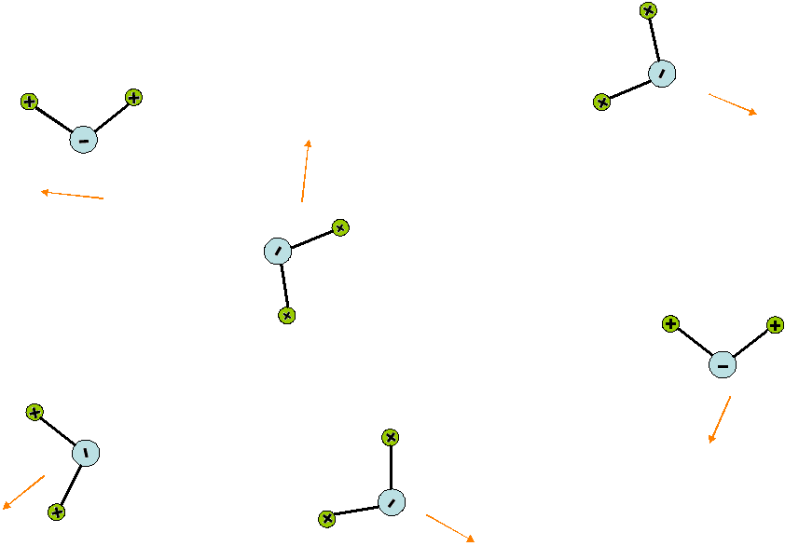
- As heat is added, water molecules move faster and break away from each other.
- They now move in random directions until they run into something and bounce away.

H ⁺

H ⁺

O–

How to Make a Large Thermometer
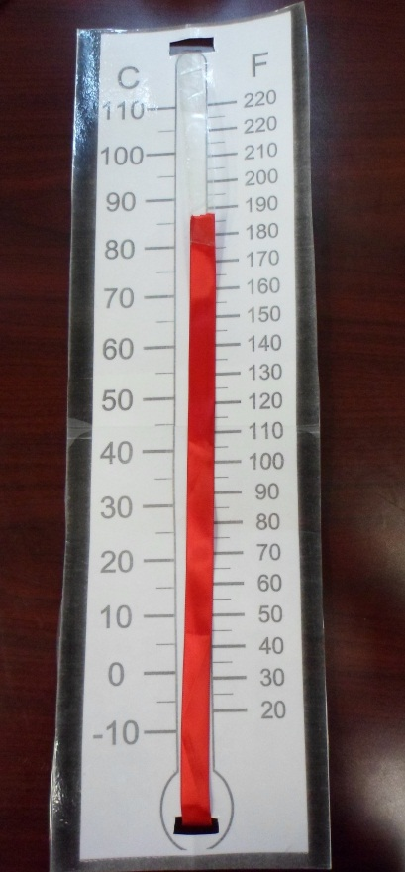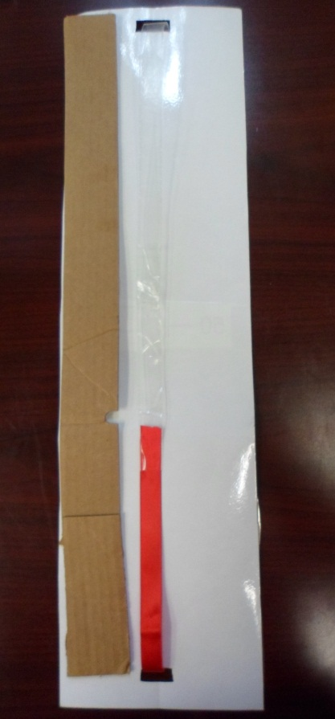

Directions:
- Cut out the two templates provided
- Tape or glue the two sheets together; you will have to overlap to them.
- Laminate the connected sheets (optional)
- Cut a 1 ¼ in slit at the bottom of the thermometer about ¾ in from the bottom
- Cut a 1 ¼ in slit at the top of the thermometer about ½ in from the top.
- Take the packing tape and fold and cut it so that it is the same width as the ribbon. Make sure there are no sticky sides on the tape.
- Connect the packing tape and ribbon together on one end, leaving the other end free.
- String the ribbon/packing tape through the holes. Cut or overlap the tape if there is excess and connect the two ends together.
- Hot glue the cardboard piece to one side on the back of the “thermometer” for stability.

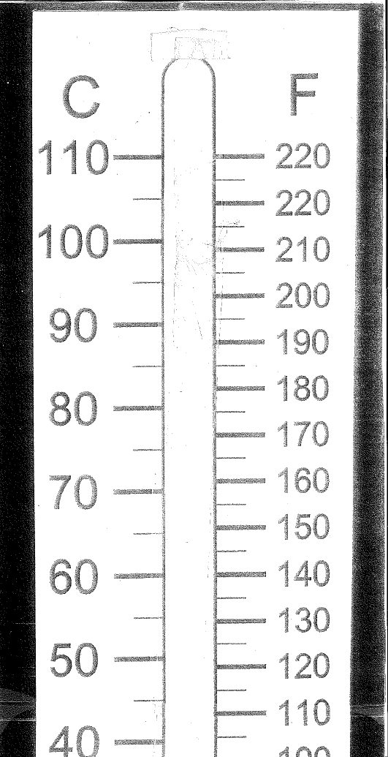

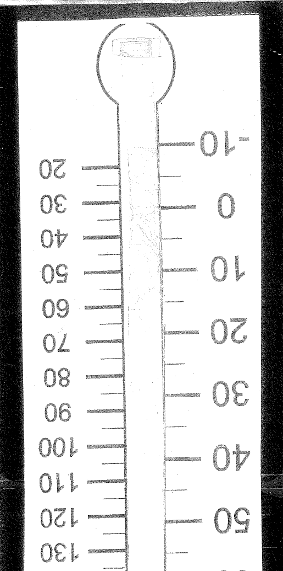

For teacher use if simulation does not work

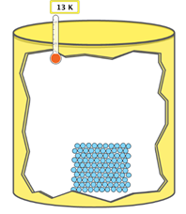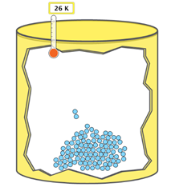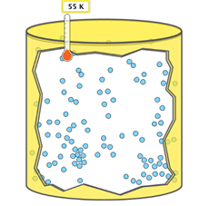

Solid phase Liquid Phase Gas Phase

ADD HEAT →

ADD HEAT →

Remove Heat →

Remove Heat →

States of Matter Basics
ANSWER KEY
I. States of Matter
a) Explore how you can change the state of matter. Draw the particles inside the container for each state.
State of Matter | My picture
 | 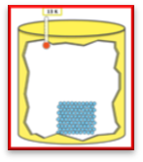
Liquid | 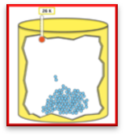
Gas | 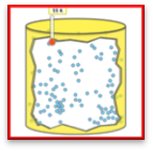
b) How do you know what state of matter particles are in?
- The movement and organization of the particles

II. Changing States of Matter
a) Explore how you can change the state of matter of the particles in the container. Use the table above to determine what state of matter the particles are in. Fill in the table with your observations.
Challenge | Add or remove heat (circle your answer) | Observations or Picture
Solid → Liquid | Add heat  Remove heat | Particles became less organized and started to spread out and move faster.
Liquid → Gas | Add heat  Remove heat | Particles were spaced out very far apart all around the container and moved much faster.
Liquid → Solid | Add heat  Remove heat | All the particles moved back together and moved very slowly.
Gas → Liquid | Add heat  Remove heat | The particles came back closer together and moved slower.
b) When heat is added or removed, what types of energy are changing?
Kinetic energy and Thermal energy

III. Analysis of a model
- What advantages does using a computer simulation have?
We are able to slow the particles down and pause the simulation.

- How is this model similar and different from what we acted out in class? List two similarities and two differences.
Similarities: We changed phases and acted as particles particles.

Differences: Temperate was measured in Kelvin and could pick between neon, argon, oxygen, and water.

Name: KEY

Show off what you know!
KEY
1. When heat energy is increased for a substance the
- particles move slower.
- particles move faster and spread out.
- particles move faster and move closer together.
- new particles are formed.

The following are temperature readings from a sample of water being heated. Use the image below to answer Questions 2 and 3.

A
B
C

Images of thermometers: © Scott Foresman – Addison Wesley 2

2. Which thermometer represents water’s melting point?
- A
- B
- C
- None of the thermometers depict the melting point of water.

3. Which thermometer represents water’s boiling point?
- A
- B
- C
- None of the thermometers depict the boiling point of water.

4. Sam was outside swimming in the pool when his mom brought him a glass of ice water. He noticed that the outside of the glass was wet after a few minutes. Over time, the there were no ice cubes in his glass and he just had liquid water. What phase changes were present in this situation?
- melting and condensation
- condensation
- freezing
- melting

5. Explain how water molecules interact in a solid, liquid and gas state using pictures and words.
See images above of water crystals, water vapor, ice, etc.

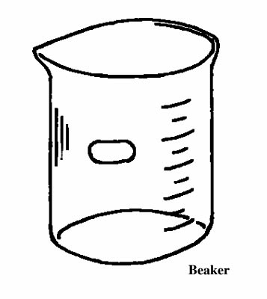
Instructions:

- Cut out and paste pictures in the squares as labeled.
- In the beaker, draw the molecules in each state. Make sure you have the same number of molecules in each beaker.
- In the arrows, write the scientific term used to describe the phase change.

Insert Liquid

Insert Solid Picture Here
Insert Gas Picture Here

Picture Here

