
UTeach Outreach The University of Texas at Austin

Energy Skate Park Basics – Scripted Version

Lesson created by: UTeach Outreach
Date of lesson: Spring 2012
Length of lesson: 50 minutes
Description of the class: Middle School Science
Resources used:
- http://www.tjhsst.edu/~jleaf/tec/html/10/potent.htm
- Video: http://www.youtube.com/watch?v=reAKFlbdhGY
- http://www.sciencelearn.org.nz/Science-Stories/Harnessing-the-Sun/Sci-Media/Images/Potential-and-kinetic-energy
TEKS and NSES addressed:
§112.18. Science, Grade 6, Beginning with School Year 2010-2011.
(b) Knowledge and skills.
(2) Scientific investigation and reasoning. The student uses scientific inquiry methods during laboratory and field investigations. The student is expected to:
(C) collect and record data using the International System of Units (SI) and qualitative means such as labeled drawings, writing, and graphic organizers;
(D) construct tables and graphs, using repeated trials and means, to organize data and identify patterns; and
(8) Force, motion, and energy. The student knows force and motion are related to potential and kinetic energy. The student is expected to:
(A) compare and contrast potential and kinetic energy;
(B) identify and describe the changes in position, direction, and speed of an object when acted upon by unbalanced forces;

NSES (1996) Grades 5-8 – Content Standard B
MOTION AND FORCES
- The motion of an object can be described by its position, direction of motion, and speed.
TRANSFER OF ENERGY
- Energy is a property of many substances and is associated with heat, light, electricity, mechanical motion, sound, nuclei, and the nature of a chemical. Energy is transferred in many ways.

Prior Content Knowledge Assumed:

Students should have a basic understanding of kinetic and potential energy. This understanding should include that kinetic energy is the energy of motion and potential energy is dependent on position.

I. Overview

The lesson begins with students being reintroduced to the terms force and energy through a class demonstration using a doll and a car. The students are introduced to the Question of the Day: “What does the potential and kinetic energy of an object depend on?” then complete an inquiry-based investigation in pairs using the Energy Skate Park Basics PhET simulation. It is through the use of this simulation that students discover that the energy of an object, in this case a skateboarder, depends on its position, mass and speed. The students engage in a class discussion over their findings of their investigation. The lesson ends with the students extending their knowledge to water park rides using a ramp and a boogie board made out of a wooden stick.

II. Objectives (learner outcomes)

Students will be able to:
- Examine how an object’s potential and kinetic energy change as it moves and how an object’s total energy remains constant.
- Determine the variables that affect an object’s potential and kinetic energy.
- Propose modifications to the Energy Skate Park Basics PhET simulation.

III. Resources, materials and supplies

Engage: per class
- 1 – doll
- 1 – Car that doll will fit in
- 1 – Ramp

Explore: per pair
- 1 – Computer

Elaborate: per class
- 1 – Flat wooden stick with object attached
- 1 – Ramp
- Supply of water

IV. Advanced Preparation:

- Bookmark the link for the Energy Skate Park Basics PhET on each computer.
- Test experiment for Elaborate to determine how much water to have.
- Attach objects to flat wooden stick.

V. Supplementary worksheets, materials and handouts

- See attached.

VI. Background Information

College level:

In this lesson there are three main ideas to understand:
1. Position: an object’s place with respect to the surroundings of the object.
2. Speed: how fast an object is moving. We often think of speed with regard to driving vehicles. Speed is always positive. This means that only a number is associated with it and it is independent of position relative to the surroundings of the object. An example of speed is 65 miles per hour.
3. Velocity: the change in position over time. Velocity depends on direction. It can be both negative and positive depending on its position relative to another object. An example of velocity is a plane travelling at 500 miles per hour heading northeast.
The total amount of energy in an isolated system is conserved. This means that the amount of energy that an object has does not disappear when acted upon by outside forces, but instead transforms into another form of energy.

Potential energy is the amount of energy that is stored within a system. Potential energy exists whenever an object has a position within a force field. The most familiar example of this is the position of objects in the Earth's gravitational field. The potential energy of an object in this case is given by the relation:

PE = mgh, where:
- PE = Energy (in Joules)
- m = mass (in kilograms)
- g = gravitational acceleration of the earth (9.8 m/sec²)
- h = height above earth's surface (in meters)

Kinetic Energy exists when an object is in motion. The kinetic energy of an object in this case is given by the relation:

KE = (1/2)mv² , where:
- KE = Energy (in Joules)
- m = mass (in kilograms)
- v = velocity (in meters/sec)

The following image illustrates a ball being thrown up in the air. When the ball is at its highest position above the ground it is at its maximum potential energy.
Maximum Kinetic Energy,
Minimum Potential Energy

Maximum Potential Energy,
Minimum Kinetic Energy

Maximum Kinetic Energy,
Minimum Potential Energy

An object reaches its maximum kinetic energy when it reaches its highest velocity. In the example above, as the ball falls its potential energy decreases because its position relative to the ground is decreasing.

6th grade level:

The branch of physics that studies motion is called mechanics. The concepts covered in this lab include position, velocity and energy.

Position and distance are similar but different. The position of an object is a description of the location of an object relative to another fixed point. The position of a ball can be 10 cm above the ground. Distance is a description of the length that an object travels and is read between two position readings. A ball can travel a distance of 10 cm when rolled down a ramp.

The velocity of an object is its change in position over time.

velocity = change in distance / change in time

The units for velocity are often meters per second or m/s. Because we have already defined distance as being the length that an object travels between two fixed position points, we can write velocity in a different form

velocity = v = distance traveled/time

Speed and velocity are often used interchangeably, but have very different meanings. Velocity is has both a magnitude and a direction (it is a vector). Speed has only a magnitude. Sometimes a velocity is negative. This is just a description of the direction of travel. For instance, an object moving to the right might have a positive velocity. If the object moves to the left it will have a negative velocity. The speed of an object does not tell the direction of travel, and is therefore always positive. When traveling in a car the speed is often measured in miles per hour but the quantity is the same regardless which way the car is moving. An example of a car’s speed is 60 miles per hour. An example of a car’s velocity is it moving 60 miles per hour southwest.
If we want to study how a skate boarder moves on a track, we are interested in two types of energy: gravitational potential and kinetic. Gravitational potential energy is a description of the amount of energy stored in an object as a result of its height above the ground.
Gravitational potential energy = (mass)(g)(height) = mgh
An object has kinetic energy when it is moving.
Kinetic Energy = ½(mass)(velocity)(velocity)
= ½ mv²

Before an object is released from a specific height, it has its maximum potential energy because it is at its maximum height. Remember: when measuring potential energy the only quantity that varies is height relative to the ground.

PE_{max}= mgh = mg (max height)

VII. Possible Misconceptions

- Something not moving cannot have energy. Potential energy is energy stored in an object due to position.
- An object has potential energy only when it is not moving. Potential energy depends on an object’s position whether it is moving or not.
- The only type of potential energy is gravitational. There are other forms of potential energy, such as, elastic potential energy and chemical potential energy.

VIII. Vocabulary & Definitions

College level:
- Speed – the measurement of the distance traveled/time, ex. 10 miles per hour
- Velocity – speed in a given direction
- Acceleration – a change in velocity with time
- Gravity – a force that pulls all objects towards each other. Earth’s gravity pulls everything to the center of the earth
- Gravitational acceleration – the acceleration responsible for the force of gravity
- Distance – the amount of separation between two points
- Force – anything that causes an object to experience a change in speed, direction or shape
- Gravitational Potential Energy – the energy stored in an object due to its position
- Kinetic Energy – the energy an object has because of its motion

Middle School Level:
- Distance (distancia) – the amount of separation between two points
- Force (fuerza) – a push or a pull
- Potential Energy (energia potencial) – the energy stored in an object due to its position
- Kinetic Energy (energia kinetica) – the energy of an object in motion
- Velocity (velocidad) – speed in a given direction; a measurement of speed and direction

IX. Safety Considerations

- Monitor all students when they are using computers to ensure they are visiting only appropriate websites.

X. Question of the Day

- What does the potential and kinetic energy of an object depend on?

5E Organization

ENGAGEMENT Time: 3 minutes
What the teacher will do | Probing Questions | Student Responses  Potential Misconceptions
Today we are going to start out by doing a quick demonstration with a doll and her car sliding down a ramp.  Put the doll in her car and have the ramp at a slight incline.  Increase the incline of the ramp and release car.  The doll had potential energy before she started moving and when she was moving down the ramp. The doll had kinetic energy when she was moving.  Today we are going to explore potential and kinetic energy as we try to answer our Question of the Day: “What does kinetic and potential energy of an object depend on?” Post Question of the Day on the board. | - What happened to the doll?  - What would happen if we increased the height of the ramp?  - What happened to the doll?  - When did the car have potential energy? Kinetic energy? | - The car rolled down the ramp. It didn’t move very far.  - She will go faster and farther.  - She went really far and fast!  - Before and as she rolled down the ramp. When she was in motion [MC: she only had potential energy before she started moving]

EXPloration |  | Time: 25 minutes
What the Teacher Will Do | Probing Questions | Student Responses  Potential Misconceptions
Define potential and kinetic energy, if needed. Potential energy is the energy stored in an object because of its position. Kinetic energy is the energy of motion. Write definitions on the board. An object that is higher above the ground has more potential energy, than an object closer to the ground. If needed, demonstrate with an object in the classroom.  Another way we can explore energy is by using an online simulation. Pass out laptops (one for each pair). Pass out “Energy Skate Park Basics PhET” Worksheet.  Today, we will be working in pairs and each of you will have a job role. Pass out job role cards. There will be two jobs: Driver and Navigator.  Navigators will be responsible for reading the information on the student activity sheet AND instructing the Driver when using the computer.  Drivers will be responsible for operating the computer and following instructions from the Navigator. It is important that we work as a team today during our investigations!  At the top of your sheet you will see a few terms in a review box. As you begin exploring with the simulation, work with your partner to fill in the blanks.  Give students five minutes to explore with the simulation. Job roles do not have to be enforced at this time. Project the simulation in front of the class after five minutes of play. Allow students to share out what they discovered by coming to the front of the class to point out their observations. Be sure that students point out “Reset All” and “Slow Motion.” If not ask questions #5 and #6.  Those are all great observations! I now want you to complete your activity sheet for the next thirty minutes. Be sure to work as a team and use your job roles. Half way through our exploration, we will switch roles so everyone has a chance to use the computers.  Allow students 30 minutes to complete their activity sheet. Circulate around the room.  Possible Probing Questions to ask students include | - What does a driver of a car do?  - Where have you heard the word “navigate” before?  - What do you think a navigator will do?  - What did you discover your simulation can do?  - (Optional) What should you do if you have lots of things on your screen and you want it to go back to what you started with?  - (Optional) How can you slow down the simulation?  - How is your simulation similar/different from the real world?  - How could you determine what kinetic and potential energy depend on?  - What evidence are you using to support your conclusions?  - In what ways would you change the simulation?  - What advantages does using the pie chart have?  - What conclusion can you make about how speed influences kinetic energy?  - In the first tab, what does the simulation not consider?  - If you were to design a skate park, what would you use? How would it look? | - Controls the steering wheel, pedals, etc.  - Sailing ships.  - Point out where to go.  - You can move the skater, pick different tracks, show different things.  - Press the reset button!  - Select the slow motion button (next to play).  - It shows the energy of the skater. It shows the speed like in a car. It’s only two dimensions.  - Try different combinations.  - The bar graph. The speedometer. The pie chart.  - Make it display numbers on the speedometer and on the graph. Have it show the mass of the object.  - It stays above the skater, which makes it easier to follow.  - As speed increases, kinetic energy increases.  - Friction.  - Lots of loops, metal, etc.

EXPlanation |  | Time: 10 minutes
What the Teacher Will Do | Probing Questions | Student Responses  Potential Misconceptions
Collect laptops.  Let’s discuss the results from our exploration. Fill in the blanks with your observations.  What we can say is that the potential energy transformed into kinetic energy. Write the word transformed on the board. If you were on the first tab, the track was frictionless. In this case, all of the potential energy transformed into kinetic energy. What we saw was an energy transformation. Write Energy Transformation on the board.  The skater lost potential energy as the skater moved down the track and gained kinetic energy. When the skater went up the ramp, the opposite happened. The skater lost kinetic energy and gained potential energy. When the skater moved down the ramp, its energy was transformed from potential to kinetic energy.  The total energy of the skater stayed the same. What you witnessed is the Law of Conservation of Energy. Write Law of Conservation of Energy on the board.  Let’s discuss how the potential and kinetic energy of the skater changed as the skater moved.  Potential energy is the energy that an object has stored inside of it. If it is higher up then it has more potential energy.  Exactly! So what we have been studying is gravitational potential energy. Write gravitational potential energy on the board. There are also other types of potential energy, such as, chemical potential energy, which is the energy stored in chemical bonds, or elastic potential energy found in springs.  Let’s discuss how an object’s speed relates to its potential and kinetic energy.  When an object is traveling faster, it has a higher kinetic energy. Later in science class, you will learn the equations for Potential and Kinetic Energy.  That’s very interesting! What we have determined is that because potential energy is transformed into kinetic energy, if there is more potential energy to start then the skater had a higher speed.  We’ve already discussed the Law of Conservation of Energy, now let’s discuss how we can change the total energy of the skater.  Right, you could change the total energy of the skater by changing the skater’s mass or the track.  The skateboarder did start at a higher place, which gave the skateboarder more potential energy.  The total energy when friction is not present is the sum of the potential and kinetic energy. This means that if you start out with more potential energy then you will have a higher total energy. If you were looking at the second tab on the simulation, thermal energy was present. In this case, the total energy was the sum of the potential, kinetic and thermal energy.  Let’s go back to our Question of the Day: “What does the potential and kinetic energy of an object depend on?” I will give you two minutes to answer this question.  Give students two minutes to discuss.  The simulation did not consider friction, if you were on the first tab, or air resistance.  Friction slows the skateboarder down. Also, when friction is present thermal energy is present.  The simulation shows many different things. A disadvantage is that it is only in two dimensions. You also can’t specify the skater’s mass or see the skater’s speed.  There are other simulations that allow you to do those things. This simulation is meant more for observations instead of calculations.  Those are all excellent examples of experiments you could do. There are also other PhET simulations that allow you to study energy.  There are many reasons why studying potential and kinetic energy is important. Engineers often consider potential and kinetic energy in their designs.  Those are all great examples of careers that study potential and kinetic energy. Basically, anyone that studies the way that things move is interested in an object’s energy. | - What happened to the energy of the skater as he rolled up and down the ramps?  - As the skater traveled down the ramp, what happened to the skater’s potential energy?  - What evidence did we have that the potential energy decreased?  - As the skater traveled down the ramp, what happened to the skater’s kinetic energy?  - As the skater traveled up the ramp, what happened to the skater’s potential energy? Kinetic energy?  - What energy transformation did we see as the skater moved up the ramp?  - What happened to the total energy as the skater moved?  - When the skater was high above the ground, did the skater have a high or low potential energy?  - Why do you think that is? Think about what the word “potential” means.  - What force(s) are acting on an object that is being held in the air?  - How did the skater’s speed relate to its kinetic energy? Potential energy?  - If you were designing a skate park and wanted to have a skateboarder go really fast, where would you want your skateboarder to start?  - In what ways could you alter the total energy bar?  - Why do you think changing the track affected the total energy of the skateboarder?  - Because the potential energy increased (or decreased), what did that mean for the amount of kinetic energy? Why?  - What does the potential and kinetic energy of an object depend on?  - What did our simulation not take into consideration?  - How does friction influence the skateboarder’s motion? Energy?  - What limitations does the simulation have?  - What are the advantages of using a simulation?  - What changes would you make to the simulation? Why?  - What other experiments could you do to study an object’s potential or kinetic energy?  - Why do you think learning about potential and kinetic energy is important?  - What careers are concerned with potential and kinetic energy? Why? | - The potential and kinetic energy changed.  - The potential energy decreased.  - The graph!  - The kinetic energy increased.  - It increased. Decreased.  - Kinetic energy to potential energy.  - It stayed the same!  - A high potential energy.  - Potential energy is stored energy.  - Gravity.  - As speed increased the kinetic energy increased. As speed decreased the potential energy increased.  - Higher so that it would go faster at the bottom.  - By changing the track or the mass of the skater.  - The skater started out with more potential energy, and potential energy is included in the total energy.  - It also increased because the potential energy transformed into kinetic energy.  - Accept various answers. Insist that students explain why and provide evidence from their simulation sheets.  - Friction and/or air resistance.  - It would have slowed it down and it would have had thermal energy.  - It’s only in two dimensions. You can’t specify the skater’s mass, etc.  - It shows the skater’s energy. It allows you to make changes to the skater.  - Allow it to show the actual speed or energy, so you could do calculations instead of just observations.  - Cars and ramps, springs, etc.  - Because it relates to the motion of objects and things are always moving.  - Engineers, scientists. When building different things or studying how objects move.

ELABORATE Time: 7 minutes
What the teacher will do | Probing Questions | Student Responses  Potential Misconceptions
Here is a picture of something similar to our lesson. Show the photo of the water park rides.  Exactly! The higher you started up for a certain angle, the faster you go.  We are going to use a model to represent what happens to a person on a water slide.  Today, we are going to use a flat wooden stick with an object attached to represent our person and a ramp to represent our water slide. Of course, we will need to pour water on the ramp.  Let’s investigate what will happen when we release the boogie board on the ramp.  Put the “boogie board” at the top of the ramp and position the catch basin. Pour a little bit of water on the ramp and release boogie board from the top.  That’s interesting! It appears that our boogie board got stuck.  Let’s try this again. Pour more water on the ramp and release boogie board.  That is true. The water reduces the friction between the boogie board and the track. | - Which rides would be the fastest?  - What else can make these rides feel so fast?  - What materials do you think we could use?  - What do you notice?  - What could we do to make it go faster or stay on the track?  - What do you think the extra water eliminates or takes away? | - Rides that start off really high!  - The water was rushing under them.  - Ramps! Small objects.  - The boogie board got stuck. It went really fast. It went slow at first then fast.  - Maybe there wasn’t enough water. I think it needed more water to water pushed it.  - Friction!

EVALUATION Time: 5 minutes
What the teacher will do | Probing Questions | Student Responses  Potential Misconceptions
Now, we are going to take a few minutes to show off what we’ve learned.

Pass out “Show off what you know!” quizzes to students to work on individually.

If time permits, give the students the following journal prompt:
You have been assigned the task of creating the world’s greatest rollercoaster ever! What would you take into consideration with your design? Draw out your design and label the points of highest and lowest potential energy and highest and lowest kinetic energy.

Question of the Day:
What does the potential and kinetic energy of an object depend on?
Name: ___________________

Energy Skate Park Basics PhET Activity
Review: (fill in the blanks)
Potential Energy is the energy _____________ in an object because of its ____________.

Kinetic Energy is the energy of _______________.

1. Explore the simulation.
Question: What can you change about the simulation?

2. Investigate how the potential and kinetic energy of the skater change as the skater moves from the top of the ramp to the bottom.
Fill in the blanks based on your observations:
As the skateboard rolls down the ramp it loses ___________ energy and gains

___________ energy. The total energy of the skateboarder remains _____________.

3. Explore how the potential and kinetic energy change as the height of the skateboarder changes. Fill in the table based on your observations.

Height of Skater (m) | What is greater? (circle your answer)
 | Kinetic Energy Potential Energy
 | Kinetic Energy Potential Energy
 | Kinetic Energy Potential Energy
0 | Kinetic Energy Potential Energy

Question: What conclusions can you make about how the height of the skater influences the potential and kinetic energy of the skater?

4. Explore how the skater’s change in speed relates to the potential and kinetic energy of the skater. Fill in the table based on your observations.

Speed | What is greatest?  (Potential or Kinetic Energy) | What is lowest?  (Potential or Kinetic Energy)
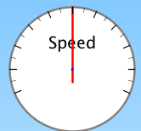
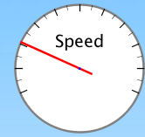
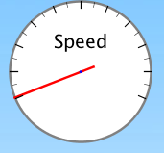

Question: How does the speed relate to the potential and kinetic energy of the skater?

5. Find ways to change the total energy bar. If you change the track, explain what makes the track different from the others (Hint: where does the skate boarder start?).
Use the table below to record your observations.

What did you do? | The total energy…. (circle your answer)
Increase the mass of the skater | Increases Decreases
 | Increases Decreases
 | Increases Decreases

Conclusion: In a few sentences describe what you think the total energy of the skater depends on. Use the tables you filled in during this activity as your evidence.

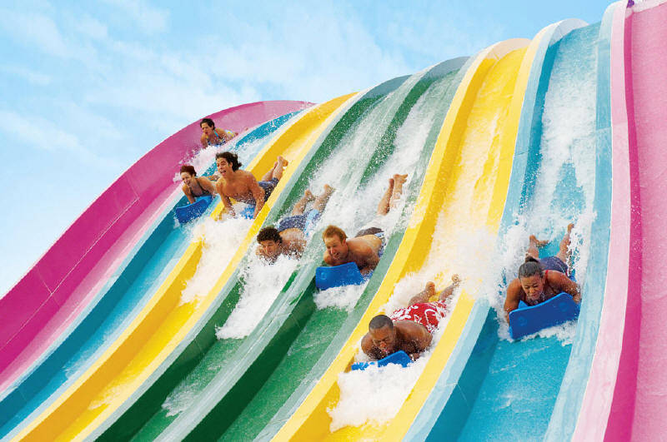
Photo of Aquatica Water Park Ride
(http://0.tqn.com/d/travelwithkids/1/0/e/h/1/aquatica_slide.jpg)

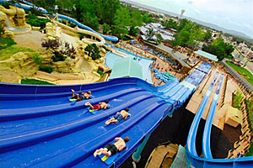
Photo of ride at White Water Park (http://www.ultimatewaterpark.com/waterparks/white-water.html)

Name: ________________________

Show off what you know!

- What does gravitational potential energy depend on?
  - Position
  - Air Resistance
  - Gravity
  - Both a and c

- A tiny pig is dropped from the top of a building and lands safely on a trampoline. The tiny pig will have an increase in what type(s) of energy as it falls?
  - Gravity
  - Potential energy
  - Kinetic energy
  - All of the above

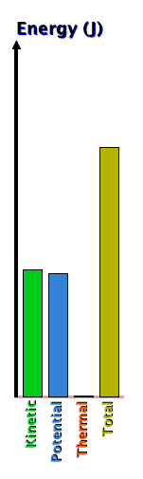
- The following is a graph of the energy of a skateboarder as he travels down a track. Using the diagram on the left, at which point on the track does the graph correspond to?

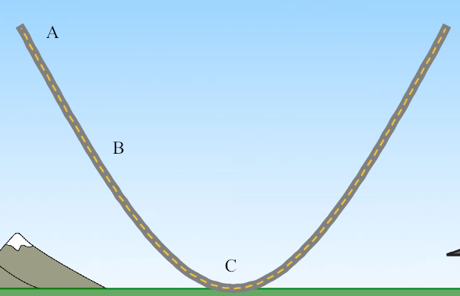

a. Point A
b. Point B
c. Point C

- Katy wants to design a rollercoaster where the passenger is traveling super fast at the bottom. What characteristics should the rollercoaster have?

- It should be flat and close to the ground. This way the passenger will have an increase in speed because he/she starts out close to the ground.
- It should have no friction and the passenger should start off high above the ground. This way the passenger starts out with a lot of potential energy that can be transformed into kinetic energy.
- It should have lots of friction and be very tall. This way the passenger will speed up because of the large amount of friction.
- It doesn’t matter how you design the rollercoaster the passenger’s speed will be the same at all points on the rollercoaster.



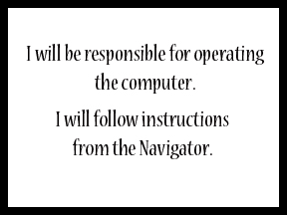



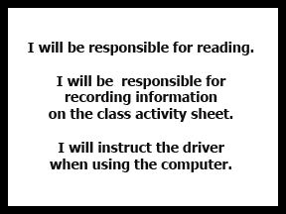
Name: KEY

Energy Skate Park Basics PhET Activity
Review: (fill in the blanks)
Potential Energy is the energy stored in an object because of its position.

Kinetic Energy is the energy of motion.

1. Explore the simulation.
Question: What can you change about the simulation?

You can make the simulation go in slow motion. You can display different things (speed, bar graph, grid, etc.). You can reset the simulation and pause it.

2. Investigate how the potential and kinetic energy of the skater change as the skater moves from the top of the ramp to the bottom.
Fill in the blanks based on your observations:
As the skateboard rolls down the ramp it loses potential energy and gains

kinetic energy. The total energy of the skateboarder remains constant.

3. Explore how the potential and kinetic energy change as the height of the skateboarder changes. Fill in the table based on your observations.

Height of Skater (m) | What is greater? (circle your answer)
6 | Kinetic Energy Potential Energy
4 | Kinetic Energy Potential Energy
2 | Kinetic Energy Potential Energy
0 | Kinetic Energy Potential Energy

Question: What conclusions can you make about how the height of the skater influences the potential energy of the skater?

The higher the skater is the more potential energy he has. As his height decreases, his potential energy decreases and his kinetic energy increases.

4. Explore how the skater’s change in speed relates to the potential and kinetic energy of the skater. Fill in the table based on your observations.

Speed | What is greatest?  (Potential or Kinetic Energy) | What is lowest?  (Potential or Kinetic Energy)
 | Kinetic Energy | Potential Energy
 | Potential Energy | Kinetic Energy
 | Potential Energy | Kinetic Energy

Question: How does the speed relate to the potential and kinetic energy of the skater?

As the skater’s speed increases, the kinetic energy increases. As the speed decreases, the kinetic energy increases.

5. Find ways to change the total energy bar. If you change the track, explain what makes the track different from the others (Hint: where does the skate boarder start?).
Use the table below to record your observations.

What did you do? | The total energy…. (circle your answer)
Increase the mass of the skater | Increases Decreases
Decrease the mass of the skater | Increases Decreases
Change the track where the skater starts at a higher position | Increases Decreases

Conclusion: In a few sentences describe what you think the total energy of the skater depends on. Use the tables you filled in during this activity as your evidence.

When the skater starts at a higher point, the total energy of the skater increases. When the skater’s mass increases, the total energy increases.

Name: ________________________

Show off what you know!
KEY

- What does gravitational potential energy depend on?
  - Position
  - Air Resistance
  - Gravity
  - Both a and c

- A tiny pig is dropped from the top of a building and lands safely on a trampoline. The tiny pig will have an increase in what type(s) of energy as it falls?
  - Gravity
  - Potential energy
  - Kinetic energy
  - All of the above

- The following is a graph of the energy of a skateboarder as he travels down a track. Using the diagram on the left, at which point on the track does the graph correspond to?

a. Point A
b. Point B
c. Point C

- Katy wants to design a rollercoaster where the passenger is traveling super fast at the bottom. What characteristics should the rollercoaster have?

- It should be flat and close to the ground. This way the passenger will have an increase in speed because he/she is close to the ground.
- It should have no friction and the passenger should start off high above the ground. This way the passenger starts out with a lot of potential energy that can be transformed into kinetic energy.
- It should have lots of friction and be very tall. This way the passenger will speed up due to the lots of friction.
- It doesn’t matter how you design the rollercoaster the passenger’s speed will be the same at all points on the rollercoaster.

