LUNAR LANDER: Let The Force be with You PART 1 Name ________________________

An analysis of VELOCITY and ACCELERATION using VECTORS

Object of the Game: To complete as many soft landings as possible with a single fuel tank.

Object of the Lesson: To observe the acceleration and velocity of the vehicle using the visual display of VECTORS that represent each.

1. Click the Lunar Lander link http://phet.colorado.edu/en/simulation/lunar-lander

2. Click “Vectors” to turn on the vector display for the spacecraft.

3. Read the instructions on how to play.

4. Play openly until the teacher asks you to do the focus exercises below.

Focus Exercise 1: Studying the VECTOR displays

Study the GREEN and YELLOW vectors as you play the game.

1. What 2 “things” about the spacecrafts motion does the green velocity vector show you?

_______________________________ __________________________________

2. What 2 “things” about the NET force applied to the spacecraft does the yellow vector show you?

_______________________________ __________________________________

Describe the term “NET” force. _________________________________________________________

___________________________________________________________________________________
3. The green velocity vector is actually showing you the “NET” velocity. It shows the “combination” (SUM) of the X-velocity and the Y-velocity.

Focus Exercise 2: Hovering the Spacecraft

1. Reset the spacecraft and attempt to make a soft landing. As you approach the ground closely, keep the spacecraft just above the ground (hover) using just enough thrust. In other words, keep your Y-velocity = 0.0 shown as “v_y(m/s)” and your X-velocity = 0.0 shown as “v_x(m/s)”

2. You should see little of either vector displayed at this point. Why is the green velocity vector gone or very tiny?
____________________________________________________________________________________

3. While the yellow acceleration vector is gone (zero), does that mean there are NO FORCE(S) acting on the spacecraft or does it mean something else? Explain.

_____________________________________________________________________________________

_____________________________________________________________________________________
4. What is the “thrust” reading when the spacecraft is hovering the best? Hover thrust: ______________

This “hover thrust” must be equal and ____________________ to the force of gravity and therefore the forces are ___________________ making the “NET” force on the spacecraft ____________.

Focus Exercise 3: Only Sideways Motion

1. Reset and get your spacecraft to hover NEAR THE GROUND.

2. Use the left and right arrow keys to rotate the spacecraft and get it to fly with v_x(m/s) = +1.0 and
v_y(m/s) = 0.0. In other words, it should fly having a X-velocity of +1.0 m/s and a Y-velocity of 0.0 m/s

3. Describe how the vectors are VISUALLY displayed when flying the spacecraft as described above?

Velocity:______________________________ Acceleration: __________________________________

4. In which direction does the spacecraft move? ____________________________________________

5. What if the X-velocity is changed so it is negative (-) 1.0 m/s? Is it’s motion different? Explain:

____________________________________________________________________________________

Focus Exercise 4: Combining Velocities

6. You may have noticed that as you play the green velocity vector points in any direction even at angles. The velocity vector is really showing the “NET” velocity. If it points perfectly only left or right, it only has left or right motion (pos. or neg. X motion). If it points perfectly only up or down, it only has up or down motion (pos. or neg. Y motion). What if the green velocity vector points at an angle as shown below?
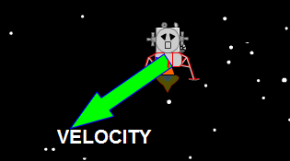

If the picture shows the “NET” velocity of the spacecraft, how would you describe its X and Y motion based on the velocity vector shown. In other words, is it moving up, down, left or right or some combination? Describe its’ velocity:

___________________________________________________________________________________

___________________________________________________________________________________
ANALYZING LUNAR LANDER: PART 2 Name ___________________

1. Open the “NET force simulation” http://phet.colorado.edu/en/simulation/vector-addition.

2. Follow the directions on the web page and experiment freely for a few minutes.

3. Complete the diagrams and questions below using the “NET force simulation”

Simulation 1: Spacecraft Hovering / Balanced Forces
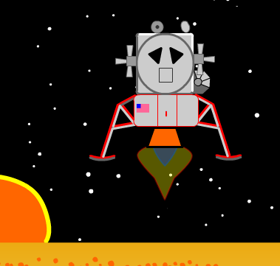

The lunar lander is pictured as it hovers above the ground. Both the X-velocity and Y-velocity are zero.
FOR ALL QUESTIONS AND PROBLEMS THAT FOLLOW, ASSUME THAT +10N OF FORCE FROM THE ENGINE IS NEEDED TO MAKE THE LUNAR LANDER HOVER.

1. Read the caption above.

2. Have you read the caption above? READ IT AGAIN!

Question 1: How much NET force is applied when the lunar lander is hovering? _________________

Question 2: If the lunar lander engine applies +10N of force to make it hover, what amount of applied force is gravity putting on it? ______________ (Note: this answer will be helpful in other questions!)

3. Use the Net force simulation to create a force diagram that illustrates the NET force applied to the lunar lander while it hovers motionless as shown above according to the caption.
Draw your force diagram in the space right:

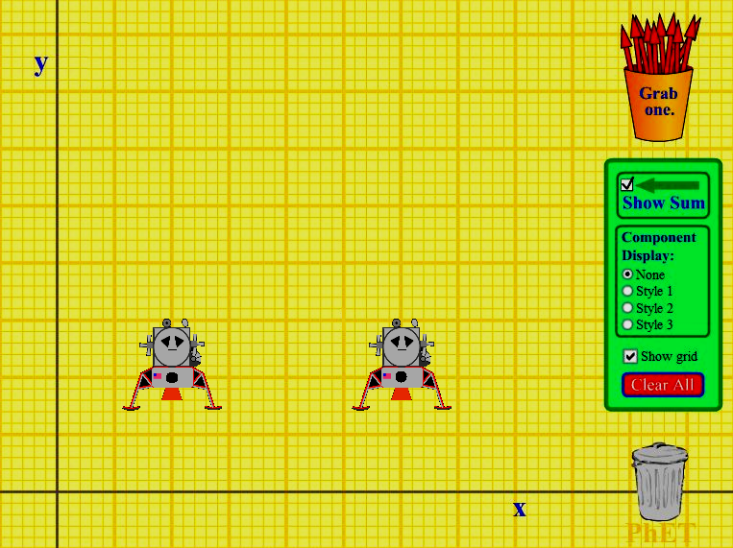
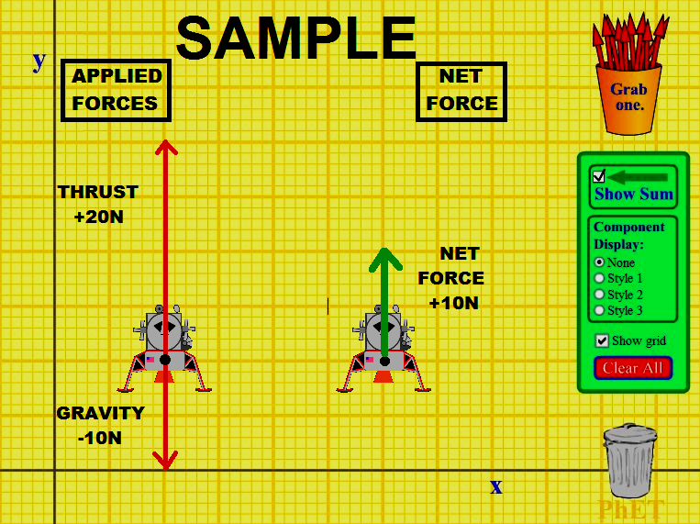
Simulation 2: Engine Off / Unbalanced Forces

The picture below illustrates the NET force applied to the lunar lander when the engine is off. Think about your answers to the questions in Simulation 1 above before answering the question below.
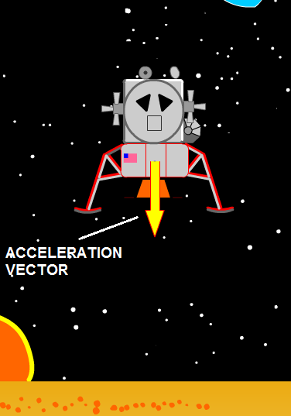

Question 3: Use the “Net force simulation" to create a diagram that illustrates the NET force applied to the lunar lander when the engine is off. What is the NET force applied to the lunar lander? ______________

Simulation 3: Engine Full Power / Unbalanced Forces

The picture below illustrates the NET force applied to the lunar lander when the engine is on full power. There is a NET force of +15N applied to the lunar lander.
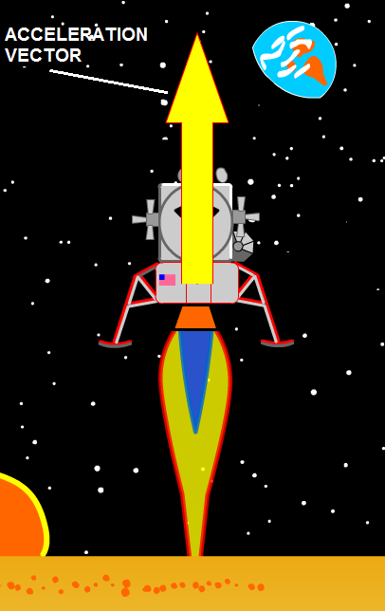

Question 4: Use the “Net force simulation" to create a diagram in the space provided that illustrates the NET force applied to the lunar lander when the engine is at full power. What amount of force must the engine
apply to the lunar lander to produce a NET force of +15N ?
______________

Simulation 4: Constant Sideways Motion

The picture below illustrates the lunar lander flying with a constant X-velocity of negative (-) 2.0 m/s
and a constant Y-velocity of 0.0 m/s
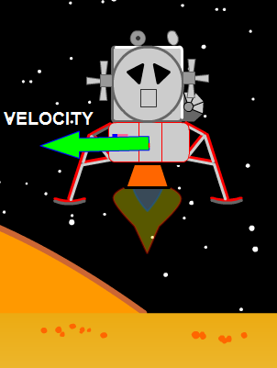

Question 5: Use the “Net force simulation" to create a diagram in the space provided that illustrates the NET force applied to the lunar lander when it has a constant X-velocity of negative (-) 2.0 m/s and
Y-velocity of 0.0 m/s. The engine is applying +10N of force.

How much “NET” force is applied to the spacecraft? ____________

Are the applied forces balanced in this simulation or unbalanced? Explain your answer ______________

____________________________________________________________________________________

The picture below illustrates the velocity of the lunar lander as well as the acceleration it is experiencing. The engine is off. The X-velocity is a constant negative (-) 14 m/s. The Y-velocity is changing at -10 m/s²
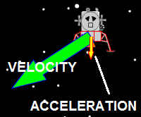

Question 6: Use the “Net force simulation" to create a diagram in the space provided that illustrates the NET force applied to the lunar lander when the engine is off and it has the motion shown in the picture.

Are the applied forces balanced in this simulation or unbalanced? Explain your answer ______________

____________________________________________________________________________________
Simulation 5: Constant Motion Downward

The picture below illustrates the velocity of the lunar lander. The engine is applying a force of +10N.
The X-velocity is a constant 0.0 m/s and the Y-velocity is a constant negative (-) 23 m/s.
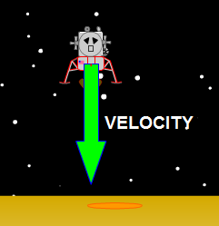

Question 7: Use the “Net force simulation" to create a diagram in the space provided that illustrates the NET force applied to the lunar lander when the engine is applying a force of +10N and it has the motion described above.

With the motion that the lunar lander has, will it eventually hit the ground? _____________.
If you said “yes”, then what will be it’s velocity when it hits? ____________

Explain your answer above. _____________________________________________________________

____________________________________________________________________________________

If you said “no”, then explain what the motion of the lunar lander is and why it doesn’t hit the ground.

____________________________________________________________________________________

____________________________________________________________________________________

Simulation 6: CHALLENGE / Maximum X-velocity

The lunar lander engine can apply 4 X the amount of force that the gravity of the moon applies.

Use the “Net force simulation" to create a diagram in the space provided that illustrates the maximum possible NET force to make the spacecraft accelerate in its negative (-) X-velocity while, at the same time, keeping the Y-velocity constant. In other words, ONLY accelerate the X-velocity in the negative (-) direction NOT the Y-velocity at all.
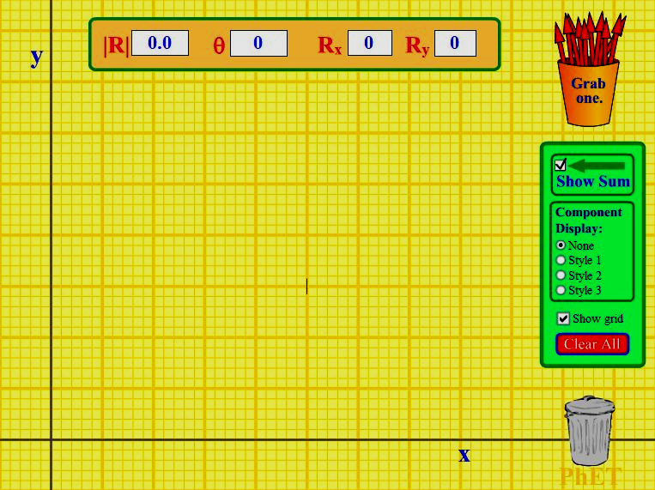
NOTE R = vector length

