Mechanical Energy Explorations Pre-simulation: Name:__________________
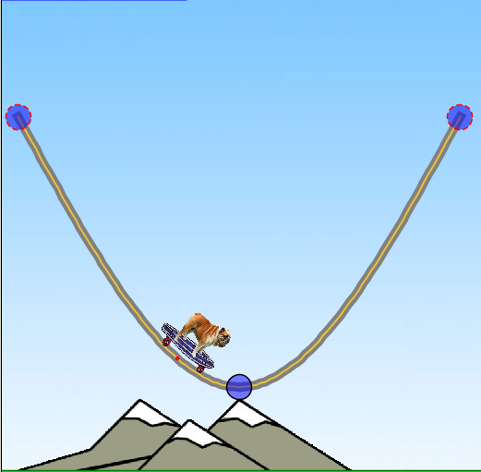
1. The dog is going down the hill. The kinetic energy will:
a. increase/go higher- because the dog continues to move faster going down the hill.
- decrease/go lower - because the dog is slowing down.
- stay the same
2. The potential energy at this point is:
  - high b. low c. equal to the kinetic energy

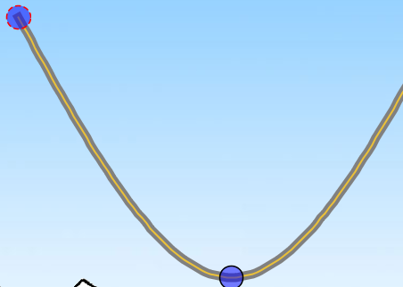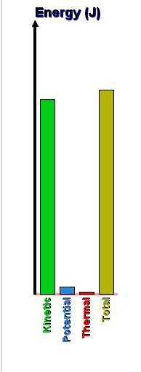
A.
C..
B
Look at the positions labeled on the track
and the bar graph information:
(circle your answer)
3. The bar graph matches _____________ best.
Position A. Position B. Position C.

4. If the ball starts where is on the picture, how far will it travel up the other side if there is no friction?
a. 1 b. 2 c. 3
5. If the ball starts where is on the picture, how far will it travel up the other side if there is friction?
a. 1 b. 2 c. 3

11
C..
2
3

