
UTeach Outreach The University of Texas at Austin

Build an Atom – Scripted Version

Name: UTeach Outreach
Length of lesson: 50 minutes – 1 hour
Description of the class: 8th Grade Science
Source of the lesson:
http://phet.colorado.edu/en/simulation/build-an-atom

TEKS addressed:
§112.20. Science, Grade 8, Beginning with School Year 2010-2011.
(b) Knowledge and skills.
(3) Scientific investigation and reasoning. The student uses critical thinking, scientific reasoning, and problem solving to make informed decisions and knows the contributions of relevant scientists. The student is expected to:
(C) identify advantages and limitations of models such as size, scale, properties, and materials;
(5) Matter and energy. The student knows that matter is composed of atoms and has chemical and physical properties. The student is expected to:
(A) describe the structure of atoms, including the masses, electrical charges, and locations, of protons and neutrons in the nucleus and electrons in the electron cloud;
(B) identify that protons determine an element's identity and valence electrons determine its chemical properties, including reactivity;
(C) interpret the arrangement of the Periodic Table, including groups and periods, to explain how properties are used to classify elements;

Overview
The lesson begins with the teacher carefully smashing a cell phone. This serves as an introduction of objects are composed of smaller things. Next, the students are handed element cards where they are introduced to the idea of atomic numbers. The students then move to a computer simulation (see http://phet.colorado.edu/en/simulation/build-an-atom). Each pair of students is given a set of element cards that resemble the boxes on the periodic table for each element. The students are also given an activity sheet where they use the simulation and their element card to identify the distinguishing parts of each element (name of element, atomic number, mass number, net charge of the atom, number of protons, neutrons, and electrons). Students are introduced to the charges associated with protons, neutrons, and electrons. In addition, students are introduced to a Bohr Model of an atom and become able to draw specific elements.

Performance or learner outcomes
Students will be able to:
- Construct a model of an atom.
- Determine the charge of an atom or ion.
- Explain how to determine the numbers and types of subatomic particles in an atom.

Resources, materials and supplies needed for each class
- A cell phone
- Hammer
- Smashing set-up (plastic sheet and cardboard)
- Goggles for teacher
- Gloves for teacher
- Computers with internet access (1 per student is ideal, but no more than 2 students should share a computer)
- Dry erase board & Markers
- Index Cards

Supplementary materials needed for each class and worksheets
- Element Card Activity half-sheets (one per student)
- Element Cards
- Challenge Cards (one per pair of students)

Advanced Preparation
- Set up cell phone smashing station
- Put a link to the simulation on a website or bookmark it on each computer for ease of access for students
- Cut out the element cards

Background Info

a. College Level
The English language has an alphabet of 26 letters, and all English words are made up of various combinations of these letters. All the words in all the books in all the libraries of the English-speaking world are made up of these same 26 letters. In the same way, there are about 100 different types of pure substances in the universe. These substances are called elements, and all the matter in the universe is made up of varying combinations of these elements.
A single particle of any element is called an atom. An atom is the smallest piece of matter that still has the chemical properties of the element. The word atom comes from the Greek word meaning “indivisible.” Atoms were initially believed to be small hard spheres with no component parts, and this view of the atom prevailed from Democritus’ early theories in about 400 BC until 1897, when an experiment by British physicist J.J. Thomson unexpectedly released tiny, negatively charged particles from samples of metal. No matter which metal Thomson used, the tiny negative particles that were released were identical. Thomson referred to these particles as “corpuscles,” but they would eventually become known as electrons. Since the metal atoms themselves were electrically neutral, the negative charge on the electrons meant that there must also be some kind of positively charged particles within an atom, which led to the 1917 discovery of the proton, and in turn to the discovery of the neutron in 1932. The resulting model of the atom, called the Bohr model, had the positively charged protons and zero-charge neutrons clustered together in the center of the atom (called the nucleus), with the negatively-charged electrons moving around the nucleus in spherical orbits, much like planets orbiting a star in a solar system. Protons, neutrons, and electrons are collectively referred to as subatomic particles.

The Bohr model of the atom is not the most recent model scientists have to work with. A more recent “electron cloud model” based on quantum mechanics and probabilities is able to explain electron behavior more fully, but it is a far more complex model than the Bohr model. As a result, the Bohr model, even though it is not the most recent or the most complete model of the atom, is the one used most often to explain atomic structure and chemical properties. The Bohr model is the one used in the online PhET simulation in this activity.

All atoms are made up of identical protons, neutrons, and electrons, but in different numbers and in slightly different arrangements. These subatomic particles don’t have chemical properties the way elements do. Looking back on the alphabet analogy, a letter b has certain properties, such as the sound it makes. But if the letter b is broken up into a stick and a circle, those pieces no longer have the properties of a letter. No sound is associated with either piece. It is only when they are combined to form a b that they have any linguistic meaning and any sound properties. In a similar way, it is only when subatomic particles are combined to form an atom that they assume an elemental identity and exhibit chemical properties based on their particular combination.

In the 1960’s, scientists showed that protons and neutrons are made up of even smaller particles called quarks. There is no evidence yet that electrons are divisible. The activity in this lesson only deals with protons, neutrons, and electrons.

The periodic table of the elements organizes the elements based on the number of protons in the nucleus and the arrangement of electrons around the outside of the atom. Because these two factors determine the chemical properties of an atom, the arrangement of elements in the periodic table also reflects trends in the physical and chemical properties of the elements. In fact, the periodic table was originally developed based solely on trends in physical and chemical properties, and it was only later when subatomic particles were discovered that the reasons for these trends became apparent.

Periodic Table of the Elements
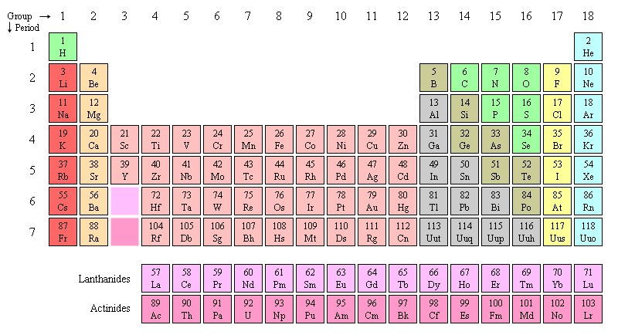

The elements in the periodic table are arranged in order of increasing atomic number, starting with 1 and currently going up to 118. The atomic number is the number of protons in the atom’s nucleus. Hydrogen has an atomic number of 1, which means that every hydrogen atom has one proton in the nucleus, and any atom that has one proton is a hydrogen atom. Similarly, carbon has an atomic number of 6, so every carbon atoms has six protons in the nucleus, and any atom that has six protons is a carbon atom.

The periodic table orders elements in series by the number of protons, and the row and column assigned to each element is determined by the position of their electrons. The periodic table does not explicitly provide any information about neutrons; information regarding neutrons is provided indirectly by looking at an element’s atomic mass.

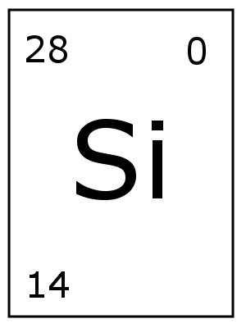
Periodic Table cell for Silicon
The bottom left number is the proton number,
upper left mass number, upper right charge number.

The unusual shape of the periodic table is the result of the arrangement of electrons in atoms. According to the Bohr model of the atom, electrons circle the nucleus in spherical orbits called energy levels or shells. The lowest energy level (the one closest to the nucleus) can only hold two electrons, and corresponds to the two elements in the first row of the periodic table. The second energy level can contain up to eight electrons, and corresponds to the eight elements going across the second row of the periodic table. Each row corresponds to the start of a new energy level, so each element in the first column of the periodic table has one electron in its outermost energy level. The Build an Atom simulation shows the first two energy levels, which correspond to the first two rows of the periodic table.

An element’s chemical properties are based primarily on the number of electrons in the outermost energy level. Since the elements in each column all have the same number of electrons in their outermost energy level, all of the elements in a single column of the table tend to have similar chemical properties. For example, hydrogen reacts with oxygen in a 2:1 ratio, forming water, H₂O. The other elements in the first column, including lithium, sodium, and potassium, also react with oxygen in a 2:1 ratio.

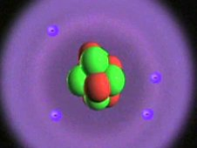
NASA Graphic of Beryllium Atom

Protons and neutrons are packed together into a very small volume in the center of the atom. Because the protons are all positively charged, there is a large electrostatic force pushing them apart. The protons are able to stay close together because of something called the nuclear strong force. The strong force overcomes the repulsion caused by multiple similarly charged particles being in close proximity. Research on the strong force is ongoing.

Protons and neutrons have approximately the same weight, and this is almost 2000 times greater than the mass of an electron. When calculating the mass of an atom, the mass of the electrons is insignificant and is ignored. There are two different ways in which atomic mass is determined. When speaking of an individual atom, we use the term mass number. The mass number is simply the sum of the protons and neutrons in the atom. When we’re talking about a larger quantity of material, we run into a slight problem – not all atoms of the same element have the same number of neutrons. Looking at a simplified case for carbon, about 99% of all carbon atoms also have six neutrons in the nucleus, but about 1% have seven neutrons. Atoms with the same number of protons but a different number of neutrons are called isotopes. Different isotopes of the same element will have different masses. Isotopes are a little bit like different species of an animal. Elephants, for example, can be African elephants, or the slightly smaller Asian elephants. They’re all elephants, but the two species have slight differences from one another.

Since all carbon atoms have six protons, an atom of the carbon isotope with six neutrons has a mass number of 12, and an atom of the carbon isotope with seven neutrons has a mass number of 13. In order to determine the mass of a mixed quantity of carbon atoms, we take a weighted average of the masses of all the isotopes. In the case of carbon, 0.99 × 12 + 0.01 × 13 = 12.01, so the atomic mass of carbon is about 12.01. The atomic mass is a weighted average of all the isotopes of that element, as opposed to the mass number, which describes a single atom. There are actually a handful of additional carbon isotopes which are extremely rare and have been left out of this calculation. When these additional isotopes are included in the calculation, the atomic mass of carbon inches up to about 12.0107. The most famous of these additional carbon isotopes is Carbon-14, which is used in radiocarbon dating.

The primary difference between isotopes is mass, but not all arrangements of protons and neutrons are stable. Carbon-12 and Carbon-13 are both stable isotopes, which means their nuclei hold together and do not fall apart. Carbon-14, however, is not stable, so this isotope is referred to as radioactive. The arrangement of six protons and eight neutrons in a Carbon-14 atom can only be achieved by adding energy to the nucleus when the atom is formed, and this added energy will eventually come out, resulting in a change to the nucleus. In the case of Carbon-14, when the nucleus decays, a neutron turns into a proton. The resulting atom now has seven protons and seven neutrons. Because it now has seven protons instead of six, the carbon atom has been turned into a nitrogen atom. The atom will now have a different set of chemical and physical properties, consistent with other nitrogen atoms. Radioactive decay also gives off considerable energy. Different radioactive isotopes decay at different rates. The rate of decay is known as the half-life. The half-life is the expected amount of time it would take for half of the atoms in a radioactive sample to decay. Half-lives range from billionths of a second to billions of years. The half-life for Carbon-14 is 5730 years. This does not mean that each Carbon-14 atom lasts for 5730 years before decaying – some might last for only seconds, and some might last for millions of years, but the statistical average lifespan of a large quantity of Carbon-14 atoms shows that half of them will have decayed after 5730 years.

In an ordinary atom the number of electrons is equal to the number of protons, so the atom has no net charge and is electrically neutral. Atoms can gain and lose electrons, however – gaining electrons will give the atom an overall negative charge, and losing them will result in an overall positive charge. An atom which has gained or lost electrons and now has an electrical charge on it is called an ion. Metals tend to lose electrons and form positive ions, and non-metals tend to gain electrons and form negative ions. The atoms in the far right column of the periodic table have a filled outermost energy level, and tend to neither gain nor lose electrons.

Note that the Building an Atom activity allows you to add or remove as many electrons as you would like from the atom. This would not be possible in real life, because it takes an increasing amount of energy to add and remove each successive electron. The PhET activity also allows you to mix any number of protons with any number of neutrons in the nucleus. The simulation indicates which of these combinations are unstable, but many of the “unstable” atoms created in fact don’t exist in nature at all. Lastly, the proportions of the atom shown in the simulation (and in textbooks and in the pictures included here) are vastly incorrect. The distance between the nucleus and the electrons is so great that if an atom was shown to scale on a computer monitor, the nucleus would be too small to see. In that sense it’s just like pictures of the solar system shown in a textbook, where the planet sizes and distances are not shown to scale. To get a more accurate picture of the proportions of an atom, if the nucleus was the size of a housefly and was sitting on the 50-yard line of a football field, the nearest electrons would be in the end zone.

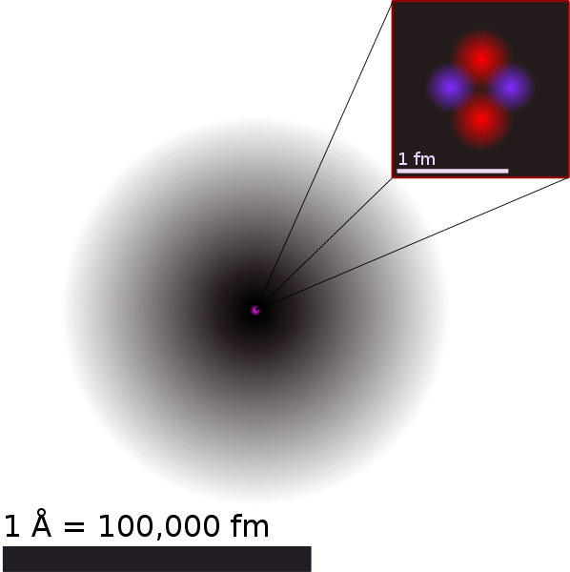
Quantum Mechanical Graphic of Helium, retrieved from
http://en.wikipedia.org/wiki/File:Helium_atom_QM.svg

b. Middle School Level

Elements are the purest form of matter and cannot be separated into any other substance. There are 118 different types of elements known, and everything in the universe is made up of these elements. The smallest amount of an element is a single particle called an atom. Atoms are particles that cannot be broken down into smaller parts and still have the same properties as the element. If an atom is broken down into the pieces that make it up, those pieces look and behave very differently from an element.

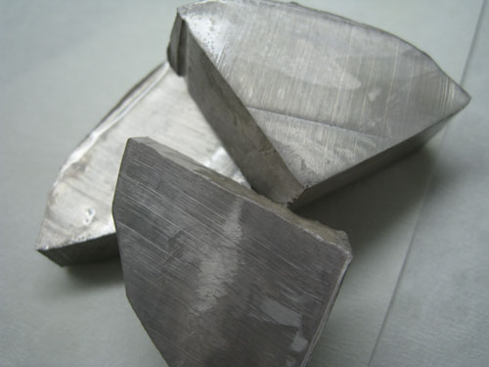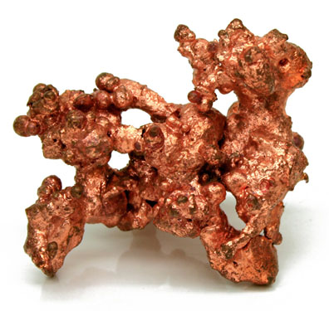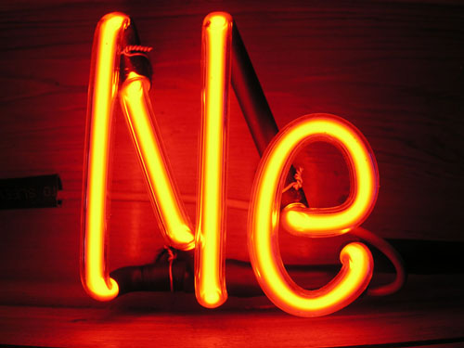
Elements from Left to Right: Sodium, Copper and Neon
Retrieved respectively from http://en.wikipedia.org/wiki/File:NatCopper.jpg, http://en.wikipedia.org/wiki/File:Nametal.JPG.jpg, and http://en.wikipedia.org/wiki/File:NeTube.jpg

There have been a number of different models of the atom over the years to help us understand and explain how an atom is put together and how the parts of an atom relate to one another. The most commonly used model is called the Bohr model of the atom. In the Bohr model, an atom is made up of smaller pieces that are arranged similarly to a solar system. In a solar system, the large sun is in the middle, and the smaller planets go around the sun in circular orbits. In an atom, the large nucleus is in the middle, and the tiny electrons whiz around it in spherical orbits called energy levels. A solar system has only one planet per orbit, but in an atom there can be multiple electrons in one energy level.

The nucleus in the center of the atom is made up of two different kinds of particles: protons and neutrons. Protons and neutrons have about equal masses, but protons have a +1 charge and neutrons have zero charge. The electrons orbiting the nucleus have a ‒1 charge, and have much less mass than a proton or neutron. If a proton weighed the same as a car, an electron would weigh as much as a can of beans. When the numbers of protons and electrons are equal, the atom has no overall charge. If the atom gains electrons, it will have more negative electrons than positive protons, and will be negatively charged. If the atom loses electrons, it will have more protons than electrons and will be positively charged. An atom whose protons and electrons are out of balance like this is called an ion.

All of the elements are organized into a chart called the periodic table. The way the elements in the periodic table are arranged, you can tell different things about each element just by where it is in the table, so you don’t have to memorize a lot of information. Each element is given a symbol that represents its name, and is assigned a number called the atomic number. The atomic number tells you how many protons are in the nucleus of atoms of that element. Since the atomic number of carbon is 6, that means all carbon atoms have six protons in their nucleus, and any atom that has six protons is a carbon atom. Neutral atoms have the same number of electrons as they do protons, so carbon’s atomic number of 6 also tells you that a neutral carbon atom has six electrons. The unusual shape of the periodic table is because the row and column assigned to each element is based on the position of the electrons in that element’s atoms. The Build an Atom simulation doesn’t go into detail on the arrangement of electrons, so we won’t go into detail here. The simulation simply shows the first two energy levels, which correspond to the first two rows of the periodic table.

In the same way that animals come in different species – like an African elephant and an Asian elephant – elements come in slightly different variations called isotopes. Every carbon atom has six protons, but they can have different numbers of neutrons in the nucleus. The most common carbon atoms have six protons and six neutrons. We add the protons and neutrons and say that this atom has a mass number of 12. The mass number is simply the protons and neutrons added together. Another isotope of carbon has seven neutrons – this is Carbon-13. Both Carbon-12 and Carbon-13 are stable, which means the nucleus of each atom will stay together and won’t fall apart, but some isotopes are unstable, or radioactive. A carbon atom with six protons and eight neutrons is radioactive – this is Carbon-14, which is used to help date ancient materials. The nucleus of an unstable radioactive isotope will eventually give off a burst of energy and make a change to become more stable.

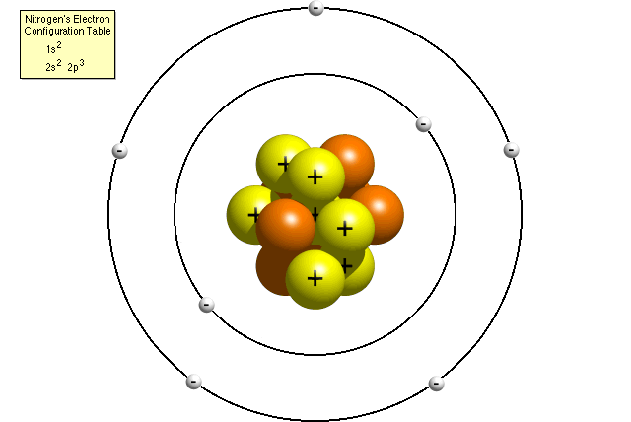

Bohr Model of Nitrogen,
From the Thomas Jefferson National Accelerator Facility – Office of Science Education
http://education.jlab.org/qa/atom_model.html

When textbooks show a picture of a solar system, the sizes and distances of the planets are never to scale, because if they were the smaller planets would just be dots. Pictures of atoms are also never shown to scale because the distance between the nucleus and the electrons is far greater than the size of the nucleus itself. To understand the proportions of the size of the nucleus to the size of the overall atom, imagine a housefly sitting on the 50-yard line of a football field. If that housefly was an atomic nucleus, the electrons would be as far away as the end zone. If you shrink that model down small enough to fit into a textbook, the nucleus would be too small to see. The pictures you see in a textbook or online show the nucleus and the electrons much bigger and much closer together than they really are.

Possible Misconceptions
- Possible Misconceptions are listed in the lesson in [brackets] and denoted with the capital letters “MC”

Vocabulary and Definitions
College Level:
- Element: a pure substance with distinct physical and chemical properties. There are about 90 naturally-occurring elements that make up everything on Earth.
- Atom: a single particle of an element, and the smallest amount of an element that you can have. Breaking this into smaller pieces results in material that no longer behaves the way the element does.
- Proton: a small, positively-charged particle in the nucleus of an atom
- Neutron: a small, zero-charged particle in the nucleus of an atom
- Electron: a small, negatively-charged particle that orbits the nucleus of an atom
- Nucleus: the mass in the center of an atom, made up of protons and neutrons
- Subatomic Particles: particles that are smaller than atoms. The relevant subatomic particles to this lesson are protons, neutrons, and electrons
- Periodic Table: a chart that arranges all the known elements according to their atomic structure and their physical and chemical properties.
- Energy Level: a spherical space around an atomic nucleus where electrons are found. An energy level is also known as a shell, and contains one or more orbitals.
- Shell: another name for an energy level
- Orbital: a space within an energy level or shell that can hold two electrons. Energy levels are composed of one or more orbitals.
- Mass Number: the sum of the protons and neutrons in an atom
- Atomic Mass: a weighted average of all the isotopes of an element
- Isotope: atoms of the same element with different numbers of neutrons. For example one isotope of carbon has 6 protons and 6 neutrons, while another isotope has 6 protons and 7 neutrons.
- Radioactive: an element with an unstable configuration of protons and neutrons in the nucleus. Radioactive atoms will eventually decay by giving off a burst of energy and mass, resulting in an atom of a different element.
- Ion: an atom in which the number of electrons is not equal to the number of protons. An atom which has gained electrons will be a negative ion, and one which has lost electrons will be a positive ion.

Middle School Level:
- Proton: positively charged particle in an atom
- Neutron: a particle in the atom that has no charge
- Electron: negatively charged particle in an atom
- Atom: smallest form of matter. It is the least amount of any element
- Element: any mater that cannot be separated into two or more substances
- Nucleus: central part of an atom that holds the protons and neutrons
- Electron orbit (or orbital): rings around the nucleus that hold electrons. The first orbital can hold no more than 2 electrons. The second orbital can hold no more than 8 electrons.
- Ion: a charged atom
- Neutral atom: an atom that has a zero charge, or no charge.

Safety Considerations
- When teacher smashes cell phone, ask students to step back. The teacher should wear goggles and gloves. There should also be a station set up so that no parts fly towards students. If an extra cell phone is available, please test before use.

FIVE-E ORGANIZATION
Engagement |  | Time: 7 minutes
What the Teacher Will Do | Probing Questions | Student Responses  Potential Misconceptions
Have a cell phone smashing station set up. Use caution and wear safety goggles!  Scientists are always trying to figure out how things work. One way to do this is to break things apart and look at what is inside of them.  Don’t try this at home! Smash cell phone. Be careful!  Now that I’ve smashed this cell phone into small pieces, let’s talk about what is inside.  Those are all great observations! Cell phones have many parts. A few elements inside of a cell phone include aluminum, gold, silicon and copper.  Yes! Gold is inside cell phones, but there is such a small amount that it would take hundreds of cell phones to get one gram of gold!  What we’ve just seen is that objects are composed of smaller things. Today, we’ll be studying atoms and discovering that they are also composed of smaller particles, too! | - How many of you have ever wondered what is in a cell phone? What do you think is in a cell phone?  - Why does breaking things into smaller pieces help a scientist figure out how things work?  - What observations can you make about these pieces? Walk around with pieces so students can see.  - What elements do you think are inside of a cell phone?  - How many cell phones do you think it would take to get one gram of gold? | - Me! Lots of tiny parts…technology!  - So they can see what is inside and make predictions about what the parts do.  - There are lots of wires and shiny parts.  - Metals, plastic (MC: plastic is not an element!)  - One, fifteen, hundreds.

Exploration |  | Time: 25 minutes
What the Teacher Will Do | Probing Questions | Student Responses  Potential Misconceptions
Show students the element cards.  Today, we are going to be exploring atoms. Each of these cards has information for a specific element that describes what the atom of that element will look like.  Pass around a couple periodic tables to the students.  As you look at the periodic table, notice how many elements there are.  Today, we will be using a simulator to explore atoms.  Instruct students on how to get to the simulator. (Look at advanced preparations.)  Play with the sim for five minutes.  Walk around the room and make sure students are not having problems opening and exploring the simulator.  Now that you’ve had a few minutes to explore, let’s share with each other what we have discovered about the simulation.  Have students “share out” what they have discovered about the simulation. Make sure that a student mentions that there is the “symbol” function in the simulation.  Today, you will figure out what each number and letter on your element card means. Label each part of the card as shown in my example. Hold up the example card showing students how to label parts of the symbol.  Pass out an element card and an Element Card Activity half-sheet to each student.  A class before you has made all of these cards for you. Your job is to solve the cards for them and then make cards for another class to solve after you.  You may now begin labeling the element card.  Once you finish labeling your element card, fill out the Element Card Activity half-sheet.  Questions to ask students while walking around the room:  Explanation: Atoms can become unstable when there are too many protons and not enough neutrons. Positive protons repel each other just like positive ends of two magnets. However, some combinations of protons and neutrons experience less repulsion and are stable. | - What do you see on these cards?  - What do you think that they mean?  - Where have you seen these types of cards before?  - How are they arranged?  - What does that number mean?  - What component of the atom determines the identity of the atom?  - Which atom do you have?  - How many protons does your atom have?  - What type of charge does a proton have?  - An electron?  - A neutron?  - What is the overall charge of your atom?  - How did you know how many protons to add?  - What happens when you add only protons and too few neutrons? Why?  - How did you know how many neutrons to add?  - How did you know how many electrons to add?  - Is your atom neutral or does it have a charge?  - What is an atom with a charge called?  - Why do ions have a charge? (What makes it have a charge?)  - If there are more protons than electrons, will the ion have a positive or a negative charge?  - If there are more electrons than protons, will the ion have a positive or a negative charge? | - Letter(s) and numbers.  - They identify something. They make it different from other cards.  - Some students may say that they have seen them on the periodic table.  - By number.  - Some may say protons or atomic mass.  - Protons  - Various answers. (Verify their answer.)  - Various answers. (Verify their answer.)  - Positive  - Negative  - No charge; it doesn’t say [MC: neutrons are negative. Because they both start with “n”]  - Various answers. (Verify their answer.)  - I added protons until the name was correct; or I added the number of protons at the bottom left of the card.  - The atom becomes unstable. [MC: It is unstable because it is not an atom.]  - I added neutrons until the mass number matched the number on the card.  - I added electrons until the charge was correct.  - Various answers. (Verify their answer.)  - An ion.  - The protons and electrons are not equal. MC: neutrons change the charge.  - Positive.  - Negative.

Explanation |  | Time: 10 minutes
What the Teacher Will Do | Probing Questions | Student Responses  Potential Misconceptions
Matching:  On the board, write:  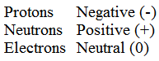  I need a volunteer to match the atomic particle to its correct charge.  Read over the results with the class.  Protons are positive, neutrons are neutral (or have no charge), and electrons are negative.  Drawing:  Draw this picture on the board:  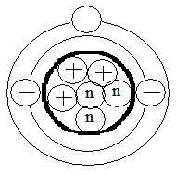  The pluses represent positive protons, the negatives represent negative electrons, and the n’s represent neutral (or no charge) neutrons.  Did you notice the sizes of the particles in the simulation? The protons and neutrons were about the same size. The electrons were smaller. Electrons are so small and lightweight compared to the protons and neutrons that the mass of the atom only depends on the number of protons and neutrons.  Symbols:  Draw the symbol on the board.  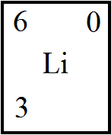  Then, write:  Protons = _____  Neutrons = _____  Electrons = _____  Here is an element symbol. Like we discussed earlier, these are found on the periodic table.  Fill in the correct number of protons, neutrons, and electrons as students answer the following questions. | - Who disagrees with this answer?  - What happens when the number of protons and electrons are not equal?  - What charge would an ion have if it has 3 protons and 2 electrons?  - If there are more protons than electrons, will the ion have a positive or a negative charge?  - If there are more electrons than protons, will the ion have a positive or a negative charge?  - What atom is this?  - What determines what the identity of the atom is?  - What is the mass number of an atom?  - What is the mass number of this Lithium atom?  - Where are the protons and neutrons located in an atom?  - Where are the electrons located?  - How many electrons can fit in the first ring?  - How many electrons can fit in the second ring?  - Can you put electrons in the outer ring first?  - What element is this?  - What is the atomic number of this Lithium atom?  - What does the atomic number represent?  - So how many protons will this Lithium atom have?  - What is the mass number of this Lithium atom?  - What does the mass number represent?  - How many protons did we have?  - So how many neutrons will this Lithium atom have?  - What is the overall charge of this Lithium atom?  - How many electrons will this Lithium atom have?  - How do you know? | - If anyone disagrees, ask why and what should be changed. Ask if anyone in the class agrees or disagrees with the change.  - An ion is formed.  - +1  - Positive  - Negative  - Lithium.  - The number of protons it has.  - The number of protons and neutrons the atom has.  - 6  - In the middle; in the nucleus  - Around the nucleus; in orbitals; in electron clouds  - Only 2  - Up to 8  - No. They have to fill up the first ring before they can go in the second.  - Lithium  - 3  - The number of protons.  - 3  - 6  - The number of protons and neutrons in the nucleus  - 3  - 3  - 0  - 3  - Because the charge is 0, so protons = electrons. If there are 3 protons, there has to be 3 electrons also.

Elaboration |  | Time: 15 minutes
What the Teacher Will Do | Probing Questions | Student Responses  Potential Misconceptions
Pass out challenge cards.

Now you have a challenge. On this card, I am giving you the numbers of protons, neutrons, and electrons of an atom. From this, draw the atom in the designated space, give me information about the atom, and then draw the symbol that would be found on the periodic table. Also, tell whether the atom has a charge (is an ion) or not.

Allow students about 10 minutes to work on this task in pairs. Circulate around the room to make sure students are on task and are clear about the directions. If students have trouble, use the same probing questions from the Exploration to help them.

One person from each group will now stand up and hand your index card to someone who is not your partner and is sitting down. Together with your original partner, you have 5 minutes to check the other team’s index card. Hand it back to them when you are finished. Raise your hand if you have any questions.

Evaluation |  | Time: 5 minutes
What the Teacher Will Do | Probing Questions | Student Responses  Potential Misconceptions
Now it is your turn to make element cards for the next class.

Pass out an index card to each student.

Draw the chemical symbol and give the correct atomic number for that symbol. Put a mass number in the correct place, and then choose a charge for the atom. You may use a periodic table to help you with this task. Turn your cards in before you leave for the day!

Name: _____________________
Show off what you know!

- Electrons do not contribute to the mass number of an atom. Why is this?
  - The mass number only counts particles which have a charge. Electrons have no charge.
  - The mass number only counts particles with no net charge. Electrons have a charge.
  - The mass number is an approximation of the mass of the atom and electrons have very little mass.
  - The mass number only represents the mass of the other particles because electrons have no mass.
- The name of an atom is determined by the number of which particle?
  - Proton
  - Electron
  - Boson
  - Neutron
- Car batteries produce hydrogen ions in the process of releasing chemical energy as electricity. The single electron in some neutral hydrogen atoms is pulled away as a result of the high current electricity. What is the charge on these hydrogen ions?
  - -1
  - +1
  - +2
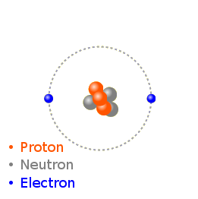
  - 0
- Which of the following atom cards best represents the atom drawn below?

6 +1
Li
3
9 -2
Be
4
1 0
H
1
4 0
He
2
Show off what you know!
KEY
1) c
2) a
3) b
4) Li
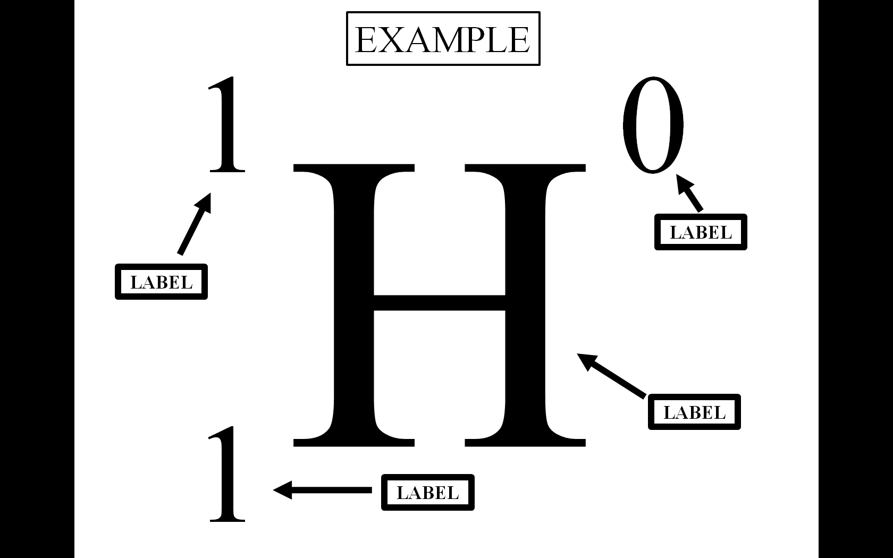

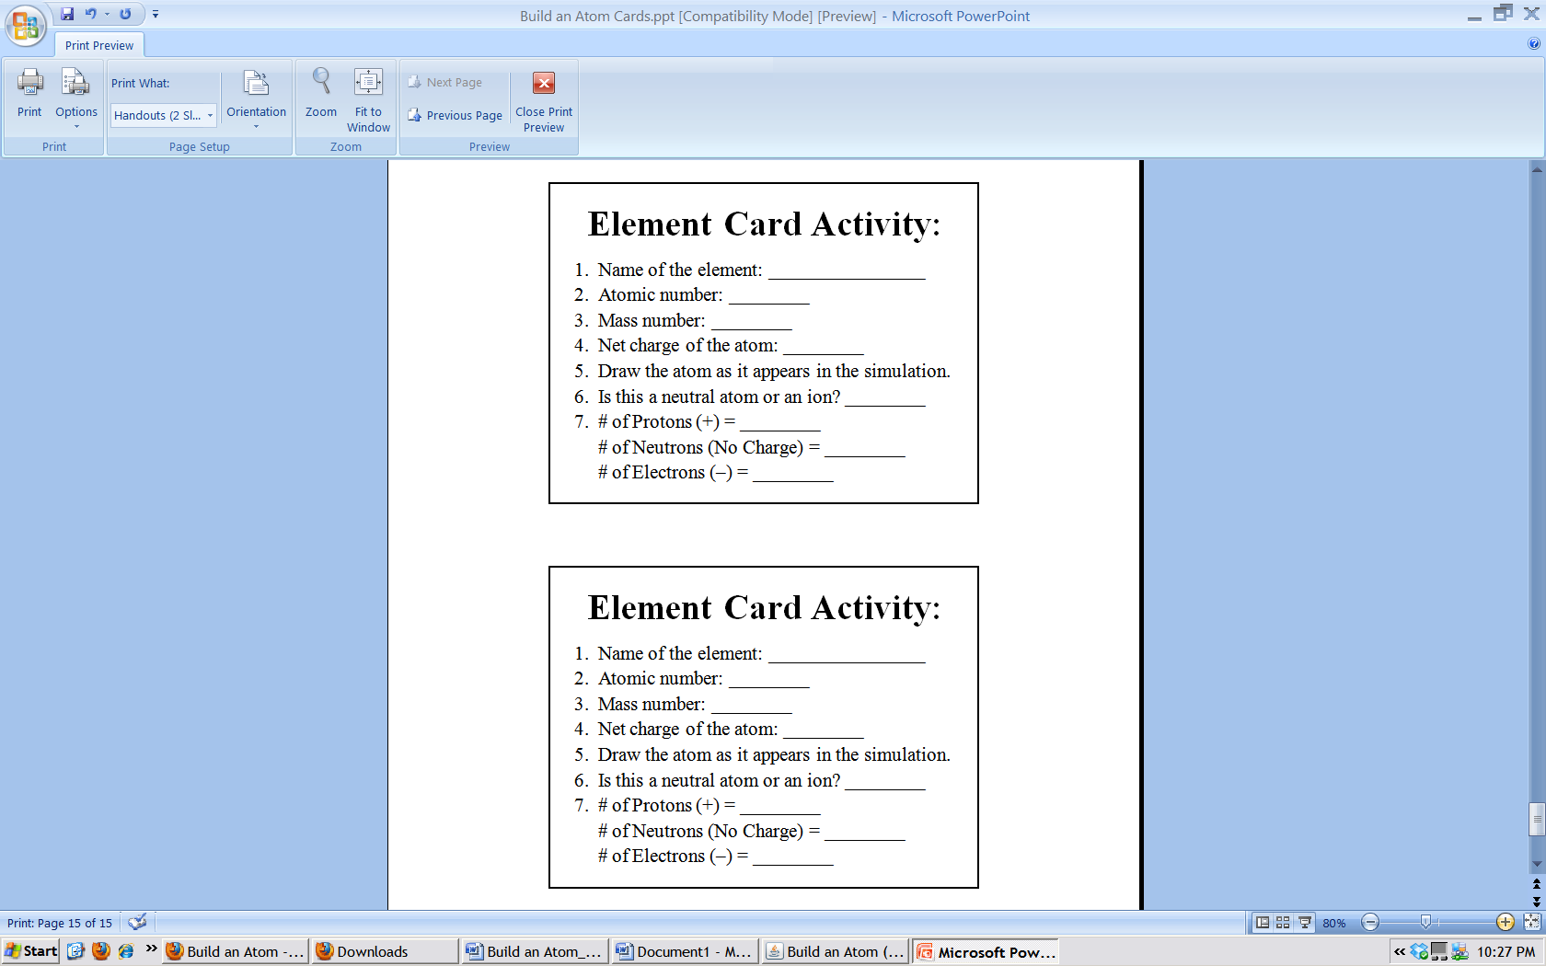
Name: _________________________________
Name: _________________________________
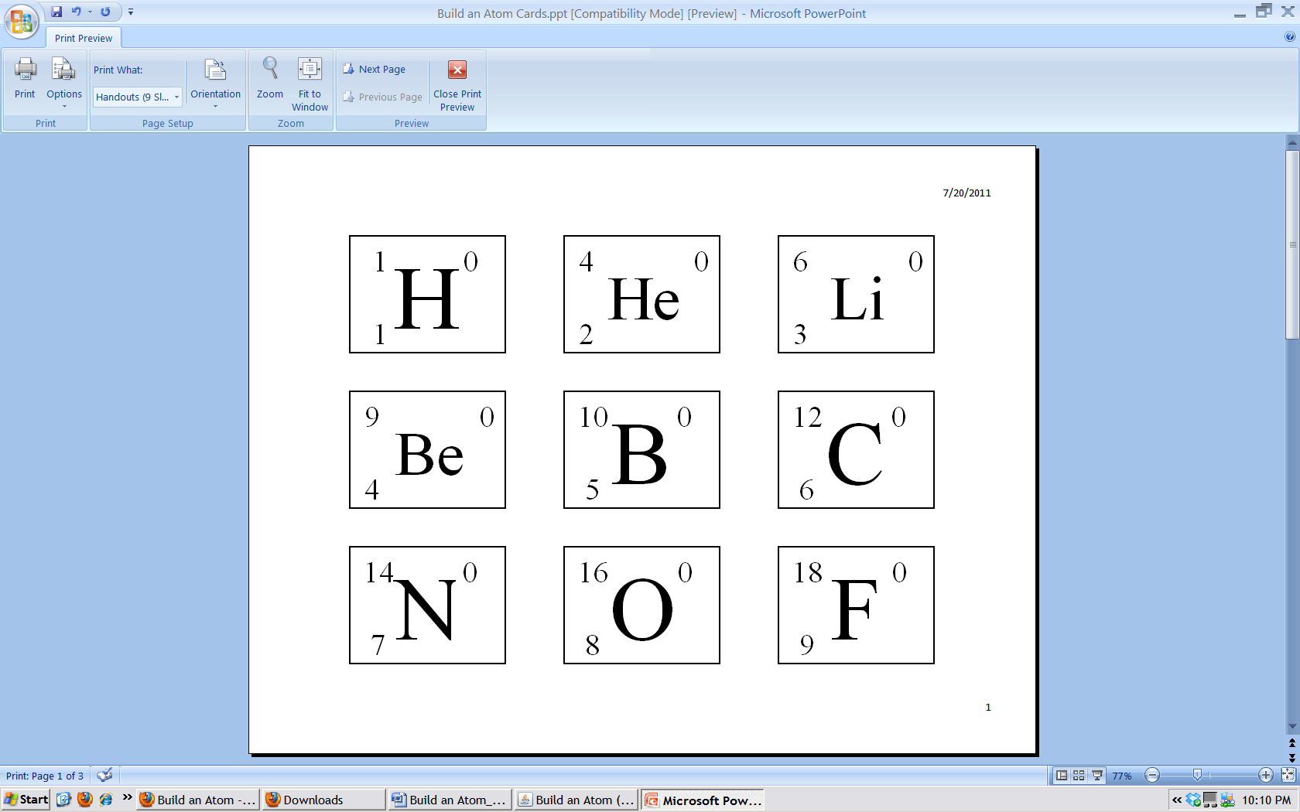
Element CardsElement Cards
Element CardsElement Cards

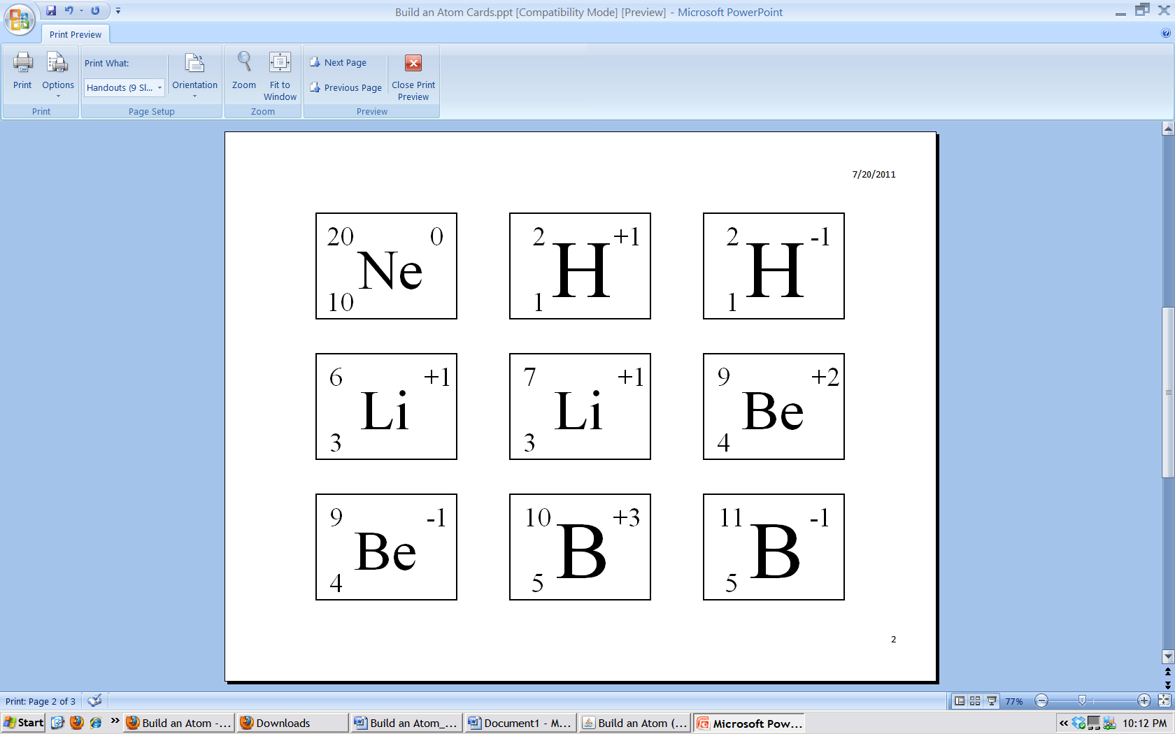
Element CardsElement Cards
Element CardsElement Cards

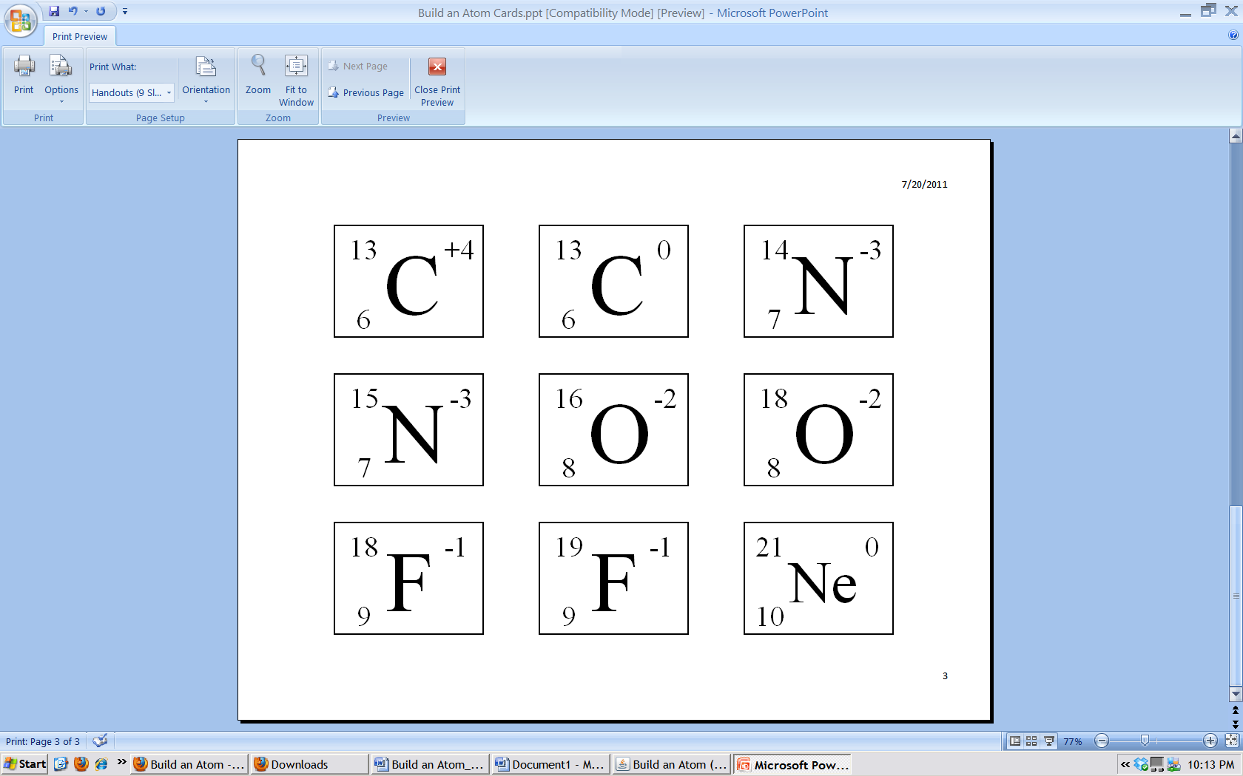
Element CardsElement Cards
Element CardsElement Cards

