
UTeach Outreach The University of Texas at Austin

Forces and Motion – Scripted Version

Lesson created by: UTeach Outreach
Length of lesson: 50-70 minutes
Teacher Note: to make fit into a 50-minute class you can remove the history taught in the lesson and make the Elaboration a class demonstration.
Description of the class: 6th and 8th Grade Science

TEKS and NSES addressed:
§112.20. Science, Grade 6, Beginning with School Year 2010-2011.
(3) Scientific investigation and reasoning. The student uses critical thinking, scientific reasoning, and problem solving to make informed decisions and knows the contributions of relevant scientists. The student is expected to:
(D) relate the impact of research on scientific thought and society, including the history of science and contributions of scientists as related to the content.
(8) Force, motion, and energy. The student knows force and motion are related to potential and kinetic energy. The student is expected to:
(B) identify and describe the changes in position, direction, and speed of an object when acted upon by unbalanced forces;

§112.20. Science, Grade 8, Beginning with School Year 2010-2011.
(3) Scientific investigation and reasoning. The student uses critical thinking, scientific reasoning, and problem solving to make informed decisions and knows the contributions of relevant scientists. The student is expected to:
(D) relate the impact of research on scientific thought and society, including the history of science and contributions of scientists as related to the content.
(6) Force, motion, and energy. The student knows that there is a relationship between force, motion, and energy. The student is expected to:
(A) demonstrate and calculate how unbalanced forces change the speed or direction of an object's motion;
(C) investigate and describe applications of Newton's law of inertia, law of force and acceleration, and law of action-reaction such as in vehicle restraints, sports activities, amusement park rides, Earth's tectonic activities, and rocket launches.

NATIONAL SCIENCE EDUCATION STANDARDS (1996):
Content Standard A (Grades 5-8)
USE APPROPRIATE TOOLS AND TECHNIQUES TO GATHER, ANALYZE, AND INTERPRET DATA. The use of tools and techniques, including mathematics, will be guided by the question asked and the investigations students design. The use of computers for the collection, summary, and display of evidence is part of this standard. Students should be able to access, gather, store, retrieve, and organize data, using hardware and software designed for these purposes.
UNDERSTANDINGS ABOUT SCIENTIFIC INQUIRY
- Mathematics is important in all aspects of scientific inquiry.
Content Standard B (Grades 5-8)
- An object that is not being subjected to a force will continue to move at a constant speed and in a straight line.
- If more than one force acts on an object along a straight line, then the forces will reinforce or cancel one another, depending on their direction and magnitude. Unbalanced forces will cause changes in the speed or direction of an object's motion.

Overview

Students are introduced to the effect of forces on the motion of objects. The students view videos of forces in action and identify the forces present. The contributions of Galileo Galilei and Sir Isaac Newton are briefly discussed and related to the motion of objects observed every day. The students observe a demonstration of Newton’s first law of motion, then transition to the Forces and Motion Basics PhET computer simulation to investigate the effect of force on motion. The students observe the effect of friction on the motion of an object, as well as, the theoretical case without friction. The students are also introduced to the relationship between an applied force and the acceleration of an object. Students consider the advantages and disadvantages of using a computer simulation to model the motion of an object. To elaborate on the material, the students use blocks and a piece of cardboard to model how buildings collapse during earthquakes. The October 23, 2011 earthquake in Turkey is discussed and students hypothesize how the movement of the earth can affect building structures. A connection is made to careers in engineering.

Objectives (learner outcomes)

Students will be able to:
- identify when an object is being acted upon by unbalanced forces.
- predict the change in motion when a force is applied to an object.
- demonstrate an understanding of how unbalanced forces relate to the total force applied to an object.
- utilize Newton’s Law of Inertia (velocity remains constant unless acted upon by an unbalanced force) to describe the motion of an object when acted upon by an unbalanced force.
- identify the advantages and limitations of using the “Force and Motion” PhET simulation.
- identify the contributions of Galileo Galilei and Isaac Newton to the study of motion

Resources, materials and supplies needed
Experiment 1: per class (if using as a demo) or per pair of students
- 1 plastic cup
- 1 penny
- 1 playing card
Explore: per pair of students
- One computer
Elaborate: per pair of students
- 30 blocks
- Piece (12 inches x 12 inches) of cardboard

Supplementary materials needed for each class and worksheets
- See attached.
- “Forces and Motion Turkey Earthquake” PowerPoint.

Advanced Preparation
Engage – Have the following video clips ready to play
- Bow and Arrow: http://youtu.be/BWZ4WJQ-624
- Triple Jump: http://youtu.be/zCvFz1oCNQ4
- Motorcycle Coming to Stop: http://youtu.be/Mk7b2oWQPR0
Explore
- Practice penny flick (Experiment 1) a few times.
- Have Forces and Motion Basics PhET simulation bookmarked on student computers.
Elaborate
- Have “Forces and Motion Turkey Earthquake” PowerPoint loaded or print out of slides made per group of four.

Background Information

College Level:
The motion of objects has long been a topic of study in physics, dating back as far as Aristotle (384 - 322 BCE). Aristotle's works on motion prompted the classification of effects acting on a moving object. While the content of his principles has been relegated to historical studies, the analytical process continues today. The motion of an object is analyzed by separating it into distinct components, paying attention to properties which remain constant, or in other terms are "conserved." This simplifies the characterization of an object's motion - conserved quantities will not change, so they are independent of circumstance. More modern kinematics, the study of motion, from Galileo and then Newton were derived from this analysis and the intermediate advancements in mathematics.
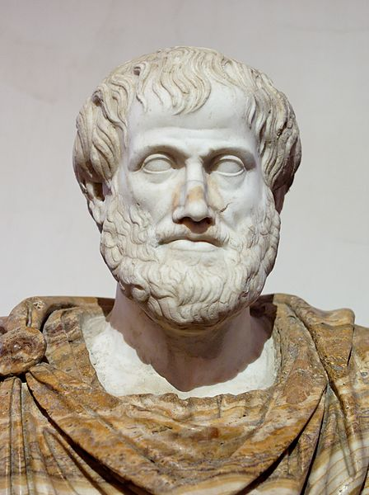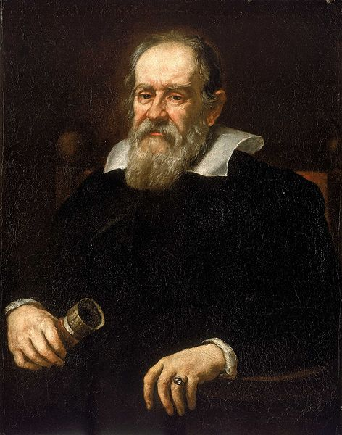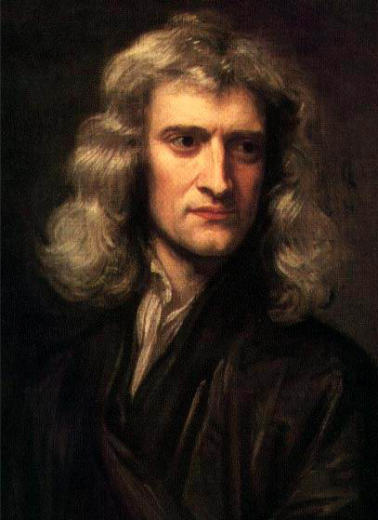
Replica Bust of Aristotle Portrait of Galileo Portrait of Newton
(384 – 322 BCE) (1564 – 1642) (1643 – 1727)
Photographs retrieved from the following web pages, respectively.
http://en.wikipedia.org/wiki/File:Aristotle_Altemps_Inv8575.jpg
http://en.wikipedia.org/wiki/File:Justus_Sustermans_-_Portrait_of_Galileo_Galilei,_1636.jpg
http://en.wikipedia.org/wiki/File:GodfreyKneller-IsaacNewton-1689.jpg
Galileo Galilei (1564 - 1642) is credited for arguing the constancy of velocity in the absence of external forces. He treated friction as a force which opposed motion, causing a deceleration. Thus, on a frictionless, infinite surface, Galileo proposed that an object would maintain a constant velocity in a straight line forever, provided it experienced no external forces. Identifying friction as the cause of objects to slow to a stop revolutionized the philosophy of motion. Motion in a straight line with constant speed became the standard behavior of objects rather than zero motion. Galileo's experiments with gravity quantified the acceleration of objects of equal size and different densities. Neglecting the force of the air, the acceleration experienced due to gravity is constant and independent of mass. These two premises were further refined in Newton's research.
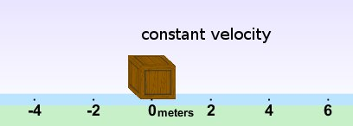
The surface in the above picture is ice, which is approximated as frictionless.
Galileo’s work on physics stated that an object will maintain a constant
velocity in the absence of external forces. Here, the wooden block has
zero velocity, and without an external force it will never change.
Image from Forces and Motion simulation
The modern equations of motion proposed by Sir Isaac Newton (1643 – 1727) in 1686 form the basis of classical mechanics, the body of knowledge still used to predict the behavior of physical systems today. For movement very slow compared to the speed of light (about 670 million miles per hour), these equations are an excellent approximation. Newton founded his model on three laws: first, an object or group of objects will maintain a state of rest or state of constant linear motion unless acted upon by a net external force; second, a force is any action or reaction which causes an object with mass to accelerate, and the force is equal to the product of the mass and the acceleration; third, for every action (force) acting on an object, there is an equal and opposite reaction (force) which is exerted back onto the body initiating the acceleration.
Newton's first law builds on Galileo's earlier work by noting that the total velocity of all objects in a closed system is not necessarily conserved, but the total momentum is. A closed system means that no energy is entering or leaving the system, so the system is isolated from external influences. This provides a good representation of a collision of two or more objects that are not under the influence of a force.
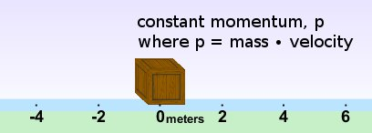
Newton’s formulation of Galileo’s earlier work states that
momentum is constant in the absence of external forces.
Image from Forces and Motion simulation
Newton's second law defines the force referenced in the second law. Earlier descriptions of force used various terms, so Newton had to specify that a Newtonian force is

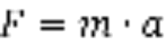,
Newton's third law states that any object which is pushed will react to being pushed. This reaction is a force applied back on whatever object initiated the push. If you push on an object, you feel the surface of the object. That sensation is due to the reaction force of the object resisting your push. The object resists your hand moving through the object just as much as your hand resists the object moving through your hand. The quantity, or magnitude, of force between any pair of objects is the same whether you look at the action force or the reaction force. The net force is the vector sum of all the forces acting upon an object. When the forces acting upon an object are in balance the net force is zero. If the forces acting upon an object are unbalanced the net force is nonzero.
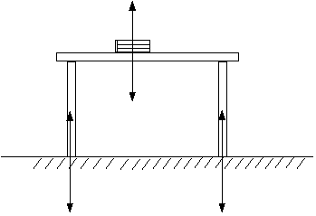
Diagram showing force pairs according to Newton’s Third Law
The force of the table on the floor is equal to the force of the floor on the table.
The force of the book on the table is equal to the force of the table on the book.
Middle School Level:
The way objects move and how their motion changes has been a topic of study in physics for a long time. In addition to many other things, Galileo Galilei (1564 - 1642) studied how objects slow down when moving on a level surface. He realized that there must be a force causing it – friction. Before Galileo, friction was not treated like a force. In fact, friction as we know it was not a part of science at all. When he realized that friction was a force, Galileo figured out that if friction was not present, an object would continue moving on a level surface forever at a constant rate. Since this rate is in fact velocity, this means that the velocity of the object would stay the same. The object’s motion would only change if it experienced a force.

v
Since the box above rests on a frictionless surface, approximated by ice,
and it has no net force applied to it, its velocity will remain constant
until it experiences a net force.
Image from Forces and Motion Basics simulation

Sir Isaac Newton (1643 – 1727) improved on Galileo’s study of motion and friction by finding out how multiple objects interact with each other. Newton realized that the effect of gravity was a force pulling all objects together. He published his findings and the mathematics he used to predict motion in 1686. In his book, Newton proposed that there are three laws of motion. His first law is that an object or group of objects will remain in motion or stay at rest unless an external force is applied. Newton’s second law defines a force as anything that causes an object to change the way it moves, in other words, a push or a pull. The third law of motion is best explained by using two objects in an example. If object A pushes on object B, object B resists the push. Object A experiences this resistance as a push (force), and the amount of force from B to A is the same as the amount of force from A to B. However, the force (push) of A on B is in the opposite direction as the force of B on A.

A B

Amount of Force from B to A = Amount of Force from A to B
This diagram shows Newton’s third law of motion.
Object A applies a force on object B, and object B resists.
The resistance is a force of the same magnitude, but opposite direction.

Using these three laws and some additional mathematics, Newton was able to predict many different types of motion. This was the start of our modern physics.
Adding up the forces acting on an object gives the net or total amount of force acting on an object. If the net force acting on an object is zero, then the forces acting on the object are in balance. If the net force acting on an object is nonzero, then the forces acting on the object are unbalanced.
VII. Possible Misconceptions

- Students may have trouble with the concept that an object slowing down has an acceleration. The key idea is that acceleration is the slowing down (deceleration) and speeding up (acceleration) of an object.
- Students may not think of friction as being a force. Friction is responsible for the slowing down of an object. It often is an unbalanced force that causes an object to come to a stop.
- When the students flick the playing card in Experiment 1, they may believe that they only apply a force to the card and not the penny, so the penny stays still until the card moves out from underneath it. In reality, the net or total force on the penny changes when flicking the playing card, both downward and sideways. Since there is not much friction between the penny and playing card, only a small amount of the force applied to the playing card is transferred to the penny. Since the net sideways force changes, even though it is very small, the penny moves in that direction. But since the force is very small, it does not move much. When the force of gravity is no longer balanced by the playing card, the penny drops down. Because the force of gravity is much greater than the sideways force from flicking the card, the direction of motion is mainly downward.

VIII. Vocabulary and Definitions

College Level:

- Force: an influence that causes an object to change direction or speed
- Gravity: a phenomenon that causes two bodies to attract with a force proportional to their mass
- Velocity: the rate of change of position of an object
- Acceleration: the rate of change of the velocity of an object
- Net force: the sum of all the forces acting on an object

Middle School Level:

- Force (fuerza): a push or a pull
- Gravity (gravedad): a force that causes two objects to come together
- Velocity (velocidad): how fast or slow an object is moving
- Acceleration (aceleración): how much an object is speeding up or slowing down
- Net force (fuerza neta): the sum of all the forces acting on an object

IX. Safety Considerations
- When students flick card in Experiment 1, ask them to flick card away from others.
X. Question of the Day
- How can forces affect the motion of an object?

FIVE-E ORGANIZATION
Engagement |  | Time: 5 minutes
What the Teacher Will Do | Probing Questions | Student Responses  Potential Misconceptions
Today we’re going to start by viewing a few video clips. Pay attention to the motion of the people in the video clips.  Play video clips for students.  Bow and Arrow:  http://youtu.be/BWZ4WJQ-624  Triple Jump: http://youtu.be/zCvFz1oCNQ4  Motorcycle Coming to Stop:  http://youtu.be/Mk7b2oWQPR0  In the bow and arrow video, the man pulls back the bow and the arrow is shot. In the Triple Jump, the jumper sprinted as fast as he can to jump a long distance. The motorcyclist applies the brakes to make the motorcycle come to a stop.  Correct, a force was applied in each video clip to cause a change in the motion of an object. Recall, a force is a push or pull, which has both magnitude (size) and direction.  Today we are going to be investigating our Question of the Day: “How can forces affect the motion of an object?”  Post Question of the Day on the board. | - What did you observe in each video clip?  - What did the person do in each clip?  - What did archer provide when he pulled back the bow?  - When the motorcyclist stopped his motorcycle what did the brakes provide?  - What did the jumper’s legs provide? | - Bow and arrow, long jumper landing, motorcycle coming to immediate stop (i.e. slam brakes)  - Person shooting arrow from bow, jumper sprinting fast and jumping as far as he can into the pit of sand, motorcycle engine moves it and brakes help it come to a halt.  - A force.  - A force.  - A force.

Exploration |  | Time: 30 minutes
What the Teacher Will Do | Probing Questions | Student Responses  Potential Misconceptions
Optional History Section (20 minutes)  To begin our lesson on forces and motion, let’s briefly discuss some history. We have observed in class that all objects fall at the same rate if there is little air resistance.  Galileo Galilei was a philosopher in the late 1500s and early 1600s that discovered the idea that objects fall at the same rate with little air resistance and found that objects have a constant acceleration due to gravity on earth. Show image of Galileo Gailei. However, scientists thought that our gravity was something unique to earth.  Some people that that if objects experienced gravity somewhere else the gravity would be different. Sir Isaac Newton, a philosopher in the 1600s, developed an equation that determined the force of gravity everywhere in the universe. Show image of Sir Isaac Newton. In order to describe gravity, he realized he needed to describe what forces are and how they relate to the motion of objects.  Excellent! Those are all great examples of Newton’s Laws of Motion.  I want everyone to pick up a small object off your desk and stand up as we attempt to release the object from our hands. Ready ‘1…2…3’, release the object! Now, everyone pick up your objects and put them back on your table.  The floor caused the object to come to a stop (or rest); otherwise, Newton claimed the objects would fall directly towards the center of the earth.  Thus, the ground must provide an upward resistance to the motion of the object. In our case, the floor provided this force. After the object makes contact with the floor, the object comes to a rest (or stop).  Those are all great examples of objects that are at rest.  Great answer! An object that is still and not moving is at rest.  Right! The forces are balanced. When our objects hit the floor, the ground provided an upward force, while gravity produces the downward force. These forces are in balance after the object hits the floor because the object has come to rest.  We can add up the forces on an object. This can give us a better idea of if the forces acing on an object are balanced or unbalanced. Forces in opposite directions have opposite signs. We call the sum of all the forces acting on an object the net force or total force. The net force tells you what the total force on an object is.  If the sum of all the forces is zero, the forces are balanced. If the sum of all of the forces is not zero, then the forces are unbalanced. Write this in your science journals.  Give an example, if necessary.  Today, we will experiment with Newton’s first law in various applications and then test it in a computer simulation.  End Optional History Section  Experiment 1:  Do experiment either as a demonstration or have the students work in pairs.  Pass out “Forces and Motion  Experiment” Sheet.  The first experiment we are going to look at will relate to Newton’s First Law of Motion.  Here I have a penny on top of a playing card resting on top of a cup. I’m going to flick the playing card and I want you to make a few observations.  Quickly flick the playing card.  Let’s talk about the forces acting on the penny. Answer the four questions on your sheet with your partner. Give students two minutes to answer questions.  Although gravity was acting on both objects, gravity was the most significant force acting on the penny. The person that flicked the playing card provided another force that caused the playing card to be moved out from underneath the penny. Keep in mind the person only flicked the playing card not the penny.  Newton’s first law says that an object in motion will remain in motion until it’s acted upon by some force and an object at rest will remain at rest unless acted upon by an outside force.  This short experiment relates to Newton’s First Law of Motion because an outside force did not act on the penny so it remained at rest. By flicking the playing card, a force was applied to the playing card so it moved.  It is important to note that the penny does move slightly forward, but gravity is a more significant force and pulls the penny into the cup.  Today, we’re going to use a computer simulation so we can see all of the forces acting on an object. These forces will appear as arrows in the simulation.  Have computer simulation loaded on projector in front of the class.  Take the next five minutes to explore the simulation.  Pass out “Forces and Motion PhET Simulation” Worksheet. Give students a few minutes to push the crate back and forth and answer the key terms on the top of their sheet.  After a few minutes, select a couple students to share what they have discovered and go over key terms, if needed.  Make sure students mention: 1. “Reset All” button  2. How you can enter in a force then press enter and the crate will move  3. How you can click and drag the box  Now that we have an understanding of how the simulation works, I want you to complete the rest of the sections in your “Forces and Motion PhET Simulation Sheet.” Be sure to write in complete sentences.  Give students 30 minutes to complete all sections.  Possible Probing Questions while students are exploring: | - Where have you heard of Galileo before?  - What do you think it would mean if gravity was unique to Earth?  - What Newton is famous for?  - What are a few of Newton’s Laws?  - What force was responsible for pulling the objects we dropped to the ground?  - And what is gravity?  - Why didn’t the objects keep on falling?  - What are a few objects around the room that are at rest?  - How would you define at rest?  - When an object is at rest are the forces balanced or unbalanced? Why?  - If there are balanced forces on an object, what would we get if we added up all of the forces?  - If the net force is zero, are the forces balanced or unbalanced? Why?  - If the net force is not zero, what does that tell you? Why?  - What observations can you make about the penny resting on the playing card?  - Are the forces balanced or unbalanced?  - What happened?  - When I flick the playing card, what am I applying?  - When I apply a force, by flicking the playing card, are the forces acting on the playing card balanced or unbalanced? Why?  - What force acted on the penny?  - What is the net force on the penny before I flick the playing card? As it falls into the cup?  - In this experiment, what was at rest and when was it at rest?  - In this experiment, what was in motion and when was it in motion?  - How does Newton’s First Law relate to what we just saw when we flicked the playing card?  - How is the simulation similar/different from real life?  - What are a few limitations of the simulation?  - How do you think friction affects the motion of an object?  - Give an example of a scenario where you experienced what is happening in the simulation.  - If you wanted to push something very far with little force, what surface would you prefer?  - Besides ice, what is another example of a surface little friction? What do we use that surface for?  - How does the size of the push relate to the acceleration of the crate?  - When do you think simulations are useful for scientists?  - How could you design an experiment to test what you see in the simulation? | - He’s a scientist. He’s old. His study of the planets.  - It’s only on Earth. Somewhere else there is a different gravity.  - Three laws of motion and talking about gravity.  - An object at rest stays at rest, for every action there is an equal and opposite reaction, etc.  - Gravity.  - A force.  - The ground caused the objects to come to a stop (or rest).  - Books on the table or the tables themselves.  - Not moving.  - Balanced.  - Nothing, zero.  - Balanced. Because the forces are in opposite directions.  - That the object may be moving.  - It is stationary, not moving.  - The forces are in balance, because objects are at rest.  - The penny fell in the cup! The playing card went flying!  - A force.  - Unbalanced. Because the playing card moves.  - Gravity. The playing card being flicked did a little bit.  - Zero. Nonzero.  - The penny before and after the card was flicked. The playing card before and after it was flicked.  - The playing card after flicking it. The penny when it moved downward.  - There was a force applied to the playing card that caused it to move forward which was provided by your finger. Once you flicked the card, it moved out from under the penny and the penny dropped to the bottom of the cup due to gravity.  - The simulation shows arrows that can’t be seen in real life. The simulation uses similar materials to what we could do an experiment with.  - The simulation doesn’t show all of the forces that might act on an object.  - Friction slows an object down.  - Sliding across the floor with socks.  - Ice.  - Air hockey table, metal (slides on playground), etc.  - Bigger push results in a greater acceleration.  - To show things that can’t be seen, to do lots of trails.  - Various answers.

Explanation |  | Time: 15 minutes
What the Teacher Will Do | Probing Questions | Student Responses  Potential Misconceptions
Let’s discuss our results from our exploration.  Negative values appear when we push the crate to the left, because we use a Cartesian-coordinate system to plot and justify positive/negative values, the right corresponds to a positive direction while the left corresponds to a negative direction.  Correct, we have arrows pointing in opposite directions. These arrows represent the forces acting on an object. These forces (or arrows) are very important when studying what happens as we push the crate.  The simulation doesn’t show the force of gravity or the force of the ground pushing up on the crate.  The force that opposes motion is friction and you saw that it points in the opposite direction of the motion of the object.  The crate is in motion so the forces are unbalanced and we saw that there was a total force arrow present. Because this arrow is on the screen we know that the net force on the object is nonzero. Remember that the simulation shows the net force as the total force arrow.  As we noted earlier, the forces acting on an object are in balance if that object is at rest or not accelerating. In our case, even though we were increasing the amount of applied force, the box still remained at rest until a certain amount of force was reached.  At the beginning, the object moves in the direction of the total force arrow. This is because there must be enough force present to overcome the force of friction (the force in the opposite motion of the applied force). However, the object slows down when friction overcomes the motion of the object and the total force arrow points in the opposite direction of the motion of the object.  Since ice is an almost frictionless surface, the simulation treats ice as a frictionless surface. We do not have friction acting on the crate.  The object doesn’t slow down in the simulation because friction isn’t present. Friction opposes the motion of an object by slowing it down.  Exactly, that is Newton’s First Law of Motion, which is an object at rest remains at rest unless acted upon by an outside force and an object in motion remains in motion unless acted upon by an outside force.  Exactly, a small force, or push, results in a slower change in the objects speed.  Correct, a large force, or push, results in a greater change in the objects speed.  Correct, the amount of force applied affects how fast or slow an object changes speed. In other words, if acceleration is defined as how fast an object changes speed, then a greater force causes greater acceleration, while a smaller force causes less acceleration.  Let’s go back to our Question of the Day: “How can forces affect the motion of an object?” In your pairs, come up with three ways forces can affect the motion of an object.  Call on students for responses. Make sure students include: force, balanced and unbalanced, speed, friction and acceleration in their discussion.  Now that we have experimented with computers, lets discuss the impact of computers during this lesson. Scientists use computer simulations, like the one we used today, to predict how objects would behave when an outside force is applied.  I want you to turn to your partner and discuss three advantages of using a computer simulation and three disadvantages to using a computer simulation. Think about how the computer simulation was different from our demos.  A few of the advantages of using the simulation are that it allows us to view the forces acting on an object. We also don’t have to have all the materials in front of us. We can model different aspects that we may not be able to in the classroom (such as, using ice).  Disadvantages include that the simulation doesn’t consider some of the forces that are acting on the object. An example would be that it doesn’t take into account air resistance. | - What did you notice appear on the screen as you attempt to push the box?  - As you pushed the crate to the right, did positive or negative values appear in the force dialog box?  - How about as you pushed the crate to the left?  - Why do you see negative values?  - What more can you tell me about the arrows, such as, the length or direction of them?  - What force(s) are not shown on the simulation?  - As you slowly drag the mouse, what do you notice about the length of the Applied Force and Friction Force?  - What did you notice about the length of the arrows once you’ve applied enough force to push the crate?  - How do you think the simulation shows the net force?  - If the forces are unbalanced, what do we know about the sum of forces?  - Are the forces in balance or unbalanced when the crate moves? How do you know?  - How does the direction of the total force arrow relate to the direction the crate moves?  - When the surface is ice what force is missing from when the surface was wood?  - How is the motion of the crate different when ice is the surface? Why?  - If the brick walls weren’t there what do you think would happen to the motion of the crate?  - If the brick walls were not there anymore, what would the motion of the crate look like?  - How much does the crate’s speed change when providing a little force?  - Why is there not much change in the object’s speed when a small force is applied? What evidence do you have? Explain.  - How much does the crate’s speed change when providing a big push? What evidence do you have? Explain.  - Why is there such a large change in the object’s speed?  - What general statement can we make about the relationship between the applied force and how fast an object changes speed?  - What advantages do you think the simulation has?  - What are a few disadvantages? | - Arrows.  - Positive values.  - Negative values.  - Because the box was moving to the left.  - The applied force arrow is pointing in the direction of the push. The friction force arrow is opposite of the applied force arrow.  - The force of gravity, a force pushing up.  - Both arrows appear to get longer.  - The applied force arrow (orange) is now longer than the friction force arrow (red).  - With the sum of forces.  - They are not zero.  - Unbalanced because an unbalanced force results in the movement of an object. The net force is not zero.  - The object moves in the direction of the total force at first, then slows down when the total force arrow changes.  - Friction force.  - The object doesn’t slow down.  - It would continue going!  - The object would continue to move.  - A small force or push resulted in a slower change in the objects’ speed.  - We only provided a small force.  - Largely. There is a large change.  - We provided a big push, or a much larger force.  - A small applied force causes a slower change in the object’s speed. A large applied force causes a faster change in the object’s speed.  - We can view the forces on an object as they are represented by arrows. It also allows us to use materials that we don’t have in our classroom.  - It doesn’t consider some of the forces that can act on the object. It can be difficult to use.

Elaboration |  | Time: 10 minutes
What the Teacher Will Do | Probing Questions | Student Responses  Potential Misconceptions
Let’s relate forces to a current event.  Teacher begins “Turkey Earthquake” PowerPoint.  Recently, on October 23rd, a strong earthquake hit Turkey.  Show Slide 2.  Tectonic plates colliding cause earthquakes.  Show Slide 3. Point out different tectonic plates.  The Arabian plate pushing against the Eurasian plate caused the earthquake. The earthquake had a magnitude of 7.1 so it was a relatively strong quake.  Show Slide 4.  The earthquake was in eastern Turkey in the city Ercis  Show Slide 5.  Here is an image of a “shake map.”  The different colors represent how strong the “shake” could be felt. This map looks similar to a weather map you might see on the news or on the Internet. The orange areas are where severe shakes were felt and the green is where a very light shake was felt.  Earthquake engineers are responsible for constructing buildings that can withstand earthquakes. Although building designs have progressed a lot in the past century, the earthquake in Turkey caused many buildings to collapse.  Show Slide 6.  According to the Washington Post, two thousand buildings have collapsed and thirty seven hundred are unfit for habitation.  Now we are going to model an earthquake with blocks and cardboard.  I want you to make three buildings of different sizes. Each row of blocks will represent a story on a building.  You will construct your tower on top of a cardboard box and then you will “shake the ground” by moving the cardboard box slowly back and forth. In your science journals, please record your observations. | - Where is the country Turkey?  - What do you think causes earthquakes?  - What two plates on this map could have been responsible for the earthquake in Turkey?  - What do you think the different colors represent?  - What do you think an earthquake engineer does?  - What could I do with the cardboard and the blocks?  - What could the rows of blocks represent?  Questions to ask as students build their earthquakes:  - When are the forces balanced and unbalanced during your earthquake?  - What did you notice about how the size of the tower relates to the movement of the tower?  - What forces are acting on the tower before you pull the cardboard?  - How is this model similar/different from a real earthquake?  - What changes could you make to your tower design so that it doesn’t fall?  - What type of material do you think would be best for an earthquake? | - Europe, near Africa, near Asia.  - Tectonic plates colliding.  - The Arabian and Eurasian plates.  - How the earthquake felt, it’s a key.  - Design things to withstand earthquakes.  - Model an earthquake!  - Different floors, different buildings.  - Unbalanced.  - Answers vary on student designs.  - Gravity and upward force from the table.  - The blocks aren’t attached to each other like in a real building. There might be buildings beside the other buildings that will bump into them.  - Connect the blocks, use other materials.  - Something that isn’t rigid and could bend. Something that is sturdy, etc.

Evaluation |  | Time: 5 minutes
What the Teacher Will Do | Probing Questions | Student Responses  Potential Misconceptions
Pass out “Evaluation Questions.”

Name: _____________________
Forces and Motion Experiment
Materials
- 1 playing card
- 1 cup
- 1 penny
Procedure
- Set the playing card on top of the cup.
- Set the penny on top of the playing card.
- Flick the playing card.
- Observe what happens!
Questions
- What force(s) acted on the playing card?
- What force(s) acted on the penny?
- In this experiment, what was at rest?
- In this experiment, what was in motion?

- Why didn’t the penny move sideways as much as the card?

Newton’s 1st Law:
An object at rest remains at _______ unless acted upon by an ______ force and an object in motion remains in _______ unless acted upon by an ______ force.

Name: ________________________
Forces and Motion Basics PhET Simulation

1) Fill in the following blanks with your partner.
a) The total force is the _______________ of all the forces.

b) An object’s acceleration is an object’s _____________ in speed.

c) Friction is a force that ________ the motion of an object.

2) Play with the simulation for five minutes. Be prepared to share what you have discovered!

3) a) Explore how the “Applied Force” and “Friction Force” arrows change as you apply different amounts of force.
b) Use the table to record your observations.

How much force is applied? | Is the applied force larger, smaller or equal to the friction force? | The forces on the crate are…  (circle one) | Observations – what evidence do you have for your selections?
balanced
unbalanced
balanced
unbalanced
balanced
unbalanced

4) a) Explore how the “Total Force” arrow depends on how the crate moves.
b) As the object moves, what happens to the total force arrow?
__________________________________________________________________
__________________________________________________________________
__________________________________________________________________
5) a) Explore what happens when you change the surface.
b) Fill in the table with your observations.

Surface | Observations
Ice (no friction)
Friction

c) The simulation assumes that ice is a frictionless surface. To have a truly frictionless environment what else would you need to consider?
__________________________________________________________________
__________________________________________________________________
__________________________________________________________________
6) a) Explore how the crate’s speed changes as you apply more and less force to the crate.
b) Fill in the table with your observations.

Size of push | Amount of change in speed  (circle one)
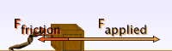 | large change in speed  small change in speed
 | large change in speed  small change in speed

c) What can you say about how the amount of force applied affects an object’s acceleration?
__________________________________________________________________
__________________________________________________________________
__________________________________________________________________

Name: _________________________

Forces and Motion Evaluation Questions

1. When the forces on an object are balanced, what is the total force?
a) 1 Newton to the left.
b) 1 Newton to the right.
c) Unable to determine without knowing the forces involved.
d) 0 Newtons.

2. An object experiences a force of 5.0 Newtons pushing towards the left and a force of 5.0 Newtons pushing towards the right. These forces are
a) balanced.
b) unbalanced.
c) complimentary.
d) inverse.

3. An object is initially at rest on a frictionless surface. We apply a force of 1.0 Newton to the right. What happens?
a) The object was not moving, so it starts moving to the right.
b) The object pushes back with a force of 1.0 Newton, so nothing happens.
c) The object moves to the right and will continue to move to the right at a constant speed.
d) The object slows down while moving to the right.

4. The table below shows the acceleration of a 50kg crate in response to applied forces. Identify which acceleration should be used in the missing spot.

a) 0 m/s²
b) 0.67 m/s²
c) 7.02 m/s²
d) 1.33 m/s²

Applied Force (N) | Acceleration (m/s²)
0.5 | ?
1.0 | 2.67
2.0 | 5.33
3.0 | 8

5. To test how an object moves without friction, you must
a) make sure the object does not touch anything (including air).
b) put the object on ice.
c) take away friction by lubricating the surface the object is on.
d) make the object move very fast to reduce the effect of friction.

6. How did Galileo’s study of motion differ from Newton’s? Why do we use Newton’s physics today instead of Galileo’s?

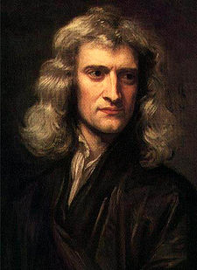
Photo of Sir Isaac Newton. Source: http://www.newton.ac.uk/art/portrait.html

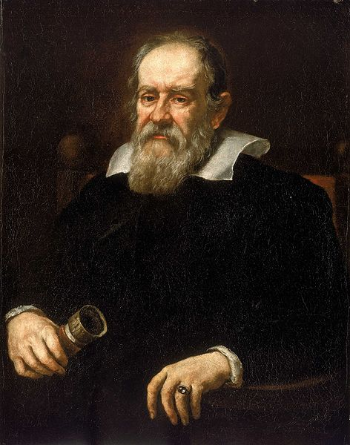
Photo of Galileo Source: http://www.nmm.ac.uk/mag/pages/mnuExplore/PaintingDetail.cfm?ID=BHC2700

Question of the Day
How can forces affect the motion of an object?

Name: ________KEY_________
Forces and Motion Experiment
Materials
- 1 playing card
- 1 cup
- 1 penny
Procedure
- Set the playing card on top of the cup.
- Set the penny on top of the playing card.
- Flick the playing card.
- Observe what happens!
Questions
- What force(s) acted on the playing card?
Gravity, my hand.
- What force(s) acted on the penny?
Gravity, the playing card transmitted a small part of the force from my hand.
- In this experiment, what was at rest?
The cup, playing card and penny before I flicked, the cup when I flicked the playing card, and the cup, playing card and penny after they fall.
- In this experiment, what was in motion?
When I flicked the playing card, the card and penny were in motion. They stayed in motion until they hit the ground.

- Why didn’t the penny move sideways as much as the card?
The friction between the penny and card was small, so only a small amount of the force of my hand was transmitted. Since it was a small amount of force, the penny only moved a little.

Newton’s 1st Law:
An object at rest remains at _rest__ unless acted upon by an _unbalanced_ force and an object in motion remains in _motion_ unless acted upon by an _ unbalanced _ force.
Name: __________KEY______________
Forces and Motion Basics PhET Simulation

1) Fill in the following blanks with your partner.
a) The total force is the ____sum________ of all the forces.

b) An object’s acceleration is an object’s ____change___ in velocity.

c) Friction is a force that _reduces_ the motion of an object.

2) Play with the simulation for five minutes. Be prepared to share what you have discovered!

3) a) Explore how the “Applied Force” and “Friction Force” arrows change as you apply different amounts of force.
b) Use the table to record your observations.

How much force is applied? | Is the applied force larger, smaller or equal to the friction force? | The forces on the crate are…  (circle one) | Observations – what evidence do you have for your selections?
200 Newtons | Equal to the friction force, in the opposite direction. | balanced  unbalanced | The box doesn’t move, and the total force arrow is zero.
-400 Newtons | Equal to the friction force, in the opposite direction. | balanced  unbalanced | The box doesn’t move, and the total force arrow is zero.
500 Newtons | Greater than the friction force, in the opposite direction. | balanced  unbalanced | The box moves, and the total force arrow points to the right.

4) a) Explore how the “Total Force” arrow depends on how the crate moves.
b) As the object moves, what happens to the total force arrow?
__If the crate isn’t moving, the total force arrow is zero. The force arrow points to the right if a positive force is applied and the object is moving. It points to the left if a negative force is applied and the object is moving. When we stop applying the force, the force arrow points in the opposite direction of motion, and is the same size all the time._______________________________________

5) a) Explore what happens when you change the surface.
b) Fill in the table with your observations.

Surface | Observations
Ice (no friction) | Any force will cause the crate to move and it only stops if it collides with something else.
Friction | The crate must get a certain amount of force to start moving and when the force stops, friction causes the crate to slow down.

c) The simulation assumes that ice is a frictionless surface. To have a truly frictionless environment what else would you need to consider?
The object touches nothing._________________________________________
__________________________________________________________________
6) a) Explore how the crate’s speed changes as you apply more and less force to the crate.
b) Fill in the table with your observations.

Size of push | Amount of change in speed  (circle one)
large change in speed
small change in speed
large change in speed
small change in speed

c) What can you say about how the amount of force applied affects an object’s acceleration?
__The greater the unbalanced force applied on an object, the greater the acceleration of the object.____________________________________________
__________________________________________________________________

Name: _________________________

Forces and Motion Evaluation Questions
Key – numbers reference learning goal #

1. When the forces on an object are balanced, what is the total force? (3)
a) 1 Newton to the left.
b) 1 Newton to the right.
c) Unable to determine without knowing the forces involved.
d) 0 Newtons.

2. An object experiences a force of 5.0 Newtons pushing towards the left and a force of 5.0 Newtons pushing towards the right. These forces are (1)
a) balanced.
b) unbalanced.
c) complimentary.
d) inverse.

3. An object is initially at rest on a frictionless surface. We apply a force of 1 Newton to the right. What happens? (2, 4)
a) The object was not moving, so it starts to move towards the right.
b) The object pushes back with a force of 1 Newton, so nothing happens.
c) The object moves to the right and will continue to move to the right at a constant speed.
d) The object slows down while moving to the right.

4. The table below shows the acceleration of a 50kg crate in response to applied forces. Identify which acceleration should be used in the missing spot.

a) 0 m/s²
b) 0.67 m/s²
c) 7.02 m/s²
d) 1.33 m/s²

Applied Force (N) | Acceleration (m/s²)
0.5 | ?
1.0 | 2.67
2.0 | 5.33
3.0 | 8

5. To test how an object moves without friction, you must (5)
a) make sure the object does not touch anything (including air).
b) put the object on ice.
c) take away friction by lubricating the surface the object is on.
d) make the object move very fast to reduce the effect of friction.

6. How did Galileo’s study of motion differ from Newton’s? Why do we use Newton’s physics today instead of Galileo’s? (6)
Galileo thought the gravity he measured on Earth was unique; Newton showed that the force of gravity could be calculated for any place in the universe. Newton’s physics applies to more situations, which is why we use it.

