Pre-lab for Build an Atom name: _____________________

- Draw a picture of how you would build a model atom in the box below:

X

Put the following subatomic particles in the model:

3 protons
4 neutrons XX
- electrons

- Circle which element this atom is on this periodic table below:
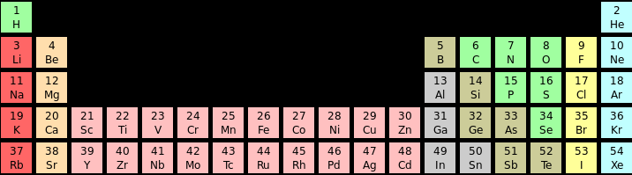

- The mass of this atom is:
- 3 atomic mass units I chose this answer because_______
- 4 atomic mass units _______________________________________
- 7 atomic mass units _______________________________________
- 10 mass units
C. I can change the type of atom by adding: _________________
For questions 4-6, Use these words:
proton
neutron
electron

D. I can change the charge of a specific atom by adding: ______
E. I can change the mass of a specific atom by adding: ______
- I want to build a model of a gold atom (Au). I will need to:
  - Add equal numbers of protons and electrons (based on the periodic table)
  - Add equal numbers of protons and neutrons (based on the periodic table)
  - Just be sure that anything I add goes into the right space.

