6. 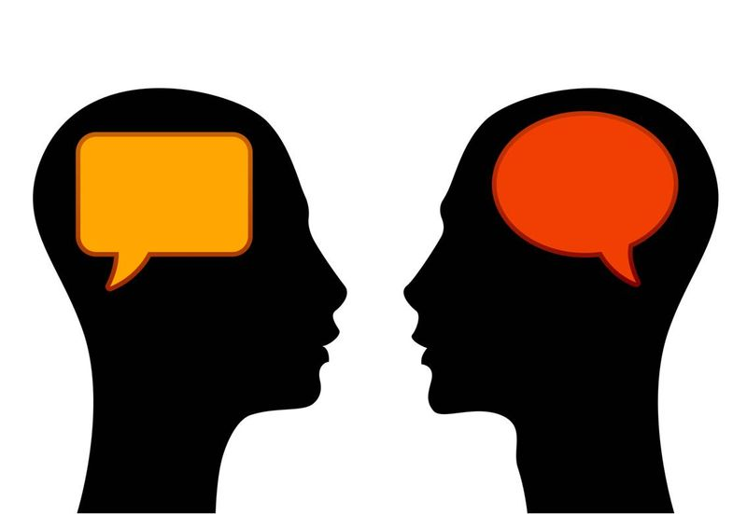 Experiment by putting some protons into the nucleus of the atom (on the X).
Getting Started Together…
Mass number? | Charge? | Stays on the X?  Yes or no | Symbol changes on the periodic table?
H
Does it add one (+), subtract one (-) , or change nothing?

Fill in the table to the right to keep track of what you are learning about
protons.
When you finish, put the protons back into the bowl.

