Student Guide for Density Simulation: Name: _________________
(note: “sink” means stays on the bottom)
Start: 1.
Google: Phet Density sim
2. Click on the first link
3. Click on the button
4. Experiment with choosing a material:
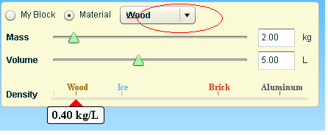
material | S=sinker  F=Floater | Density given
Put the materials in the correct boxes

- Try to get aluminum to float. Talk with your partner about this possibility- can you change the mass of the aluminum block without changing the volume of the aluminum block?
- What do you and your partner notice about the density triangle at the bottom of the box? Why do you think this does or does not move?
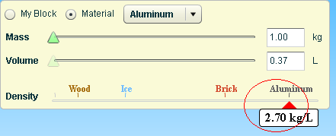
- How does the density of aluminum (2.70 kg/L) help explain what you see?
_________________________________________________________________

Frame: The aluminum will _______________ in the water because the density of the aluminum is _______kg/L____ and the density of water is _________kg/L_. We have learned that ________________________________________________________
8. Density = ---------- “_______ over ______ equals _______________”

In the “Blocks” box, click on Mystery:
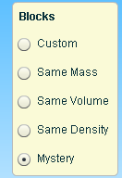
Test the boxes in the water- just drag and drop!!!

When you have determined which ones sink and float, fill in the data table for each box.

Sample | Starting volume of water (A) | volume of water and block (B) | Volume of block alone  (difference B-A) | Mass (kg) | Density (kg/L) | What is it most likely made of? (hint: use Show Table for help)
A | 100-L
B | 100-L
C | 100-L
D | 100-L
E | 100-L
- Look closely at green box C and red box D and discuss your observations.
List three observations you made while comparing the two boxes.

1st observation | 2nd observation | 3rd observation

- Dear Students,
I am going to build a boat. My partner says I cannot put a refrigerator and a television in my boat because that would make it too heavy-and the boat might sink. Then we would be swimming with the sharks!!!!

What would you advise me to tell my friend? Is she right or wrong? Be sure to give me some evidence based on what you learned from the boxes or other places in this activity.
__________________________________________________________________________________________________________________________________________
…you can write on the back if you need more room to write! Signed, your teacher

