Table of Contents for Density lesson (Jackie Esler activity):
- Connection with Boulder Valley School District Standards/Essential Learnings
-Teacher notes/lesson plan
- Ideas for Pre-teaching density
- Pre-simulation assessment
- Student Guide for use during simulation
- Enrichment/Additional activity/extension homework

Guiding Question: What do I need to consider when predicting if matter will “Sink” or “Float” in water? (note: “sink” means stays on the bottom)
Learning Goals: Students will be able to:
- Explain how to do science experiments with a PhET simulation.
- Investigate relative density (sink or float) by looking at a cube’s properties (mass and volume, material)
- Design an experiment and use a data table to keep track of their experimentation with “mystery” objects.
Background:
This is the first simulation I do with my students. It is within the first 3 weeks of school. I have already done the lessons outlined in other documents and we go, as a class, to the computer lab. Students are working with a partner or group of 3. Some middle schoolers work better alone this early in the year and, if possible, I let them work alone “next to” someone. I like to establish the “partner” aspect of lab work early, since it is important for collaborative work.
 indicates students write a response  indicates students discuss with partner
Teacher notes
- When students first try to “sink” the floaters they will not be able to. As they change the mass the object will “take up more/less space” or change volume. This is complicated for students without a decent understanding of proportional change, but worth pointing out that density is more than just how “heavy” the object is.
- Students will need to be in the correct mode to complete the part of the activity that involves filling in the data table. Remind them to match the picture on their student-guide to the screen on the simulation.
- 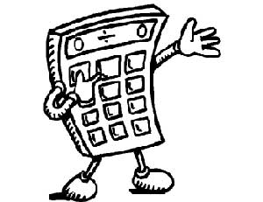I allow students to use calculators while calculating density. I give them many opportunities to think about numbers and work with units both with and without calculators. Students can find a calculator under the accessories link on the computer, or you can supply them.
- I have included an additional assignment/enrichment activity for more depth and using another simulation. Enrichment/extension/homework

