Inquiry based lessons to develop the concept of density before doing the simulation:
- Introduction of concept: Density is a characteristic property of matter. It can help identify a substance – for example a real gold stature versus a fake! When we know the density of matter we can predict how it will behave when mixed with other matter having a different density.
Personal note: I introduce the jingle: “M over V equals density” and use hand signals like the old classic “YMCA” song. I have them make an M with their hands on the top of their head and then divide it into a V and there you have it…M÷V = density
As part of the introduction process, I challenge my students with two questions (I call them research questions (RQ’s)) that we will discuss as a class at the end of the first lesson:
1. Why would it be important for scientists/people to know how matter will react when mixed with other matter? -answers vary and I come back to this at the end.
  - My focus is on the properties of matter- but often we end with things like it might blow-up, hurt someone, or “end up like the Titanic”- sink. This unit is at the beginning of the year so my middle school students are often less willing to try out their more creative thoughts in the discussion format.
2. Is density a measurement of matter or a calculation? What evidence supports your choice?
Personal note: My teaching objectives are broad and hit new material as well as review since it is the beginning of the year. They include: accurately measuring mass and volume using balances, rulers and graduated cylinders, review/introduction to the metric system, lab and lab equipment use and safety rules, and collaborative work with partners and small groups. I spend a fair amount of time with the density unit because I can touch on all of these things and fill in gaps that some students have in the scientific nature of measurement and density.
- *“Frame:” is used for scaffolding and to facilitate written response for English Language Learners. It guides the thinking to the type of answer I am expecting. I include it and explain to students that they can use it or not. It is great for some students and very frustrating for others. As the year goes on I am able to use it less, and it disappears by the end of the year.
- Activity Day I,II and III I use three hands on activities to introduce the concept with minimal lecture. For each day/lesson, I typically pose a research question to guide their work and give them a pre-assembled “kit” with the necessary daily supplies.
Each activity typically takes a full 50 minute class period for me and if we do not finish the instructions at the end of the class (our wrap-up) are to make a note in their notebook and begin there the next day.
- Activity #1, I keep the objects in a separate container so students can select (3) objects of choice to measure and calculate density. Samples include regular objects like marbles, dice, small boxes and irregular objects like Monopoly pieces, their pencils etc. – whatever I can find around my lab that will fit in my plastic graduated cylinders. Students make data table in notebook. I project the following example on the board to remind them of which tool to use for each type of measurement.
Sample data table:
Object | Mass (g) 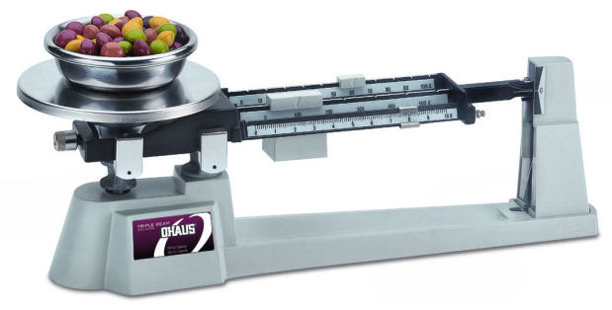 | Volume (cm₃) Formula: _______  Or volume (mL) 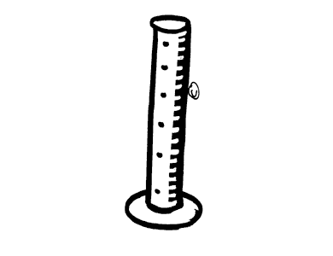 | Density (g/mL)
Regular - ________
Irregular-________
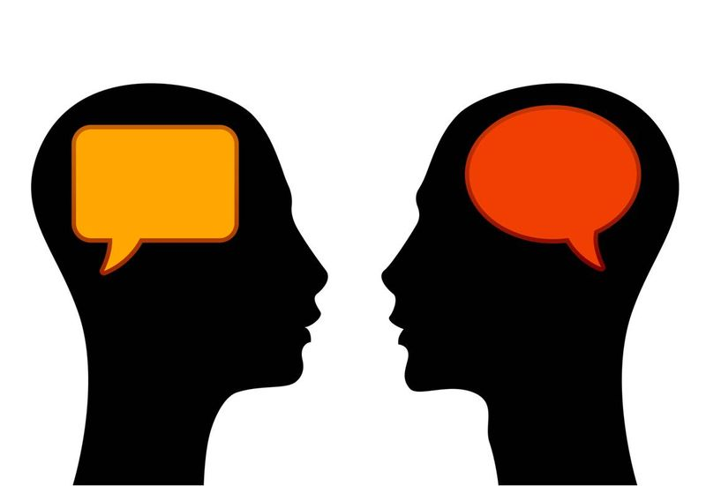 Discussion: 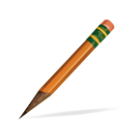 Wow! Mass seems pretty easy to find. I just put the object on the _____________ and move the pieces on the arm. Record the __________ and add the units-which are ________.
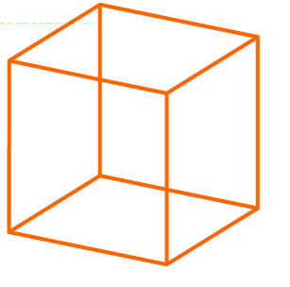
Volume is another matter. There are __________ different ways we measured volume. Explain or draw a picture to show the two different ways you might find the volume of a cube.

Which method is better to use and why do you think so?

*Frame: I think using the ruler is better when ____________________________________ The graduated cylinder or displacement of water would be better for ______________________
- Activity 2, I add laminated density charts to the daily supplies and have each group select an aluminum nail and a steel nail from the supplies I set up.
  - They could also look up the density in a book or in the internet.
  - I give a quick introduction to the chart, pointing out that this is a short list and that all elements have their own density. I introduce the idea of density as a property; it is one feature that helps us identify a type of matter.
  - Once they calculate the density, they can compare their result to the chart and see if they can identify the type of metal-material from which each nail is made.
Object | Mass (g) | Volume (cm₃) | Density (g/mL) equation:_________ | Material that nail is made of:
Nail #1
Nail #2
Discussion: I am building a small boat where the lighter and faster boat will be the winner in the town’s yearly race. I found two kinds of nails in my garage that I thought I could use to save some money on my project. The problem is, I don’t know which one would be better to use. I have the old boxes and one says they are made of iron and the second box says they are made of aluminum. What do I need to consider in making this decision?

*Frame: I would use the _________ nails because _________________
- Activity 3 - Density of water (find the mass of 1-mL of water, 10- mL of water and 50-mL of water and calculate density of each (approx. 1.0-g/mL)
Purpose is two-fold: (1) establish the density of water and, (2) set up the notion of relative density; why matter might sink or float in water.
Materials include the balance, graduated cylinder and water samples (I use small Gatorade bottles re-labeled as “water”- this way I can put them in group bins ahead of time –to alleviate the congestion at the sink, and the screw on caps keep them from spilling. Discussion on how to measure the mass of a liquid on a balance might be necessary. I use the difference between the mass of the graduated cylinder full of the desired volume of water and the empty cylinder. I use the same type of cylinder for all students and put the number of mine on the board so they can compare their measurements to my numbers.
Object | Mass (g) | Volume (cm₃) | Density (g/mL) equation:_________
water |  | 1-mL
water |  | 10-mL
water |  | 50 - mL
Discussion: Tell me about the mass of the three samples.
Does the same pattern fit the volume measurements?
Look down the density column for the three different samples of water. What do you notice about the numbers you calculated?

*Frame: The mass for 1-mL of water is _____________, the mass for 10-mL of water is ________, and the mass for 50-mL of water is _______________. As I look at the mass column, I notice _____________________
When I look at the volume column right next to it, I noticed that the volume ________________
The density column is interesting because __________________________________________

Next…on to the simulation
After the Sim-activity:
- Since we did not work in the activity on “Same mass”, “same volume” and “same density” screens, I do this with the whole class asking them what information this part of the simulation teaches us. This allows students to communicate what they have learned from their simulation activity and connect it to something slightly new.
- Enrichment/Extension/Homework:

  - Students often wonder about the objects floating or sinking if we change the liquid. I assign the Buoyancy simulation for homework with the question:
    - What did you discover about the objects in water vs. the objects in oil? Why do you think this might happen?- we discuss it as a class the following day with the simulation open and projected.

