Learning Goals:
- Predict the kinetic and potential energy of objects.
- Examine how kinetic and potential energy interact with each other.

In the space provided, define the following words:
Kinetic energy-

Potential energy-

Open Internet Explorer. From the FMS Jump Page. Click the Potential and Kinetic Energy Skate Park link. Or type in http://phet.colorado.edu/en/simulation/energy-skate-park

Observations of KE and PE
Start your skater at the top of the track. Draw or write what happens to the skater.

Position of Skater | Result | Possible reasons why it happened.
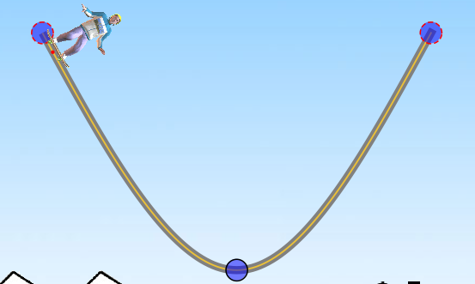

Click on  and run your skater through the track again. Use this tool to help you label the spots on the ramp where there is the greatest KE and PE. Label your results below:

Watch what happens to the PE as the skater is higher on the track.
What is the relationship between the PE and the height of the skater on the track?

Watch what happens to the KE as the skater moves faster and slower on the track. He is slowest at the top of the track just before he reverses direction and fastest at the bottom of the bend.
What is the relationship between the KE and the speed of the skater on the track?

Watching the bar graph…what general statement can you make about the relationship between KE and PE?

Effect of Starting Height on PE and KE
Drag and drop your skater half way up the track. Draw or write what happened to the skater.
Position of Skater | Result
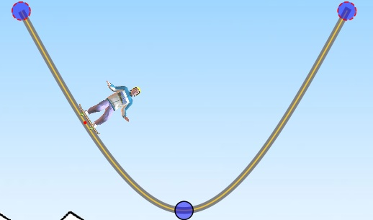
What do you notice about the bar graph, now, compared to when the skater started higher up on the track?

Effect of Length of the Track
Make the right side of the track longer. Start your skater on the right side and draw or write what happens to the skater.
Right side longer | Result | Possible reasons why it happened
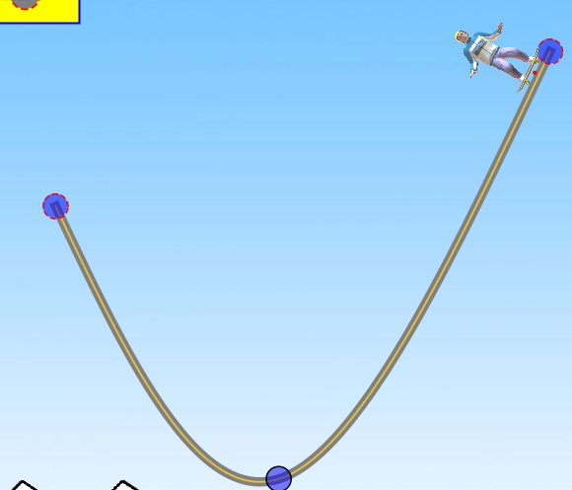
Make the left side of the track longer with a short right side. Start the skater on the right side again, and draw or write what happens to the skater.
Left side longer | Result | Possible reasons why it happened
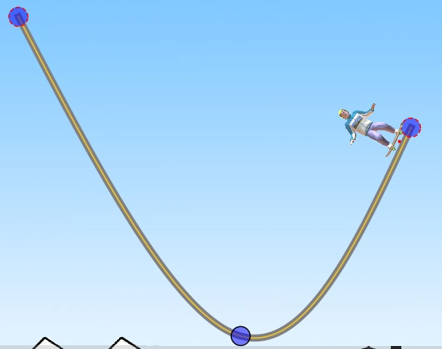

Loops
Under the “tracks” menu at the top of the page, add a loop to the track. Draw or write what happens to your skater when you start it from the top of the track.
Picture of track with loop | Result

Click Show grid.
Start your skater at different positions on the ramp. What happens if you start the skater on the ramp at or below the highest height of the loop?

Pendulum PE and KE
Open Internet Explorer. From the FMS Jump Page. Click the Pendulum link. Or type in http://phet.colorado.edu/en/simulation/pendulum-lab
Click Show energy of 1 ….  and 1/16 time 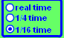

Drag and release the pendulum to set it in motion. Watch the graph of PE and KE.
Label the points on the pendulum’s path where PE and KE are at their maximum.
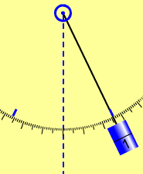

How does the PE and KE of the Pendulum compare to the Skate Park?

You may now design your own skate park. Make sure it all works!
You need…
A loop and 2 hills

