Comments for teacher are included throughout activity.
Note: All objects in the simulation are moveable (you can drag the earth, moon, sun, satellite around to change the orbit).

Name: ________________________________________
Grade:_________________________________________

Gravity and Orbits

Pre-lab
Teacher: If you don’t want to have a pre/post lab, you might want to include the pre-lab questions into the main activity, as a warm-up if there’s time in your class period.

1. In the picture below, draw how you think Earth moves.

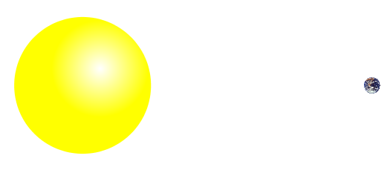

2. Draw a picture using arrows to show what you think the forces might be on the Earth and the Sun.
You can draw a longer arrow to represent a big force, and a shorter arrow to represent a small force.

3. Draw a picture of how you think the Earth would move if these forces were not there.

Name: ________________________________________
Grade:_________________________________________

Gravity and Orbits
Learning Objectives- Students will be able to:
- Draw motion of planets, Moons and satellites.
- Draw diagrams to show how gravity is the force that controls the motion of our solar system.
- Identify the variables that affect the strength of the gravity.
- Predict how motion would change if gravity was stronger or weaker.

Part 1: Understanding motion
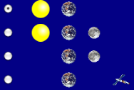
- Open the Gravity and Orbits simulation. Take 5 minutes to explore how the Earth, Moon, and the Space Station move. Talk about what you find with your partner.

CLASS DISCUSSION: What controls have you found?
Teacher: This is a good place to let students demonstrate on a projector what they’ve found. From their responses, you can double check that students understand how to turn the “Path” and “Gravity Force” on, as well as use the reset button.
- Compare the motion of the Earth moving around the Sun with the Moon moving around the Earth.
If you and your partner each have a computer: Try choosing a different view on each computer for this question.

Earth moves around the Sun  Your Picture  Your Description | Moon moves around the Earth  Your Picture  Your Description
What are some things you find that are the same about these motions?

What are some things you find that are different about these motions?

Part 2: Understanding Gravity
- For the Sun and Earth system:
  - Draw the path of the Earth with Gravity ON and Gravity OFF

GRAVITY ON GRAVITY OFF

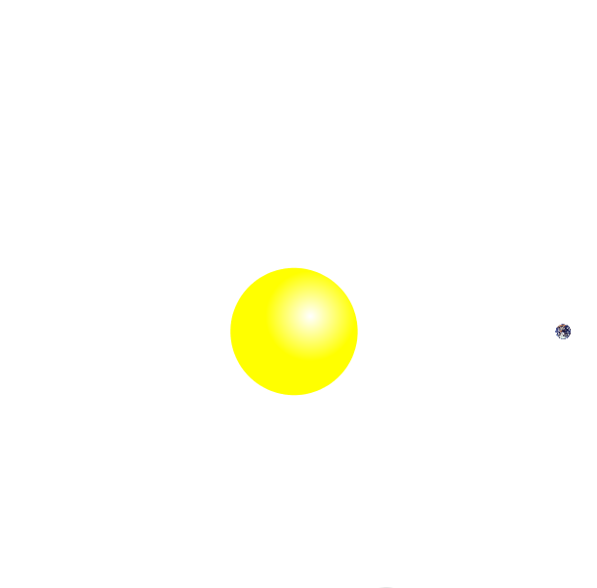

  - Why do you think gravity is important?

- Explore the simulation to find out how you can change the force of gravity and observe what happens.

CLASS DISCUSSION: Share what you found with the class.
Teacher: This is a good place to discuss what the gravity arrows mean.

- Draw the Sun’s gravitational pull on the Earth Draw the Earth’s gravitational pull on the Sun
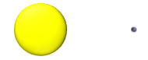

CLASS DISCUSSION: Why do you think the Earth moves, but the Sun does not move?
Teacher: You can bring up here the difference between the “Cartoon” and “Real” coordinates, and emphasize that the Sun is much, much larger than the Earth, so the Earth’s effect on the Sun’s motion is small.

- Return to your pictures in Questions 2 and add arrows to show the force of gravity. Label them with “Gravity Force”.

- Play with the sim to find ways to change the length of the blue gravity force arrows. Collect your results in the table below.
- Fill in an ACTION below and write whether or not the gravitational force increases or decreases.
Teacher: Depending on how much direction you feel your students need, you can have the students fill in this table with their own actions, or you can add some yourself. I suggest leaving at least 1-2 blank “ACTION” spaces for your students, if you choose to add more guidance.

ACTION | Gravity Force Increases | Gravity Force Decreases
Put star and planet closer together

b) What can affect the strength of gravitational force? What can you conclude from the results in your table?

- Comparisons:
a) Compare these two cases:
CASE 1 CASE 2
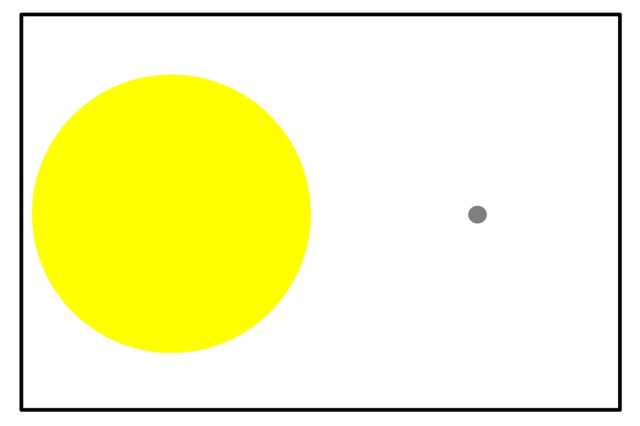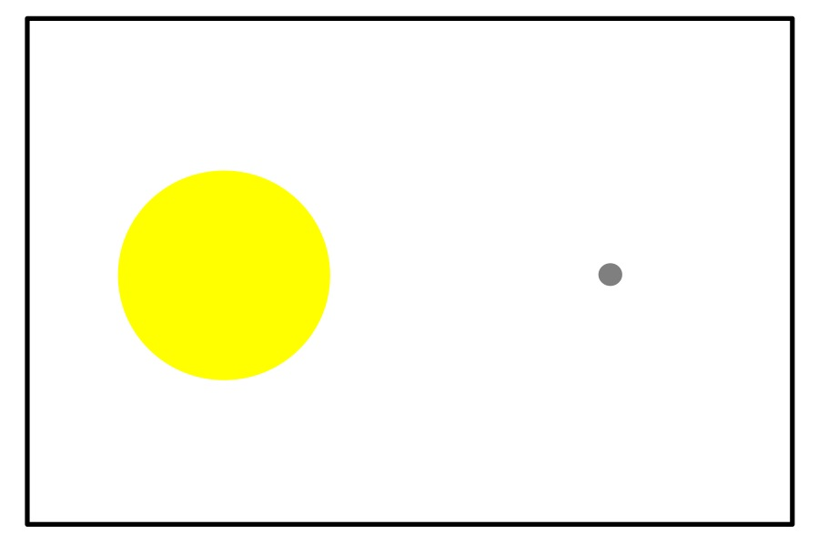

What was changed between Case 1 and Case 2?

Draw the force of gravity on the Earth in each case.

b) Compare these two cases:
CASE 1 CASE 2
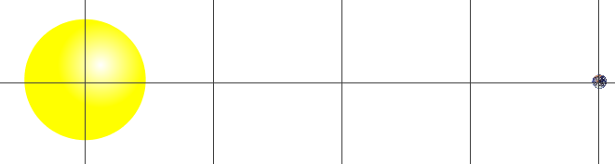
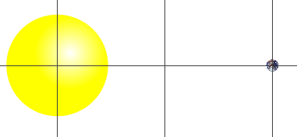

What was changed between Case 1 and Case 2?

Draw the force of gravity on the Earth in each case.
Part 3: Gravity and Motion
- Fill in the table to help describe what you find out.

How can you…. | Explain what you changed | Draw the motion paths | What other changes do you notice?
...make the Moon
go around the Earth in a bigger circle?

...make the Earth
take more time to go around the Sun?

...make the Earth
take less time to go around the Sun?

THIS PAGE IS BLANK

Name: ________________________________________
Grade:_________________________________________

Post-Lab

- In the picture below, draw how you think the Earth and the Moon move.

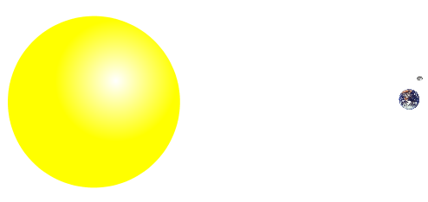

- On the picture above, show the gravity forces on the Earth, Sun and the Moon.

3. Fill in the following table with your predictions and a drawing of each case.

Predict what would happen to the gravity force if you… | Gravity Increases, Decreases or Stays the Same? | Your Drawing
...increase the size of the Star
...move the star and the planet away from each other
...decrease the size of the Planet

...move the Star and Planet closer to each other

4. Show in the picture below how you think the Earth and Moon would move if there were no gravity forces at all.

Explain why you think the Earth and Moon would move in this way.

5. Tell us what you think about the activity:
a. How useful for your learning was this science activity, compared to other science class activities? (circle)
More useful About the same Less useful

b. How enjoyable was this science class activity, compared to other science class activities? (circle)
More enjoyable About the same Less enjoyable

c. Why did you or did you not find it useful or enjoyable?

