Name _____________________________________________ Date Period
Circuit Simulation Lab
Go to the Shared Folder
Open Student Work → Students Save
then click on “Circuit Kit” application (near the bottom)

Experiment 1

- Grab components from the right side of the screen and drag them to the work space. Build this circuit. You will have to click the check box next to ammeter to use it.
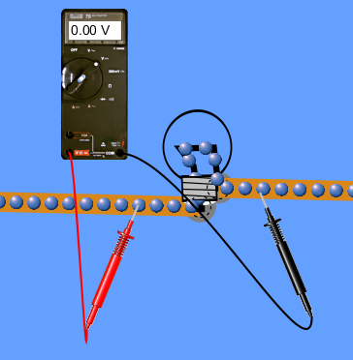
- Now check the box for Voltmeter. Attach one the Voltmeter’s wires to each side of the light bulb.

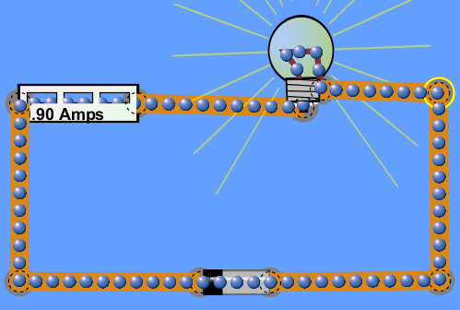
Light Bulb
Ammeter
Battery
wire

- Record the voltage across the light bulb and the current through it in the table below. Then “right-click” the light bulb to remove it.
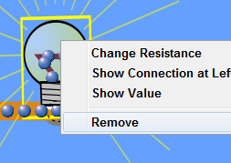

- Click on the “Grab Bag” and add a penny to your circuit. Record its voltage & currient.

- Next, measure and record the voltage & current of a pencil

- Use Ohm’s Law ( V = I R ) to calculate the resistance of each item.

Table 1
Item | Voltage (V) | Current (A) | Resistance (Ω)
light bulb
penny
pencil

Experiment 2
- Press the “Reset” button to delete your old circuit. You will now build a Series Circuit by connecting two resistors (one after the other) to a battery and ammeter.
- Using the Voltmeter, measure the voltage across each resistor. Record them here.

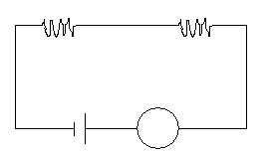

Resistor
Resistor

Ammeter
Battery

4. Record the current here.
- Measure and record the voltage across the battery here.

5. What relationship do you see between the voltages across the resistors and the battery?

- Plug the battery’s voltage and the current into Ohm’s Law to calculate the total Resistance.

7. Extra Credit:
Rebuild the series circuit with the ammeter in-between the two resistors. Record the current here.

Experiment 3
- Press the “Reset” button to delete your old circuit. You will now build a Parallel Circuit by splitting the path out of the battery to 2 resistors then re-combining it. Each circle represents an ammeter.
- Record each current in the corresponding circle.
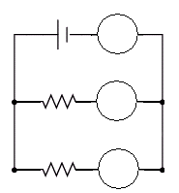
- What relationship do you see between the currents?
I_{T}

- Using the Voltmeter, record the voltage across the battery here.
- Record the voltages across the resistors here.
I₁
- Plug the battery’s voltage and the total current into Ohm’s Law to calculate the total Resistance.

- Use the 1st resistor’s voltage and its current (I₁) to calculate its individual resistance.
I₂

- Which is greater (the individual resistances, or the total resistance)?

Conclusions
- In which type of circuit was there more total resistance? (Series, or Parallel)
- In which type of circuit did more current flow? (Series, or Parallel)
- In Experiment 2, if you added a 3rd resister in series, would the total resistance (increase, or decrease)?
- In Experiment 3, if you added a 3rd resistor in parallel, would the total resistance (increase, or decrease)?

