Physics Web Search: Circuit Diagrams Name_________________________
Period ________________________

- On the desktop, find the Physics Animations Folder
- Open “Circuit Construction Kit DC”

Basic controls:
- Use the mouse to click and drag the components on the right onto the construction area
- Right click to change values
- Right click to show values
- Right click to break wires apart “Split Junction”

Circuit #1
- Construct the following circuit

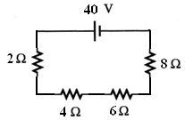

- What is the current through and voltage across each resistor? Show your work! Click on the Voltmeter and the regular Ammeter to check your values. (After this circuit switch to the Non-Contact Ammeter)

Resistor (Ω) | Current through (A) | Voltage across (V)
2
4
6
8

- To use the voltmeter, the meter must be in __________________ with the circuit because voltage doesn’t change in this type of circuit.

- To use the regular Ammeter, the meter must be in __________________ with the circuit because current doesn’t change in this type of circuit.

Circuit #2
- Construct the following circuit
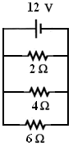
- What is the current through and voltage across each resistor? Show your work! Click on the Voltmeter and the Non-Contact Ammeter to check your values.

Resistor (Ω) | Current through (A) | Voltage across (V)
2
4
6

Circuit #3
- Construct the following circuit
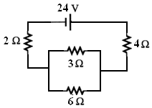

- What is the current through and voltage across each resistor? Show your work! Click on the Voltmeter and the Non-Contact Ammeter to check your values.

Resistor (Ω) | Current through (A) | Voltage across (V)
2
3
4
6

Circuit #4
- Construct the following circuit
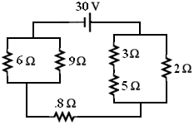

- What is the current through and voltage across each resistor? Show your work! Click on the Voltmeter and the Non-Contact Ammeter to check your values.

Resistor (Ω) | Current through (A) | Voltage across (V)
.8
2
3
5
6
9

Circuit #5
- Construct the following circuit
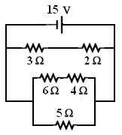

- What is the current through and voltage across each resistor? Show your work! Click on the Voltmeter and the Non-Contact Ammeter to check your values.

Resistor (Ω) | Current through (A) | Voltage across (V)
2
3
4
5
6

