Lab : Magnetic Fields
(bar magnets & electromagnets)

Learning Goals

During this lab activity, you will learn to
- Predict the direction of the magnet field at different locations around a bar magnet and an electromagnet.
- Compare and contrast bar magnets and electromagnets.
- Identify the characteristics of electromagnets that are variable and what effects each variable has on the magnetic field’s strength and direction.
- Relate magnetic field strength to distance quantitatively and qualitatively

Procedure

1. Go To: http://phet.colorado.edu/simulations/sims.php?sim=Faradays_Electromagnetic_Lab

Hint: Download the file using the ‘save’ option then run the ‘.jar’ file using Java.

2. Complete the following tasks to help you investigate Faraday’s Electromagnet Lab. These tasks will help you conduct appropriate experiments to answer the lab questions.
We will be using the Bar Magnet and Electromagnet tabs for this activity and the other tabs later in the unit.
- Click on the Bar Magnet tab. 

- Click on . Explain the two changes this causes in the simulation.


- Move compass to various locations around the bar magnet. Explain what orientation the needle takes with respect to the bar magnet.

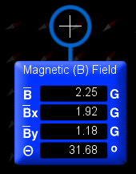
- Select ‘Show Field Meter’ . The image below will appear. The meter can be moved to various locations and indicates the magnetic field strength at the crosshairs. Label: Total magnetic field, y-component of the magnetic field, x-component of the magnetic field, angle and units in the following diagram.

- You should be able to determine the direction of the magnetic field vector using the meter.

- Select . Observe the orientation of the small compass needles.

- Click on the Electromagnet tab. .
- What is behaving like a magnet : The battery or The coils of current carrying wire ?

- Using the slider on the battery, change the voltage of the battery from 10V to 0V.
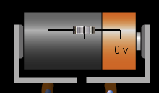

Then from 0V to ‘-’ 10V.
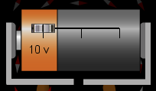

Record the changes you observe in the direction of the compass needle.

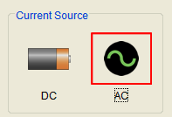
- Select AC as your current source.

Observe and record the changes in the compass needle.

3. Design and execute an experiment using the simulation that will allow you to understand the direction and strength of the magnetic field around
(a) a bar magnet
(b) an electromagnet
You do not need to submit the procedure of your experiment, only your results.

Questions

- Using diagrams and written explanation, explain the magnetic field direction and strength around a bar magnet, and an electromagnet. (5 marks)

- Explain the similarities and differences of a bar magnet and an electromagnet. (4 marks)

- Identify the characteristics of electromagnets that are variable (can be changed) and what effects each variable has on the magnetic field’s strength and direction. (4 marks)

