AP-C |  | Electricity & Magnetism  Induction  LR Post Lab | Name ____________________  Teacher __________________  Period _____

Purpose

Materials computer and internet
http://phet.colorado.edu/new/simulations/sims.php?sim=Circuit_Construction_Kit_ACDC

Background Tipler Chapter 30-8
http://hyperphysics.phy-astr.gsu.edu/hbase/electric/induct.html#c1

Directions
- Construct the circuit shown below.
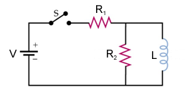

- Set the values of the circuits elements to
V = | 5 volts
R₁ = | 1 ohm
R₂ = | 4 ohms
L = | 1 henry
Place voltmeters and ammeters in the circuit to measure the currents and voltages in step number 3

Place a voltage chart across R₂.

- Experimentally determine the following:
- Case I – The switch is just closed.
- Case II – The switch is closed for a long time (time > 4-5 L/R)
 | Case I | Case II
Current – i₁
Current – i₂
Current through Switch
Potential – V₁
Potential – V₂

- Experimentally determine the voltage across R₂ immediately after the switch is opened.

