Name: ______________________

Date: _______________________

Per.:________________________

Gas Properties and Atmospheric Pressure

Learning Goal: You already know that the atmosphere has multiple layers. One of the properties the atmospheric layers are based on is pressure. During this lesson you will apply different variables in order to predict the relative pressure at different atmospheric layers. You will demonstrate this understanding by creating a diagram showing the factors that effect pressure in an open and closed system, and by transferring this understanding to their previous knowledge of atmospheric layers through writing.

Prediction: What factors do you think will affect pressure?

Procedures:
1. Open Gas Properties simulation in PhET (http://phet.colorado.edu/simulations/sims.php?sim=Gas_Properties)
- Test your prediction using the simulation. Does anything else affect pressure?
- Click on measurement tools, located on the right side of the page.
- Select layer tool.
- Explore how pressure relates to layers in open and closed systems.

Analysis:
Draw or diagram what causes pressure to vary at different layers.

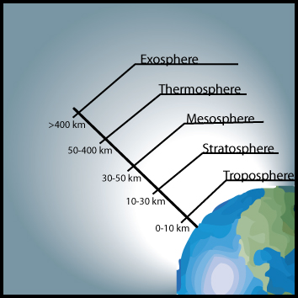

Conclusion (done on back of paper): Applying what you have learned in the simulation, predict the patterns of pressure you would expect to find as you travel through the atmospheric layers. What else do you think would affect the pressure at each layer other than the distance from the surface of the earth?

