Phet Activity Homework: Waves & Electromagnetic Spectrum

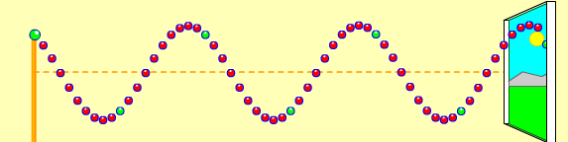
Figure 1.
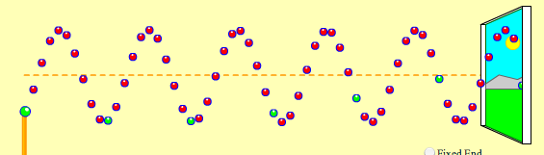
Figure 2.
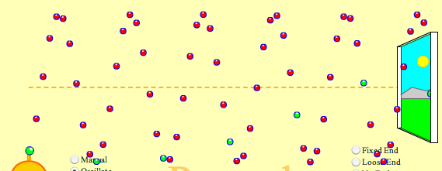
Figure 3.

- Compare and contrast the three waves shown in figures 1-3 above.

- Could the waves shown in figures 1-3 be examples of sound waves? Explain.

- Within the figure 1, draw a wave which has the same amplitude, but has twice the wavelength.
- Within figure 2, draw a wave which has twice the frequency as the wave shown.
- Within figure 3, draw a wave which has ½ the amplitude as the wave shown.


Step 1 Step 2 Step 3

- In the energy diagrams above, show the step by step process by which the emission of electromagnetic radiation (light) occurs. Then, describe each step below:

Step 1:

Step 2:

Step 3:

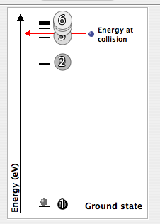
- Imagine that an electron with the energy shown in figure 4 below collides with an atom of hydrogen. How many possible types of electromagnetic waves could be produced? Explain.

