Lesson Plan for Reaction Rate Simulation
Approximate Length: 55 min
Learning Goal:
Students will be able to demonstrate their knowledge of reaction rates through illustrations and descriptions. These illustrations and descriptions should include:
- How varying the temperature changes the rate of a reaction.
- How varying the concentration changes the rate of a reaction.
- How activation energy changes the rate of a reaction.

Background
Prior to this lesson, students have been assessed on gas laws and properties, as well as states of matter. They should be able to demonstrate what molecules of a solid, liquid and gas look like and understand the relationship between the kinetic energy of molecules and heat.
The previous day, the students were introduced to the “collision theory” through a POGIL activity, which is also linked to the Phet webpage. The activity begins by describing an effective collision in terms of baseball. Effective collisions will occur for the hits that results in a homerun. This analogy was used to discuss the aspects of the collision theory:
- Particles must have enough kinetic energy to produce an effective collision
- Particles must collide in the correct orientation for an effective collision to occur
Lesson Plan with Simulation:
Students will begin this lesson by discussing what “rate” means and provide examples. In small groups, students will draw the number of reactants and products present in a reaction over time. Reactants are represented by squares and products are represented by circles. Students will draw what the reaction looks like every 15 seconds. The illustrations will be discussed and shared as a large group.
The following graph is then shown to the students. In a small group, they are asked to label the terms “reactants”, “products”, and “activation energy” on the graph. This graph is then used to discuss how activation energy affects the number of effective collisions and the formation of the products in a reaction.
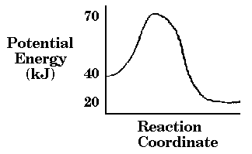

Students will then receive the handout and data tables used with the Reaction Rate Simulation. See Student Handout

After the Lesson:
The next day in class, students will be testing how variables such as temperature and concentration change the rate of a reaction by performing the Iodine Clock Reaction.

