Battery-Resistor Circuit SIM Homework III

Note: This homework has a bunch of calculations on it. Many are quite straightforward if you understand conceptually what determines current and voltage drops (loss of energy by the electrons flowing round) in a circuit. If you find yourself having difficulty, review the Answer Key for HW2.
1) (8 pts) In an old house or cabin, it is common for the lights to dim when you turn on an appliance that uses a lot of power, for example an electric space heater. In this problem, we will see why this happens.
First, let’s review what we learned in last week’s homework. We looked at a circuit made up of wires, a fuse, and a light bulb. We calculated the current flowing through the circuit and amount of power going into each of these components (the wire, the fuse, and the light bulb). If we replaced the light bulb with a heater and redid the calculation, the power going into the different components would change. These two circuit and the results are shown below:
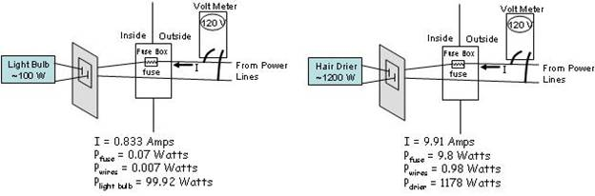
In this problem, we will examine what happens if we plug more than one light or appliance into the same outlet. Our circuit is made up of the wires inside the house from the power lines to the outlet and the appliances we plug into the outlet (for simplicity, we will not put a fuse in this circuit). We will use the Circuit Construction Kit Simulation on PhET to aid us in understanding this problem. Construct the circuit below, where the battery represents the power coming into the house, the two wires attached to the battery represent the wires from the breaker box in your garage to the outlet plug in you living room, and the two bulbs represent a regular light bulb and a heater with a switch. Set the resistance of the regular light bulb to about 36 ohms. A heater draws a lot more power than a regular bulb. Set the heater bulb to a resistance such that it will draw more power than the other light bulb. Your circuit should look something like this:
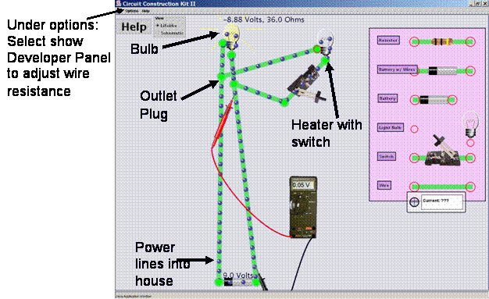
The wires in any real home have some amount of resistance. Use the developer panel under the options menu to add some resistance to the wires. You should see this affect how much the voltage drops in the wires and across the light bulb.
a) Explore what happens when you turn the heater on and off by closing and opening the switch.
i) (1.5 pts) As you open and close the switch, what changes do you see in
(1) the current passing through the wires, the light bulb, and the heater,
(2) where the electrons lose their energy as they flow round the circuit (as measured by a change in voltage using the volt meter), and
(3) the amount of power (energy per second) that is going in to the wires, the light bulb, and the heater. (Hint use all of the visual cues and the tools you have like the volt meter to explore the changes). Be sure to explain the physics reasoning behind why these changes make sense given the fact that the wires have resistance.
ii) (1 pts) Closely observe the change in the wires. If turning the heater on increases the current through the wires by 10 times, does the power loss in the wires increase by 10 times, more than 10 times, or less than 10 times? Would a 10 times increase be consistent with P=IV?
b) In this part of the problem, we calculate some of the changes that would occur in your home when you turn on the heater. Again, our circuit is made up of the wires inside the house from the power lines to the outlet and the appliances we plug into the outlet:
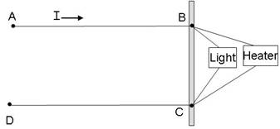
The voltage drop in your home between A and D is 120 V. The point B and C represent the two prongs in the outlet where you plug in your light and your heater. Your light has a resistance of 144 ohms and consumes 100 Watts when supplied with 120 V. Your heater has a resistance of 5.8 ohms and consumes 2500 Watts when supplied with 120 V. Your house has old, thin wires running from the power lines to the outlet. The total resistance (A to B plus C to D) of the wires running between the power lines and the outlet is 0.5 ohms.
If the light is on and the heater is off,
i) (0.5 pt) Calculate the current flowing through the circuit.
ii) (1.0 pt) The resistance of a coil of wire is proportional to its length. If you double the length, you also double its resistance from end to end. If we consider that the resistance in the home wiring from A to B is 0.25 ohms and from C to D is 0.25 ohms, what is voltage drop in the home wiring from A to B?
What is the voltage drop in the home wiring from C to D?
What is the voltage drop across the prongs of the outlet (from B to C)?
iii) (0.5 pt) What is the power going into the home wiring? (That is how much power is deposited in the wires themselves).
What is the power going into the light?
If we leave the light on and turn the heater on, the current through the circuit increases to 19.8 Amps.
iv) (1.0 pts) What is the voltage drop in the home wiring from A to B now that the heater is ON?
What is the voltage drop in the home wiring from C to D?
What is the voltage drop across the prongs of the outlet (from B to C)?
v) (0.5 pts) Calculate the power going into the home wiring now that the heater is ON. (That is, the amount of power deposited in the wires themselves).
Into what form of energy is this electrical energy converted?
vi) (0.5 pts) Knowing the voltage drop across the outlet prongs, you can calculate the power going into the light bulb and into the heater. What is the power going into the heater?
vii) (0.5 pt) So, why does the light dim when I turn on the heater?
c) (1 pt) We upgrade the wiring inside the house. The new wiring is thicker. The total resistance of the wires running between the power lines and the outlet is now 0.01 ohms. We observe that the light no longer dims when the heater is turned on. Explain why this observation makes sense.

