Radioactivity Activities

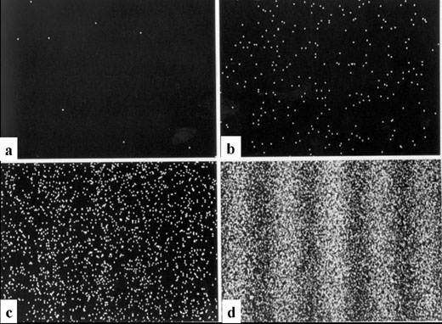

A) Introduction

Processes governed by quantum mechanics are intrinsically random. For example, we can’t know where the next particle will land in the two-slit experiment. We can only predict the pattern we will get if there are many, many particles.
Another clear example of this intrinsic randomness is radioactive decay.

B) Decay Simulation with Dice

1) Each person will represent an atom that may decay. Whether you decay or not, depends on the roll of a die. If you roll a one, you have decayed. What will a graph of the number of undecayed atoms vs. roll number look like? Graph the expected curve on the grid below.

2) Plot the results of the experiment on the graph above. How and why did the results differ from your prediction?

3) Which description best describes the results of the roll of a die?
- The results are only pseudo random. They depend in a strict causal way on properties of the die and how it is released.
- The results are intrinsically random. There is no cause and effect.

Explain your choice:

C) PhET Simulation of Nuclear Decay

Go the PhET simulations at http://phet.colorado.edu/simulations/ and choose Quantum Phenomena, Alpha Decay. Hit the reset button a few times.

4) Label the diagram above locating the
- total energy of the alpha particle
- potential energy of an alpha particle due to Coulomb repulsion
- potential energy of an alpha particle due to the strong nuclear force
- the classical limit of how far the electron can go from the centre of the nucleus
- the quantum limit of how far the electron must go, to be able to escape

5) How is the movement of the alpha particle different from a classical particle?

6) A particle that appears beyond the quantum limit and then repelled, is said to have ‘tunnelled’ through the barrier. How is this different from classical tunnelling?

7) Why won’t a second alpha particle escape?

8) How long will it take until the next decay?

9) Is the PhET simulation intrinsically random or just pseudo random?

D) Real Radioactive Decay

10) Is atomic decay truly intrinsically random?
- What did Einstein think?

- What is the Copenhagen Interpretation?

- Who is right?
E) Half-Life
10) The half-life of a nucleus is the time needed until there is a 50% chance that it will have decayed. It can be found by taking a large sample and measuring how long until half of them have decayed. Using the dice model
- How many rolls is one half-life? Explain how you get this answer.

- Do an experiment with many dice. What was the half-life?

- Why were these answers different?

- Calculate the percentage difference of your two answers.

- What would you need to do to get them exactly the same?

- What is the whole-life? How long will it be until all the dice have decayed?

- Suppose you came in late and there were 15 students in the class still undecayed. How many rounds do you think occurred while you were out? Explain how you got your answer.

11) Go to the PhET simulations at http://phet.colorado.edu/simulations/ and choose Quantum Phenomena, Alpha Decay.
- Measure the decay times for 25 events.

- What was the have-life for these 25 nuclei? Explain how you calculated this.

- Compare your answer to someone else’s. How different is it? Why is it different?

- To three digits, the half-life of Po-111 is 520 ns according to Fred Noel Spiess in Physics Review 94, 1292-1299 (1954). How many rolls would you need to be certain to have two significant digits?

12) Radioactive decay is used to date fossils, rocks etc. They measure the ratio of decayed nuclei to undecayed nuclei. However, for this information to be useful, you need to know what the starting value was. Do research to find out how this is done for two different techniques.

