Learning Goals: This is a lecture demonstration meant to introduce Electric Energy and Capacitance, so that the students will be able to solve the textbook problems.

Background: I used this as an intro to the Electricity unit which has a focus on circuits; the previous unit included Static charge and magnetism.

Charges and Fields:
If you grab a charge and don’t let go you can emulate a charge moving through a field, but the field is not uniform.
Lesson: I made a slide presentation to use, but I included some of the notes here too.
Notes from text: PE_{electric} = -qEd (charge x electric field strength x displacement from a reference point in the direction of the field) [joules = coulombs x newtons/coulomb x meters] Potential energy increases for a negative charge and decreases for a positive one. Only the displacement parallel to the field effects the energy like gravitational potential energy is only effected by vertical displacement.
E can also be measured in $\frac{V}{m}$ $\frac{N}{C}=\frac{V}{m}=\frac{\frac{J}{C}}{m}=\frac{\frac{\text{Nm}}{C}}{m}$
PE= -qEd [unit analysis: J= $C∗\frac{\frac{J}{C}}{m}∗m$

I used the PhET sim to demonstrate a charge moving through a field even though you cannot make a uniform field. You can show E field with direction only so that the arrows are all dark red; I put one negative charge to help remind the students that field points towards negative. If you grab a charge and drag it without letting go, it won’t change the field like a small charge in a relatively large uniform field would.
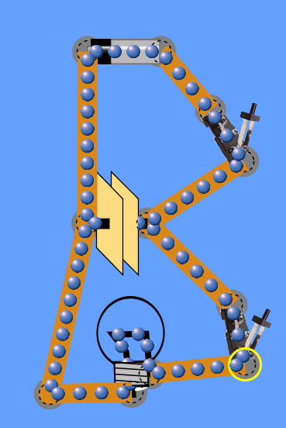
If you build the circuit with the default values, the capacitor will charge almost instantaneously, but I found that using about 3 v slows it down enough to be helpful.

