Resistance in Parallel Circuits
Name _______________
You are designing a Holiday light and Santa display at your house. You need to decide what you may want to place in series and what you may want to place in parallel (next activity). First you must discover the attributes of both. You will do this using a computer simulation.

Goals:
Correctly place voltmeters and ammeters in a parallel circuit.
Find the voltage and amperage in parallel circuits.
Determine which is constant in a parallel circuit, voltage or amperage.

- Open the phet website and go to the Circuit Construction Kit simulation.
- Make a parallel circuit using three resistors.
- Add a voltmeter over each of the resistors.
- Add an ammeter between each resistor and the resistors and the source.

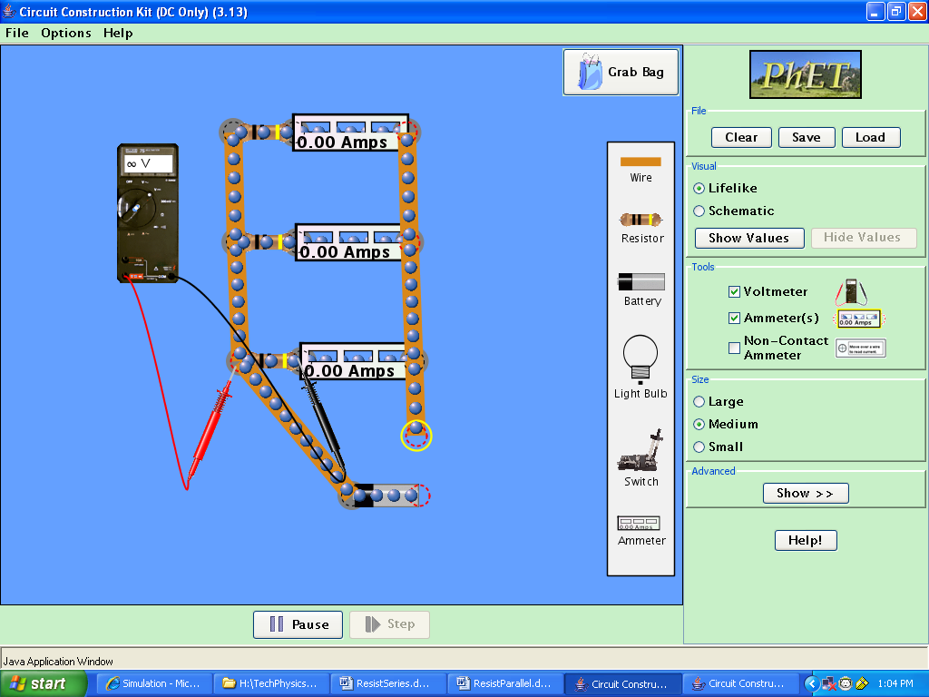
- Change the resistor values by right clicking the resistor. Make the resistors at least 10 Ohms different!
- Record both the resistor value, voltage and the amperage in the table below.
- Unhook one of the resistors from the circuit. What happens?
- Discuss with another student, what conclusions can be drawn from this data?

 | Voltage Resistance | Amperage | Voltage

Resistor 1
Resistor 2
Resistor 3
Source |  | A1+A2+A3= | V1+V2+V3=
Questions
1) When placing a voltmeter in a circuit, does it go in series or parallel?

2) When placing an ammeter in a circuit, does it go in series or parallel?

3) What conclusions can you draw from the readings on the voltmeters?

4) What conclusions can you draw from the readings on the ammeters?

5) What are the advantages to placing lights and motors in parallel?

6) Which best describes a parallel circuit? Circle all that apply:
a) V_{s} = V₁ + V₂ + V₃ d) V_{s} = V₁ = V₂ = V₃
b) I_{t} = I₁ + I₂ +I₃ e) I_{t} = I_{t} = I₁ = I₂ =I₃
1 1 1 1
c) R_{t} = R₁ + R₂ +R₃ f) R_{t} = R₁ = R₂ =R₃

7) Compare and contrast a parallel and a series circuit. How are they alike? How are they different?

6) Will you use series or parallel to wire your holiday display?

