Name _________________________ Chemistry

Models of the Hydrogen Atom – PhET Simulation
Objectives:
- Determine how well different models of the atom agree with observations
- Explain spectral lines for hydrogen gas in terms of the wavelength emitted
- Calculate the relationship between wavelength and energy of a photon

Prelab Questions:
1. Sketch the electromagnetic spectrum. Label X-rays, UV, Visible, Infrared, Radio. Label the wavelengths smallest to largest, frequencies and energies.

2. What is white light? How do we know?

3. What speed does light travel (c)?

Use c = λν and calculate:
Frequency of green light at 545 nm.

Wavelength of the carrier wave of your favorite radio station:
Frequency = ________ MHz (if FM) = _______________ x 10⁶ sec⁻¹

4. Sketch your own model of an atom to include: Positive nucleus, 3 “orbits” of negative electrons. Are electrons attracted or repelled from the nucleus? Which level are they most likely to exist? Why?

Procedure:
Access the website: www.PhET.colorado.edu
Click on Simulations
From the left hand menu pick Quantum Phenomena
Choose Models of the Hydrogen Atom from the choices to the right.
Check the Show Spectrometer box and turn on the “White light gun”
Have upper left lever on “Experiment”

Part I: What can we observe going into and out of this experiment ?
1. The “White light gun” is shining white light onto the sample of Hydrogen Gas molecules in the box. Watch awhile and see if anything happens to the different colored “light particles” (photons) going in or coming out of the box. What does the box represent?
Record your observations.

2. Why do the photons (particles) of white light have different colors?

3. The spectrometer (bottom right) shows which colored photons are emitted (released by) the atom represented in the box. After the simulation has been running for awhile, list the wavelengths of the colors that have come from the atom.

4. Calculate the energy (in Joules) corresponding to a “photon” for each wavelength you see. Use E = hc/λ below where h = 6.63 x 10⁻³⁴J-sec. Show work for one energy calculation.
Wavelength Energy (Joules)

5. Are photons of all colors being emitted by the atom and being detected by the spectrometer? Use the diagram below to help formulate your answer:
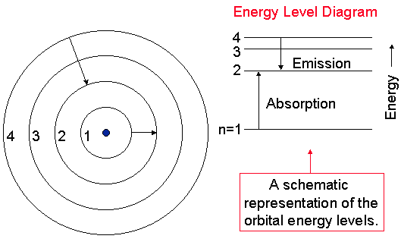
Part II: How well do predictions explain the observations?
The Bohr Model of the Hydrogen atom was specifically developed to explain the emission spectroscopy associated with pure elements as you have seen. What models of the atom did it replace? Why? For this, take a look at the models of the atom that have come before:

1. Switch from Experiment to Prediction in the upper left hand corner of the simulation.
Highlight the Billiard Ball model (Dalton’s model). Do you see any spectral lines?
What did this model of the atom say about the internal structure of the atom?

2. Switch to the Plum Pudding model (proposed by JJ Thompson). What observations in the spectrometer results are different? Is this model adequate? What did this model of the atom say about the internal structure of the atom?

3. Switch to the Classical Solar System Model (Rutherford from Gold Foil Experiments). What happened? Also turn on the Show electron energy level diagram in the upper right hand corner. Why did scientists not accept this model for very long, and search for a different explanation of atomic structure?

4. Switch to the Bohr model. Watch to see what happens in the simulation, the electron energy level diagram and the spectrometer. Do results agree with the original simulation? Explain all correlations.

5. What do the n=1,2,etc refer to? Which one is the “ground state” of the hydrogen atom. Why do electrons often go there?

6. It turns out, that new modern physics really got going when Bohr proposed his model of the atom because there were still mysteries about the behavior of atoms that needed to be addressed. Turn on the deBroglie model. What is different about how the electrons are represented here? How well does the energy level diagram and the spectrometer results agree with Bohr? Write your observations.

7. Finally, turn on the Schrodinger model of the atom. An analogy to the energy levels in the atom is the "Quantum Stepladder" where the rungs on the ladder correspond to energy levels in the atom. List your observations.

