Stretch Armstrong:

-Quick guided inquiry as an introduction to translation of parabolas (x² functions).

Learning objectives:
- Analyze the effects of changing the a, b, and c values of a quadratic function
- Describe how each individual coefficient affects the graph
- Sketch various examples of each individual translation

Remember Stretch Armstrong? (The gooey man who could stretch in all directions) Could you look at him and imagine EXACTLY how he would look when you pulled on him in different directions? Maybe you have a good idea…but not EXACTLY how he would look, or maybe not at all… Well today we are going to pull, tug, and stretch graphs, just like you could with Stretch


Since graphs are usually on paper or your calculator, and we cannot actually, physically ‘pull’ on them, we have to find another way.

1. Brainstorm some ideas as to how we could change the shape of graphs………

2. As a group, decide which of the ways you brainstormed would most likely work best, which one was it?

Using the equation grapher simulation, you will discover the exact way to stretch, squash, and move your graph.

Using ax² + bx + c = 0

3. a.) the a value is always next to the ___________
b.) the b value is always next to the ___________
c.) the c value is always ____________________

Play with the sim for a few minutes.

4. What does changing the a value do?

5. Sketch 3 graphs of very different a values all on the following coordinate plane. USE: 3 different colors, and label each function.

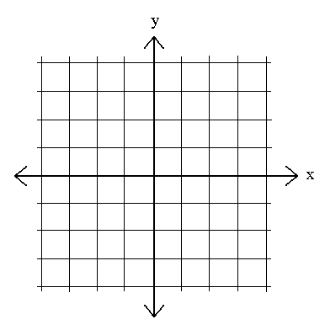
6. What does changing the b value do?

7. Sketch 3 graphs of very different b values all on the following coordinate plane.
USE: 3 different colors, and label each function.

8. What does changing the c value do?

9. Sketch 3 graphs of very different c values all on the following coordinate plane. USE: 3 different colors, and label each function.

10. Write a paragraph comparing and contrasting how the a, b, and c values pull, stretch, and squeeze quadratic functions.

