Circuits
Name ___________________
Goals: You are a networking specialist. Should you run your Cat 5 network cable in parallel or in series?
- Build a series circuit.
- Build a virtual parallel circuit.
- Measure voltage in parallel and series circuits.
- Measure amperage in series and parallel circuits.
- Compare the amperage and voltage in series versus parallel circuit.

Prediction: Do you believe the lights (and therefore your network signals) will be brighter in a parallel or series circuit?

Directions:
  - Go to the phet web site: http://www.colorado.edu/physics/phet
  - Select Circuit Construction Kit.
  - Make a series circuit with 3 lights. (remember series and circle)
  - Add a voltmeter over the light.
  - Add an ammeter in the circuit. You will have to move the conductors to get it in!
  - Take readings for each light.
  - Repeat with parallel.
Series | Parallel
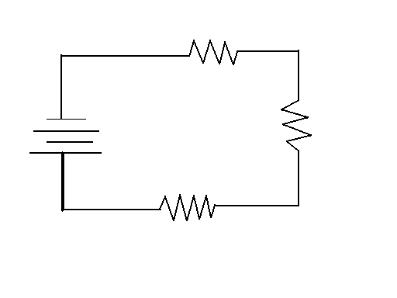 | 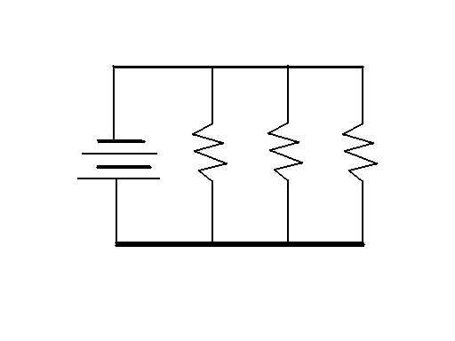

Data:
 | Source Voltage | Light 1 voltage | Light 2 voltage | Light 3 voltage | Amperage
series
parallel

Questions
1) What do the balls traveling through the circuit represent?

2) Which circuit had the brighter light?

3) What happened when the voltage remain constant in both the series and parallel circuits?

4) Explain the connection between the amperage and the brightness of the light?

5) What else did you notice in the circuits you built?

