Electric Field Hockey SIM Homework
1) Consider the following 5 arrangement of charges. It may help to use the Electric Field Hockey Simulation to consider these arrangements, but notice that here the puck has a negative charge (!) You can CHANGE the charge on the puck in the simulation by checking the box at the bottom. When thinking about these arrangements, you should be sure you understand how Coulomb’s Law works to tell you how the force the puck feels under each of the circumstances will differ.
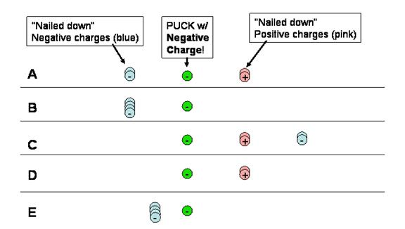

a) Consider the following statements about these configurations.
True False All of the pucks feel a force to the right.
True False The puck in C feels a greater force to the right than the puck in D.
True False The puck in E feels a force to the right that is four times greater than that felt by the puck in B.
True False The net force on the puck in A is zero.
b) We can use the electric field hockey game to help us think about electrostatic forces that are occurring in our everyday lives. Which one of the above charge distributions would be a helpful guide in thinking about the electrostatic forces in the following scenarios?
a charged balloon (puck) sticking to the wall:
a charged sock (puck) sticking to a shirt:
a charged dust particle (puck) in an air cleaner:
a corona discharge:

c) The following figure shows a charge arrangement that is effective at producing a goal for Level #1 on Electric Field Hockey (here the pink are plus charges and the green is the positively charged puck). The path of the puck is shown as the green dash.
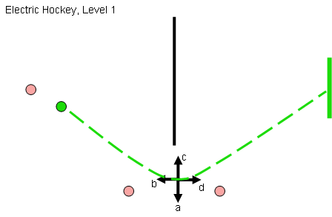

Which of the arrows best represents the direction of acceleration of the puck when it passes this point? Hint: recall what you’ve learned about net force and acceleration.

