Learning Goals: Students will be able to
- Predict the pattern of a reflected wave
- Relate two dimensional representations of waves to three dimensional waves
- Explain wave patterns from interfering waves (Apply the superposition principle to water, sound and light)
- Recognize the Doppler effect and predict the change in frequency that occurs.

Background:

This lesson uses three simulations: Waves on a String, Wave Interference, and Sound. The students will have done the activitites that I wrote: Waves on a String Activity (PhET), Fourier-Making Waves part 1 & 2 (PhET) and a Sound lab with Labpro as well as some homework on superposition and standing waves. I use Physics by Serway and Faughn 1999 Holt.

Lesson: Have all three sims open before the lesson starts and the Power Point presentation that goes with this lesson. I will also have a long piece of Tygon (rubber) tubing and a wave tank that fits on my overhead. We had discussions in several places that I did not specifically denote.

- Predict the pattern of a reflected wave
  - Use the slides 2-3 (clicker questions 1-2) and show how Waves on a String demonstrates the different ends.
  - Then use slides 4 and 5 (clicker question 3) to have students relate string waves to sound waves. Use the pulse mode in Sound to show the answer to the slide.
  - Move the barrier to different locations and angles to see how the 2D wave reflects.
  - Talk about how wave front direction is represented by vectors. p483
  - Use a water wave demonstration on the overhead to see this phenomenon with water as seen in 2D.

- Relate two dimensional representations of waves to three dimensional waves
  - Use Slide 6 for small group discussion
  - 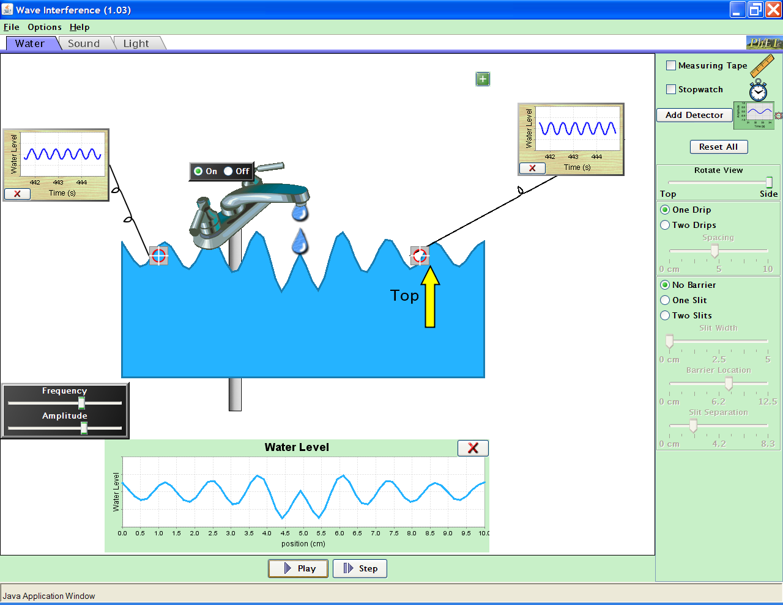Discuss the 3D nature of most waves. It would be good to have the Tygon tubing and show a standing wave by twirling the rope. Note that the text has no illustrations for 3D except p521 for EM waves and 525 to illustrate brightness inverse square law.
  - Use a water wave demonstration on the overhead to see these phenomena with water.
  - Use Wave Interference:
Water tab with faucet moved to middle. Use Rotate view, Show Graph and add detectors.

.

- Sound tab in the particle mode to show one wave to represent 3d.

- Explain wave patterns from interfering waves (Apply the superposition principle to water, sound and light)
- Use slide 7 for small group discussion. Then open Waves on a String. To demonstrate interference with, I used the Pulse feature with Zero damping. First I set the wave characteristics, then pulsed and paused quickly. Then I reset the characteristics and sent another pulse. Quickly, I paused again and used the Step feature for slow motion. You can cycle through the waves interactions many times because the waves will reflect as if from a fixed end from the generator. (You can use slides 8 & 9 if you want the students to practice as a group. I didn’t because my text has good sample problems and I have included practice on a worksheet)

- To show how interference works with 3D I used Wave Interference, Water tab. Show Graph and add a detector. Then add a barrier with zero slit width. You can tab between the barrier and no barrier easily and see how the water graphs change. You can Rotate views to see the other view, but I don’t think it is as demonstrative.
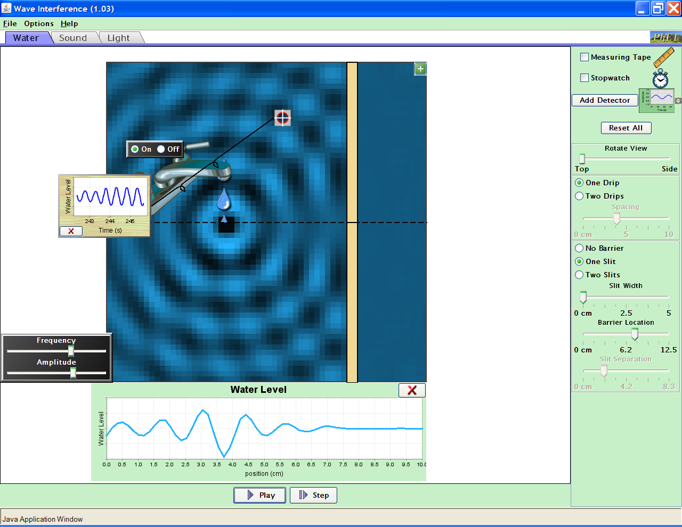

- Switch to the Sound tab and Light tab to show similar patterns

- Recognize the Doppler effect & predict the change in frequency that occurs.
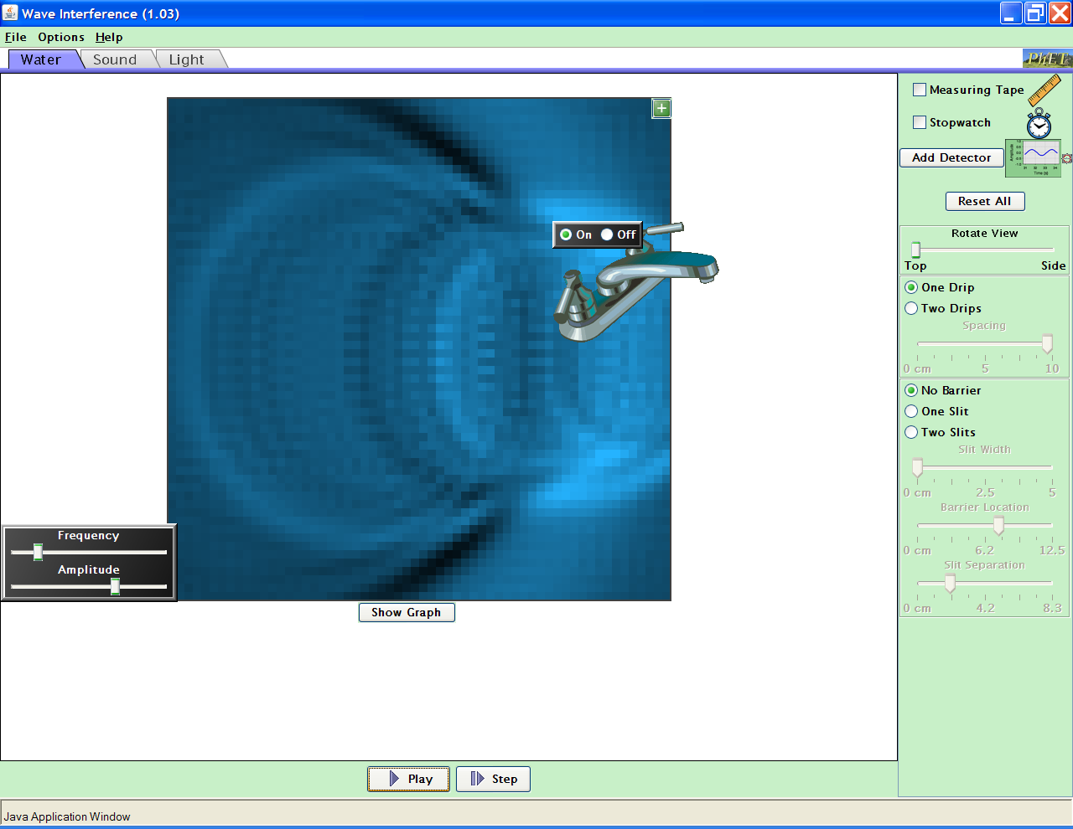Use Wave Interference, Water tab. Low frequency, high amplitude and move the faucet slowly. It is difficult to pause to freeze the pattern.
Use Sound, set the Listener sound on and have your speakers loud. Move the person around and you’ll hear the Doppler Effect.

Also, there is an effective applet at http://library.thinkquest.org/19537/java/Doppler.html
We discussed how the frequency would be different depending on whether the source was moving away or towards you. We talked about Doppler Radar is used to identify the direction and speed of a storm.

