Sarah Borenstein
Energy Skate Park

Learning Goals:
- Predict the kinetic and potential energy of objects.
- Design a skate park
- Examine how kinetic and potential energy interact with each other.

Open the PhET simulation “Energy Skate Park.”.
Either type in: http://www.colorado.edu/physics/phet or Google “phet”.
Click on Simulations, then Work, Energy, and Power on the left side. Click on Energy Skate Park.

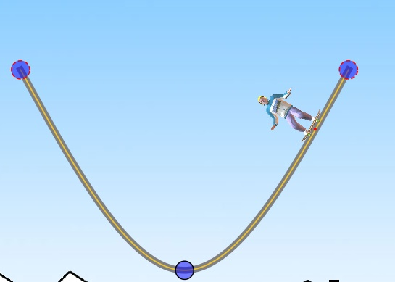

Part 1-Designing a Skate Park

- Thanks to your great skateboarding skills, city officials have asked you to add your expertise with designing a new skate park. In the space below, draw what your idea of what it would look like.

- Re-create your drawing using the simulation. Pick a skater and test out your track. Describe/draw what happened to your skater when you put them on the track (ex. skater got stuck in the loop, skater fell off, skater made it through the whole track). Save your design under the file menu.

Part 2-Predictions, definitions
a. In the space provided, define the following words:

Kinetic energy-

Potential energy-

b. On a scale of 1-10 (1 being the least, 10 being the most), predict the amount of kinetic and potential energy when the skater is on different parts of the track.
Skateboarder Location on track* | Predicition-Kinetic energy | Prediction-  Potential energy | Explanation of your reasoning | Corrections  (#2)
Top of track
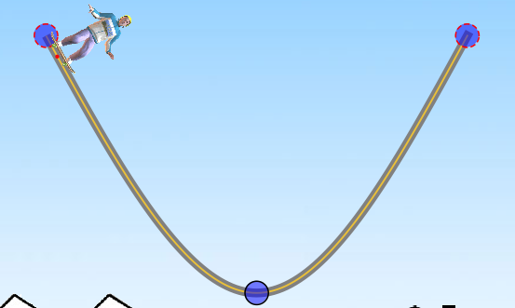
Middle of track
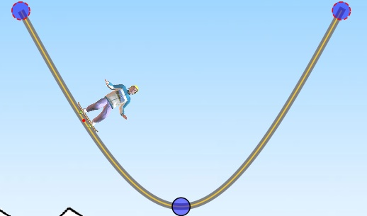
Bottom of track
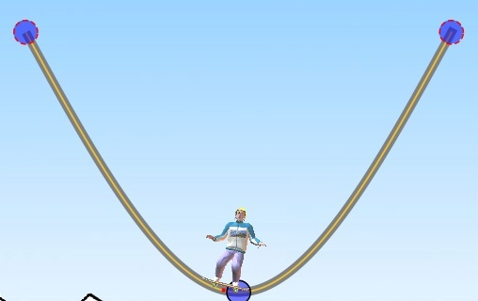

*Before starting the simulation, drag the bottom part of the track so that it touches the ground.

- Start the skateboarder simulation. Click on the bar graph icon and check your predictions. Go back and make corrections if needed.

- Compare what happens to potential energy and kinetic energy as the skater moves up and down the track. What general statement can you make about the relationship between potential and kinetic energy?

Part 3-Observations

  - Skater
Start your skater at the top of the track. Draw or write what happened to the skater.

Position of Skater | Result | Possible reasons why it happened.

Start your skater in the middle of the track. Draw or write what happened to the skater.

Position of Skater | Result | Possible reasons why it happened.

  - Length of the track
Make the right side of the track longer. Start your skater on the right side and draw or write what happens to the skater.
Right side longer | Result | Possible reasons why it happened
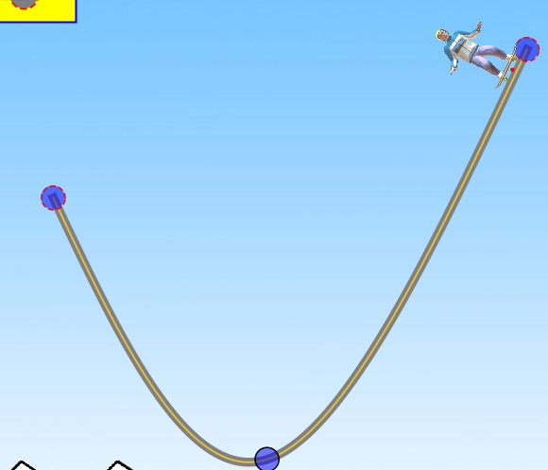

Make the left side of the track longer. Start the skater on the right side again, and draw or write what happens to the skater.

Left side longer | Result | Possible reasons why it happened
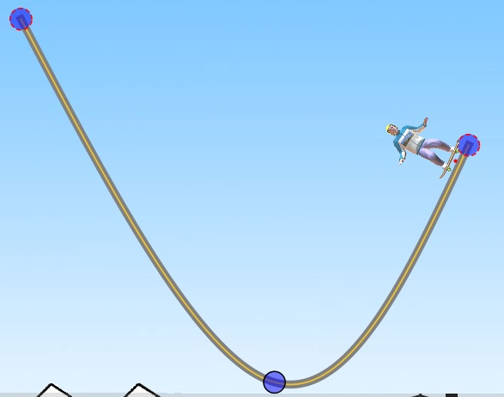

c. Loops
Under the “tracks” menu at the top of the page, add a loop to the track. Draw or write to your skater when you start it from the top of the track.

Picture of track with loop | Result | Possible reasons why it happened

d. Explore
Change the position or shape of the track on your own. Write down what you changed, and what happened to your skater in the table below.
Changes you made (manipulated variable) | Description of what happened to the skater (responding variable)

Part 4-Refine your design

  - Reopen your original design from Part 1. Click on the pie chart or bar graph icon.

  - On your design, draw what point is the potential energy of the skater the greatest.

  - On your design, draw what point is the kinetic energy of the skater the greatest.

  - On your design, draw what point the kinetic energy is equal to the potential energy.

  - Explain how kinetic energy and potential energy affected your track design.

  - If your skater was not able to complete the track, design another track. Draw or write how you changed your track in the space below.

  - Compare your track with 2 other people. Write down your observations in the space below.
Illustration | Similarities | Differences
Your design

#1

#2

