Name, Date___________________________
Series Circuits

- Simple Series Circuit- One Resistor

  - ۞ Construct a simple circuit that contains the following components: Light bulb, 10-V battery, and an ammeter.
    - Make sure that the components are in series; that is, you can trace a charge traveling through the entire circuit from the positive end of the battery to the negative end.
    - Right-click the battery and the light bulb, and check the “Show Value” box.
    - Call your instructor to check your setup.

  - Use the voltmeter to confirm that the voltage of the battery is, in fact, 10 volts. If it is not 10 volts, change it by right-clicking the battery and using the keyboard to enter in 10V.

  - Record the current flowing through the circuit by reading the ammeter value: _________

  - **Use Ohm’s Law to predict the resistance of the light bulb, and record the answer

here: R_{bulb} = __________

  - Confirm this resistance by right-clicking on the light bulb and then clicking the “Change Resistance” button. You should see the resistance listed on the screen.

  - ۞ ** Was Ohm’s Law verified here? Why or why not?

- Simple Series Circuit- Two Resistors

  - Add another light bulb in series to the simple circuit above. Right-click the light bulb to make sure it is also a 10-Ω light bulb.

  - Confirm that the battery is still producing a 10-volt potential difference using the voltmeter.

  - Determine the current flowing through the circuit by recording the ammeter reading here: __________

  - **Using Ohm’s Law, calculate the total resistance of the circuit, and record this value

here: R_{total} = _____________

  - **Add a third light bulb to the circuit by connecting it in series to the others. Repeat steps b→d and calculate the total resistance of the 3 bulbs, and record this resistance. This is called the equivalent resistance of the circuit.

here: R_{eq} = ______________

  - **You should notice a trend developing for resistors that are connected in series. Based on this trend, predict the equivalent resistance of a series of 5 light bulbs, 4 with a resistance of 10 Ω and the 5th with a resistance of 20 Ω. Confirm your prediction by building this circuit.

Answer: R_{eq} = ____________

  - ۞ Now, for a final definition of equivalent resistance: given a series of resistors R₁, R₂, R₃, R₄…etc., write a formula that determines the total equivalent resistance R_{eq}:

- Simple Series Circuit: Voltages of Components

  - Next, change the resistances of the light bulbs until you have: one 10-Ω bulb, one 20-Ω bulb, and one 30-Ω bulb, all connected in series. Also, remove the ammeter.

  - Using the rule developed from part 2(f) above, calculate the equivalent resistance of the 3 bulbs, and record this resistance

here: R_{eq} = ________________

  - Use the voltmeter to determine the voltages across each of the three light bulbs. Record these voltages below in the appropriate spots.

V_{10Ω} = _________ V_{20Ω} = _________ V_{30Ω} = _________

  - **How are these voltages related to the total voltage supplied by the battery?

  - ۞ ** What can be said, in general, about the relationship between (a) the voltages of components that are connected in series, and (b) the voltage supplied by the battery?

  - **Predict the current flowing through the circuit by using Ohm’s Law. use R_{eq} for the circuit as your R, and use the voltage of the battery for V. Record your current prediction

here: I = ____________

  - Put the ammeter back into the circuit, and check your prediction.
- Exit Slip – Turn this part in before you leave with your name on it.

Figure 1: Simple Circuit with 1 resistor
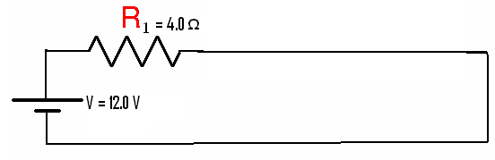

1. Using Ohm’s Law, Calculate the current I flowing through the circuit in Figure 1. Show all work.

Figure 2: Series Circuit with 2 resistors

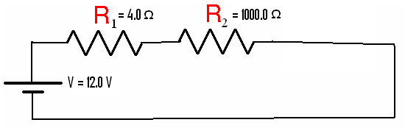
2. Using the rule for equivalent resistance for series circuits, calculate R_{eq} for the circuit in Figure 2.

3. Using Ohm’s Law, and your value for R_{eq} from #3, calculate the current I flowing through the circuit.

4. Compare your answers to #1 and #3. How could a resistor be used to prevent a 4-Ω car speaker from blowing out (due to too much current)?

