Learning Goals:
Students will be able to:
- Explain the kinematics’ variables for rotational motion by describing the motion of a bug on a turntable. The variables are:
  - Angular displacement, speed, and acceleration
  - Arc length
  - Tangential speed
  - Centripetal and tangential acceleration
- Describe how the bug’s position on the turntable affects these variables.
To look at varying tangential velocity, use the Θ ϖ v graph

Background:
My students are using Physics, Serway and Faughn , Holt First Edition 1999. I have not lectured at this point in the unit. They will have read sections 7-1 and 7-2 and done several practice problems involving the following learning goals:
Chapter 7: Rotational Motion and the Law of Gravity
7-1 Measuring rotational motion
- Relate radians to degrees.
- Calculate angular displacement using the arc length and distance from the axis of rotation.
- Calculate angular speed or angular acceleration.
- Solve problems using the kinematic equations for rotational motion.
7-2 Tangential and centripetal acceleration
- Find the tangential speed of a point on a rigid rotating object using the angular speed and the radius.
- Solve problems involving tangential acceleration.
- Solve problems involving centripetal acceleration.

Ladybug Revolution Tips for Teachers:
1. The bugs have basically no mass, but have very high attraction to the table. There are two different ones so that you can compare location easily. The bugs fly off if the change in speed is too high.
2. The acceleration vector denotes the centripetal acceleration, not the tangential.
3. To look at varying tangential velocity, use the Θ ϖ v graph

Lesson:
1. I told my students that the bugs are riding on a platform like a merry-go-round and were so sticky that they don’t slide.
2. Explain to the students what I mean by: “In this activity, you must use values that you measure to write your stories.” Open the slide show and go over first three slides. I will project the simulation, show how to turn on the ruler and show how they could determine the distance that the bug has traveled using the ruler and angle (I made this by turning on the ruler, closing all the other graphs, then I grabbed the handle and moved the table 25 degrees counterclockwise.) On the board, I’ll write : To find the distance traveled: (ask for ideas from class). Our book has Δθ =Δs/r, Δθ is in radians so they need to change the display or calculate 25 * π/180. I want Δθ =Δs/r,
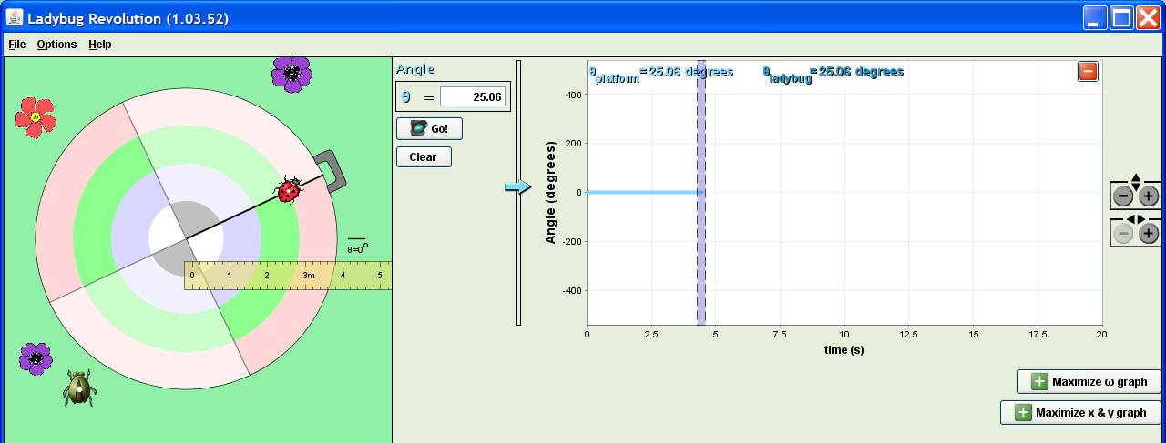

Have the students use the lab sheet for guidance. The activity took my college physics students about 30 minutes.

Post lesson: There are 5 clicker questions from Dubson’s lectures at CU following the introduction slides, some I have reworded and some I have just used the sim to help explain the answers. It might be a good challenge to have the students use Lady Bug or Torque to make slides that help explain the last question.

