Learning Goals:
Students will be able to
- Calculate speed or height from information about a different position.
- Describe how different gravity fields effect the predictions.
- Describe how changing the PE reference effects the predictions. I decided to leave this goal out of the students’ directions and either discuss it with the class or omit it.

Background:
My students will have done Energy Skate Park Activity 1 & 2 and some concept questions from the text.

Pre-Lesson: I projected clicker questions 1-4 to have the students think about their present understanding, but I wouldn’t go over the answers until the post-lesson.

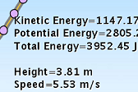Lesson: Have the students use the lab sheet for guidance. You may want to show the students how to get data from the Skater by using the Show Path button. Then they can Right Click on any purple spot to see measurements about the Energy, Height (relative to the PE reference line), and speed. You can hide the data by Right Click on the dot again.
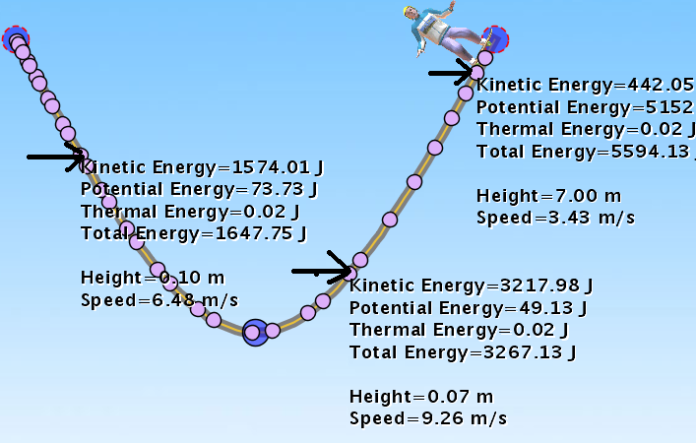Simulation hints: The data recorded at the purple dot is in reference to the PE reference line with the variables that have been selected like mass; the data does not change if you make changes. The example here was made by showing the path, and then I paused the sim and moved the PE line, paused and moved the line again. The data does not make sense if you do not pay attention to the changes. I advised the students to clear the path if they want to look at how variables effect the measurements or take careful notes.
Remember that changing the Skater only changes the mass.

Post lesson: Use the clicker questions with the simulation during discussion of the answers. I would open Skater and the track for questions 1-3 before class and change the character to the female one because the track saves with the male skater. The blue dots on the questions were drawn in paint and I couldn’t make the same track using track pieces to get the blue dots. Also, I have included some clicker questions that I adapted from those used at University of Colorado for the first year algebra based course.
I may have a class discussion around the last learning goal. I did include a challenge to find the PE reference in the Masses and Springs activity that I will be using on the following class period.

Next lesson: I also have a conservation of energy homework activity using Masses and Springs. I think it is better to use after the students are familiar with PE gravitational and KE.

