Learning Goals: Students will be able to explain the motion of an object on an incline plane by drawing free body diagrams.

1. Joe is going off to college and is loading his file cabinet onto the moving truck by sliding it up a ramp like in the picture below.
a. Sketch what you think the free body diagram would look like for the file cabinet and explain your reasoning.
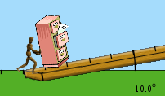

b. Use Ramp: Force and Motion to simulate Joe’s situation. Compare your free body diagram to the simulation and make any corrections to your drawing and reasoning.
c. Investigate the simulation to see what effects how hard Joe must push to move the cabinet up a ramp.
d. Describe your experiments and results including the free body diagrams.
e. Draw the free body diagrams for the cabinet if it were being pushed on a flat surface and if it were being lifted straight up. Compare those to the ones you observed on the ramp, and then describe the differences and similarities.

2. Next, Joe wants to load his crate of books.
a. Predict what you think the free body diagram would look like.
b. Explain what might cause similarities and differences between Joe moving the crate versus the file cabinet.
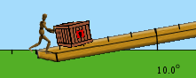

c. Test your prediction and thoughts using the simulation.
d. Describe your experiments and results including the free body diagrams.

3. Think of some other things that Joe might want to move using a ramp and explain what he would have to consider when thinking about how hard to push.

4. Joe has some friends that want to help, but they’re not as strong. How do you think the ramp design be changed so they could help? Verify or adjust your ideas by experimenting with the simulation.

5. Joe wants to stop on the ramp to catch his breath. Would he be better off stopping on a rough spot on the ramp or a smooth spot? Verify or adjust your ideas by experimenting with the simulation.

