Applications of Quadratic Functions in Modeling Path of Motion

Part 1. Analysis of Parameters a, b and c

Purpose: In this activity you will consolidate the techniques of sketching linear and quadratic functions. You will predict the forms of functions and then you will verify them by checking it using TI-83 or simulations.
For all examples, you will refer to the general form of: $y={\text{ax}}^{2}+\text{bx}+c$

1. Determine the general values for a, b, and c to have functions that satisfy the given below conditions. Sketch possible graphs.

- The graph has no turning points (no turns), its y-intercept is 2,
as
a_________
b_________
c_________

B. The graph has one turning point; its y-intercept is 0,
as
a_________
b_________
c_________

C. The graph has no turning points, its y-intercept is 3, and its rate of change is constant and equal to 1/2.
a_________
b_________
c_________

2. Sketch possible graphs that satisfy the given conditions.

A. a >0, b=0, c=0.

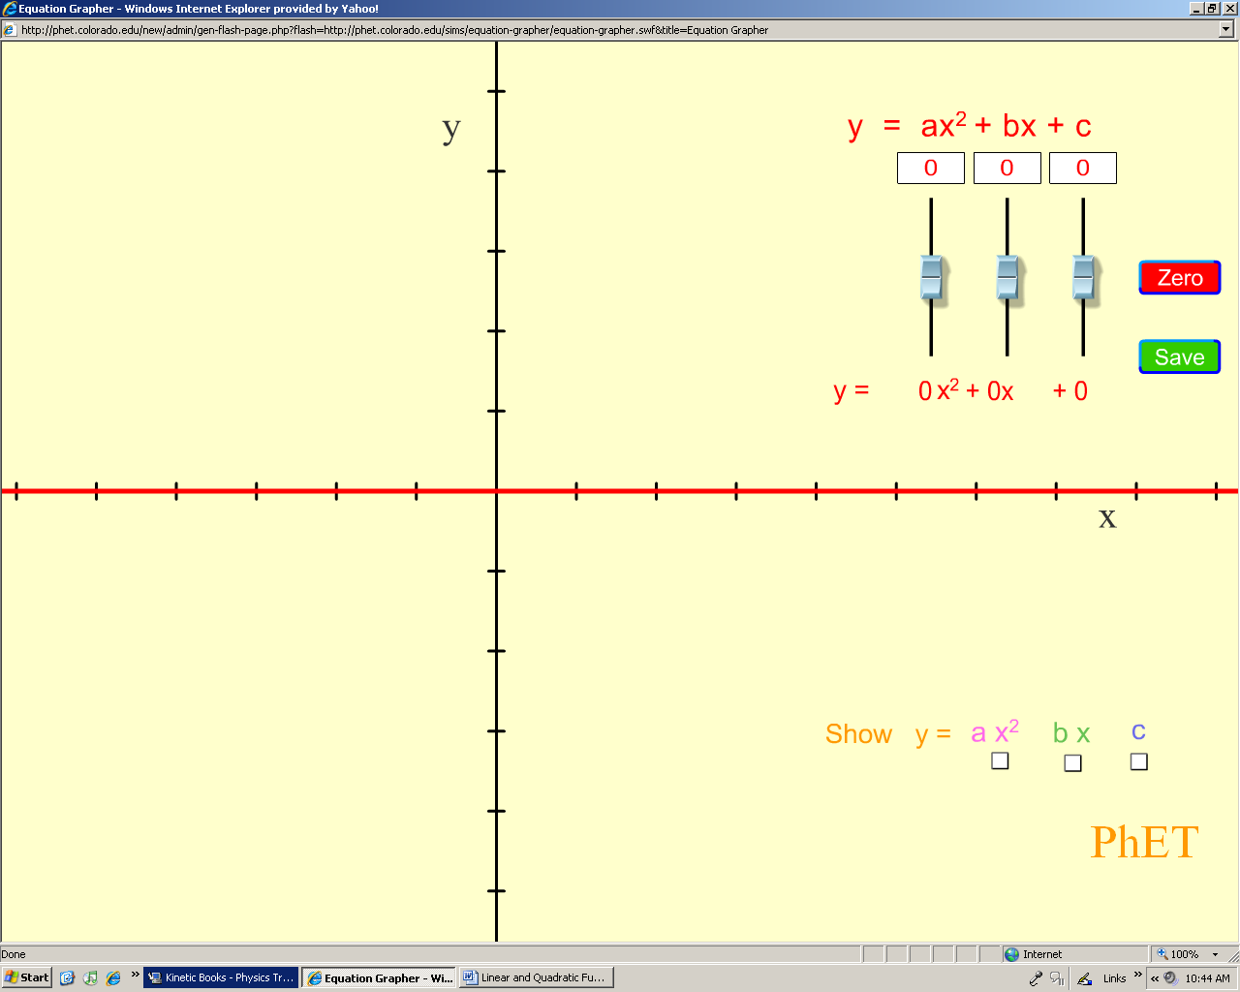

B. Parameter “a” increased twice, b=0 and c>0.
How will graph in A compare to graph in #B?

C. Parameter “a” has opposite value to the one in #B, b=0, c<0.

D. a=0, b<0, and c=0.

E. a >0, b>0, and c=0.

F. a=0, b=0, c<0.

Part 2. Applications

During this part you will analyze the motion of a tankshell fired at different angles.

A. Suppose that a tankshell is fired with an initial speed of 25m/s at 85º toward the horizontal axis.
What type of function can be used to model the path of motion?

_________________________________________________________________

B. What are the possible values for the parameters a, b, and c? (Use >0, <0, or =0)

__________________________________________________________________

C. Suppose that the tankshell is fired at an angle of 95º.
a. Will the maximum height reached by the tankshell change? ___________
b. How will the components of a, and c change?

__________________________________________________________________

D. Suppose that the initial speed of the tankshell remains 25m/s but the angle decreased to 60º.
a. Will the vertical position of the vertex change? _______________________

b. Will the horizontal position of the vertex change? _____________________

c. How will the value of the x-intercept change? _________________________

d. Check your answers observing the demonstration.

e. Were your predictions correct? ___________________________________

E. What mathematical relation can be used to describe the path of motion when the tankshell is fired at 90º?

4. In this part you will find function equation for the given paths of motion.

You can use either $f(x)=a(x−x_{1})(x−x_{2})$or $f(x)=a(x−x_{v})^{2}+y_{v}$ to find the function equations.

You will use a ruler to measure necessary dimensions.

A.
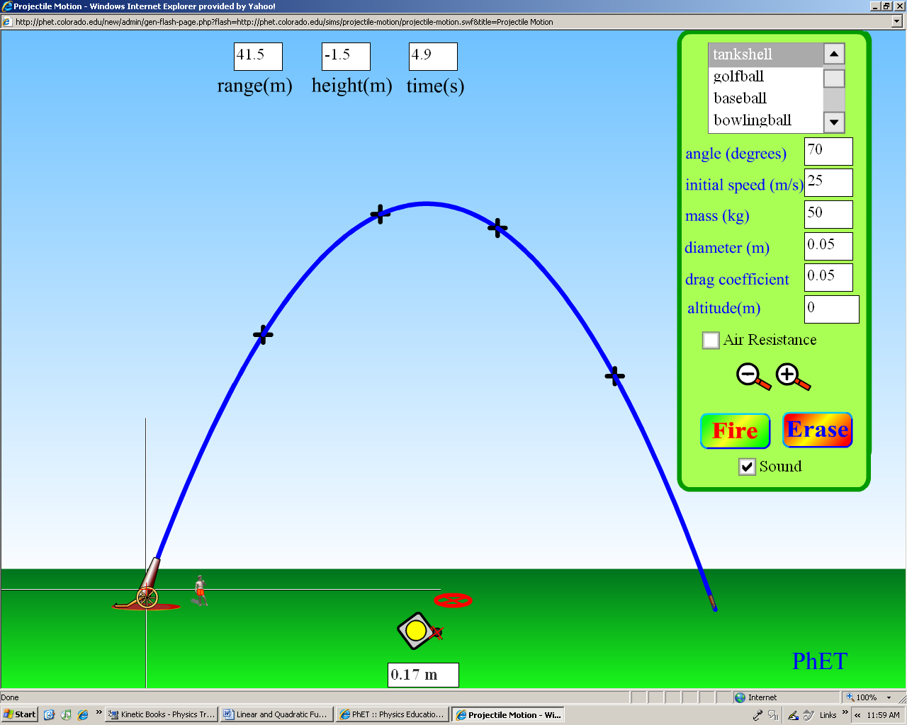

Show all of your calculations.
- Determine the domain and range of the graph due to given constrains.

D=_____________ R=____________

- What is the axis of symmetry of the graph? ________________________

B. Before you take necessary measurements, answer the following questions:

a. How did the value of the component “a” of the parabola change; did it increase or decrease? Consider its absolute value. ________________________

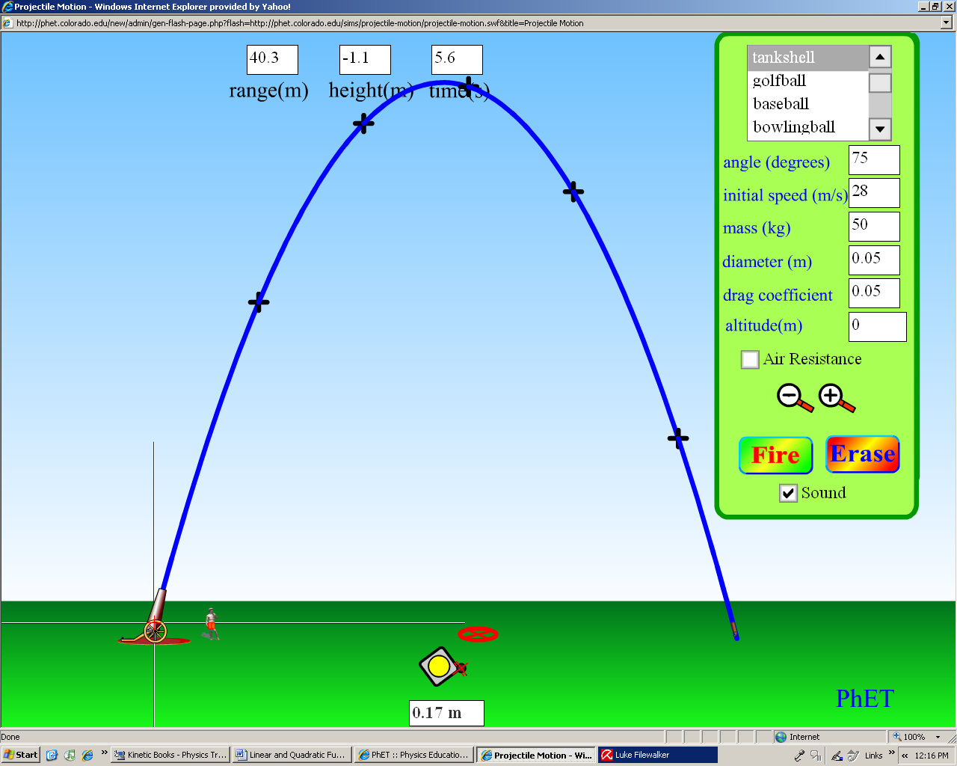

b. How did the domain and range of the function change? ______________________

C. At an angle of 82º and the initial speed of 28m/s the tankshell hits the target (a circle marked red). Suppose that as measured on the paper, the vertical position of the vertex increased by 5 mm with respect to the one shown in part B.
a. Sketch a possible graph for the projectile.
b. Find its function equation.

