THE PHOTOELECTRIC EFFECT: Internet Assignment

- Open Internet; http://phet.colorado.edu
- From the left menu select Quantum Phenomena
- Click on The Photoelectric Effect (on the right side of your screen) to see.

General description of the features of the simulation

  - Intensity cursor (attached to light source) enables to change the intensity of the external source of energy from 0% to 100%.

  - Frequency cursor (attached also to light source) enables to change the wavelengths of the external rays, thus the energy of the emitted photons by the light source, from Infrared (IR; very right) to Ultraviolet (UV very left).

  - Target cursor (the very top-right side) enables to change the type metal (electrode) from which the electrons are ejected for example: sodium, zinc, copper, platinum, or calcium.

  - Battery cursor (attached to the battery, lower part of the diagram) enables to change the potential supplied to the circuit from -8.0V to +8.0V. Note that the varying potential difference enables to apply stopping (retarding) potential.
Note: Red color of the plate indicates a positive terminal, blue indicates a negative terminal.

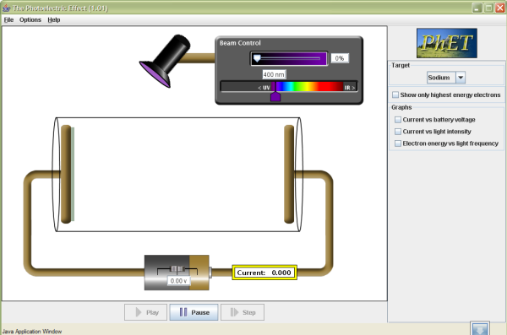

PART 1: Finding the work function for sodium

- Place the intensity cursor at 10% and the battery cursor on 0V.
- Move the wavelength cursor staring from IR to the left. As you move the cursor, do you increase or decrease the energy of emitted photons? _______________________________________________________

- Stop moving the cursor when you observe that the electrons are emitted from the plate.

- Calculate the work function for sodium: _______________________________

Compare your calculations with the expected value for the work function.

Part 2: Finding KE of emitted electrons at 210 nm

- As the electrons are being ejected, move the wave cursor to 210 nm.
- Is the kinetic energy of the emitted electrons increasing or decreasing during the process of reaching the wavelength of 210 nm? ___________________________________________________

- Write the formula to find the KE of emitted electrons and then follow with the calculations.

PART 3. Does the intensity of external light source affect the kinetic energy of the ejected electrons?

Hypothesis: _____________________________________________________

- Move the cursor to intensity of 100% to check your predictions.

- Was your hypothesis correct? _________________________________

PART 4. Analysis of Graph Energy of Ejected Electrons versus Frequency of the Source

1. Move back the intensity cursor to 10 % and the frequency cursor to the threshold frequency.

2. Highlight Energy versus Frequency Graph from the Right Side of the Manu.
.
3. Predict the type of graph you would expect as you increase the wavelength of the external source of light?

4. Check your predictions.

5. What does the slope of the graph represent?

6. Calculate the slope and show your calculations.

7. Change the metal plates for copper. Do you expect the graphs Energy versus Wavelength to be identical (in terms of the x-intercepts and the slopes) for both metals?

____________________________________________

8. Check your predictions_______________________

PART 4. Analysis of Intensity of External Source versus Intensity of Current Graph.

1. Highlight Current versus Light Intensity Box form the right menu.

2. As you move the wavelength cursor, do you expect the intensity of the current to change? Support your answer.

3. Check your predictions.

Part 2. Analysis of Energy versus Frequency Graph

