Name_________________________
Physics: Lens Simulation
Messieurs Gaines and Graham
April, 2007

Warm-Up:
Copy the ray diagram for the double-convex lens below.

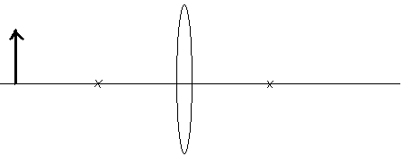

Describe the image? (smaller, larger, etc.)

Follow the instructions below, answering the questions as you work your way through the sheet.

- First go to: http://phet.colorado.edu/web-pages/simulations-base.html

- Click on the link marked “Light & Radiation”. It is on the far left, near the bottom of the webpage.

- Scroll down through the simulations until you find the one called “Geometric Optics”, and then click to open this simulation. Make your ray diagram look like the one in the warmup.

  - Using the mouse, slowly slide the pencil horizontally toward the lens, but do not slide it past the focal point of the lens (the “X” on the line). Describe what happens to the image.

  - Using the mouse, place the object on the focal point of the lens (the “X” on the line). What happens to the rays when they leave the lens: are the bent or parallel? Do you think you could see an image? Why or why not?

  - Use the mouse to slide the pencil back to where it was when you started. Now, use the sliders to change the values of the lens curvature radius and lens diameter. Fill in the table below.

 | What happens to the focal point? | What happens to the image?
Lens Curvature Radius is larger

Lens Curvature Radius is smaller

- Do your answers match what you found when we did the lens stations?

Cool Down: Use the simulation program to draw a schematic of a projector on the other side of this sheet.

